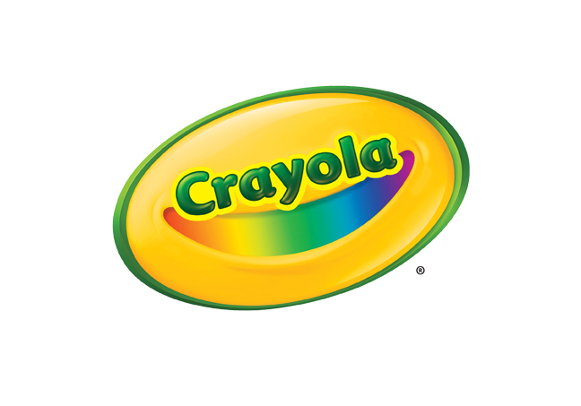
MEDIA CONTACT
Erika Merklinger
Crayola
eamerklinger@crayola.com
(610) 253-6272 ext. 4625

Jaclyn Giuliano
Golin for Crayola
jgiuliano@golin.com
+1 212.373.6070

Crayola Glitter Dots

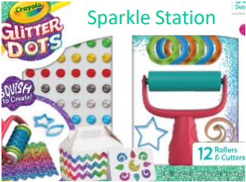
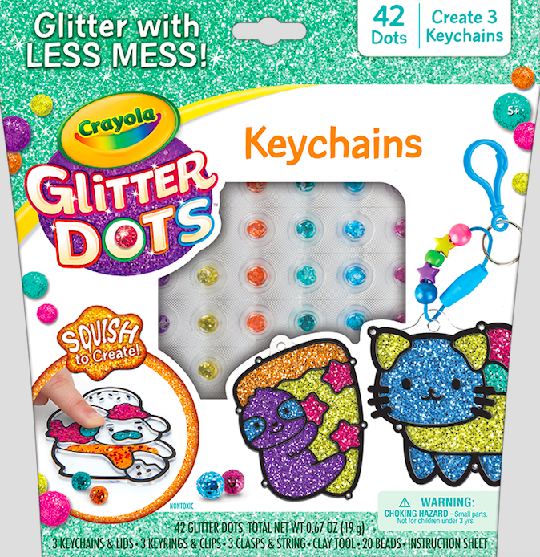
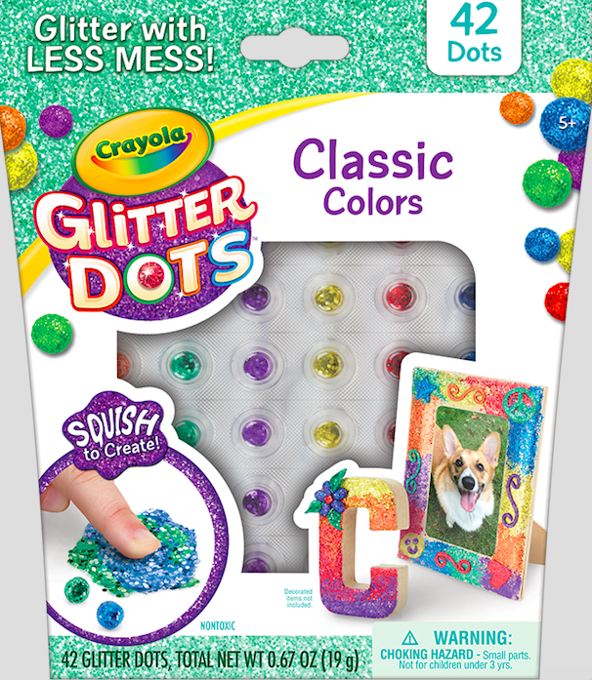

With Crayola Glitter Dots, kids can create with glitter in a whole new way, without all the mess! Just squish each dot to create glitter-infused outputs. Each dot contains a special coating so the glitter stays in the dot and not on your hands! Glitter dots are easy to use and versatile for any type of craft or project – they can be used on a variety of surfaces including paper, wood, craft foam, felt and more.

Glitter dots are available in a variety of ways:
- Glitter Dots Single Packs ($4.99): Contains 42 dots each and comes in three different color palettes
- Glitter Dots Activity Kits ($9.99): Each kit focuses on one activity using Glitter Dots; activities include creating keychains, stickers, mosaics, and sparkly signs. Kits include 42 Glitter Dots.
- Glitter Dots Sparkle Station ($19.99): Comes with 84 dots and gives kids all the tools they need to squish, roll, and cut custom glitter dot creations that can be applied to a variety of surfaces

BENEFITS
- Glittery Fun With Less Mess: Kids love to play with glitter but traditional glitter and glue can be messy; with Glitter Dots, the glitter is contained in the dots, providing a perfect less mess solution for moms and kids.
- Color Variety for Custom Creations: Glitter Dots are available in 13 different sparkly colors and three different color palettes; classic, tropical and bold
- Endless Possibilities to Create: Glitter Dots will adhere to a variety of surfaces including paper, wood, felt, paper mache, fabrics, craft foam and more

TARGET AUDIENCE
- Children aged five years and older

WHERE TO BUY
- Price: $4.99-$19.99
- Available at Crayola.com and retailers nationwide in August 2019

