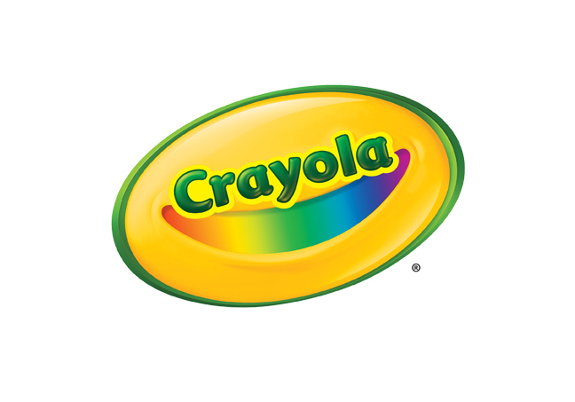
MEDIA CONTACT
Erika Merklinger
Crayola
eamerklinger@crayola.com
(610) 253-6272 ext. 4625

Jaclyn Giuliano
Golin for Crayola
jgiuliano@golin.com
(212) 373-6070

Crayola Scribble Scrubbie Safari Oasis

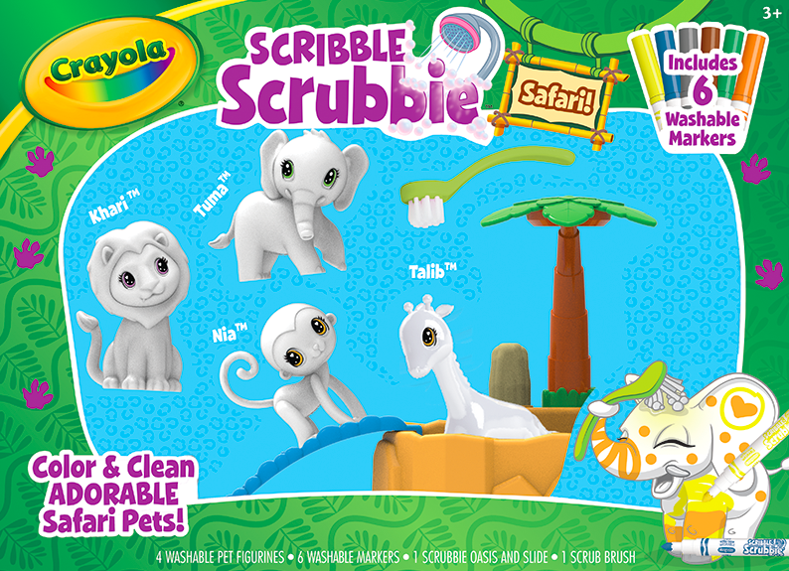

Crayola Scribble Scrubbie Safari Oasis includes adorable, colorable and washable pet figures that kids can customize with color, wash in the kid-powered Oasis Tub, and color again. Following the popularity of Crayola Scribble Scrubbie Pets, Safari Oasis features all new safari-themed pets that kids can color customize with the six included Scribble Scrubbie Ultra Clean® Washable Markers. When they are ready for a color change, they can brush their Safari pets clean in the kid-powered Oasis Tub, dry them off and start over. In addition to the four safari pets included, there are additional expansion packs (sold separately) for a total of 12 adorable safari animals that kids can collect and customize again and again.

The set includes four all new safari pets including a monkey, an elephant, giraffe and lion, kid-powered hand-pump Oasis Tub with a fun slide attachment, a scrub brush and six Scribble Scrubbie Washable markers.

BENEFITS
- Collectible Fun For Kids: With the four included Scribble Scrubbie Safari Pets and expansion packs, kids can continue to expand their collection of adorable pets to customize, nurture and clean
- Customizable Creativity: Kids can use the special Scribble Scrubbie Ultra Clean® Washable Markers to design and customize their pets however they choose
- Create Over and Over: Using the included hand-pump Oasis Tub, kids can wash off their pets, customize with brand new designs when they dry, and wash again

TARGET AUDIENCE
- Children aged three years and older

WHERE TO BUY
- Price: $19.99
- Available at Crayola.com and retailers nationwide in August 2019

