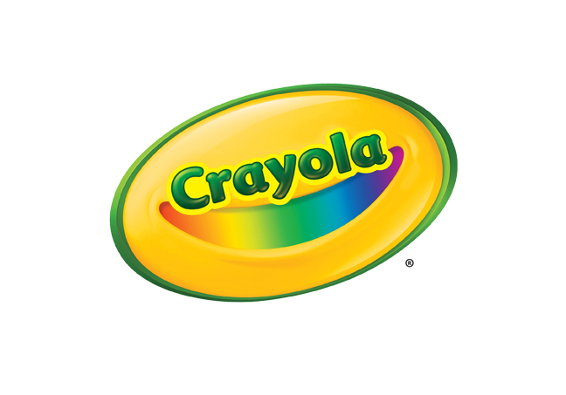
MEDIA CONTACT
Erika Merklinger
Crayola
eamerklinger@crayola.com
(610) 253-6272 ext. 4625

Jaclyn Giuliano
Golin for Crayola
jgiuliano@golin.com
(212) 373-6070

Crayola Sprinkle Art Shaker

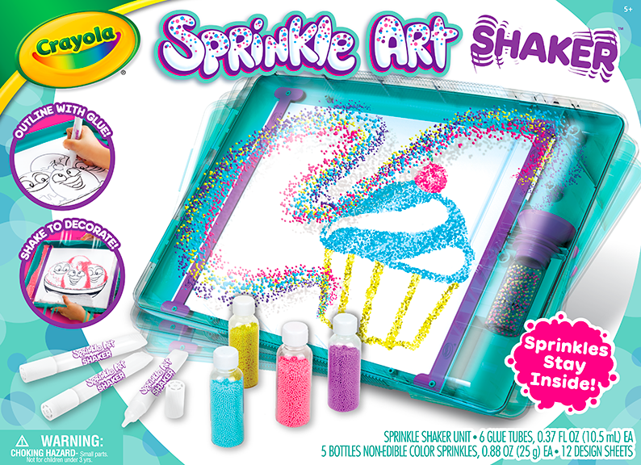

With the brand new Crayola Sprinkle Art Shaker, kids can create art using glue and colorful sprinkles – with less mess! Using the enclosed case, kids can outline content with glue, insert the sprinkles, and then shake until the sprinkles stick. Shake again for the remaining sprinkles to roll back into the inserted sprinkle tubes for virtually no clean up and can be used again and again. Kids can decorate the included food-themed content pages or can use their imagination to create any design they choose on their own paper!

BENEFITS
- Custom Sprinkle Art: Kids can use content pages, glue and colorful sprinkles to create 2D art
- Less Mess for Colorful Creativity: Sprinkle bottles fit easily into enclosed Shaker unit and funnel into unit and back into bottle seamlessly for less mess and lots of color
- Customizable for Continued Playtime: Any 8.5 x 11 paper fits into the unit and can be decorated so, once content pages are decorated, kids can continue to create colorful outputs with their own custom designs or other Crayola line art!

TARGET AUDIENCE
- Children aged five years and older

WHERE TO BUY
- Price: $19.99
- Available at Crayola.com and retailers nationwide in August 2019

