Epoch Sweet Suite 2020 Fact Sheet

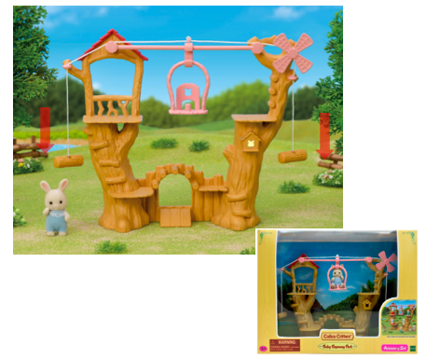
Baby Ropeway Park, Ages 3+/ Available

The Baby Ropeway Park brings a playful environment to the campsite. This set comes with Henry Sweatpea Rabbit baby critter and includes a slide, windmill and gondola. Pull the string to move the gondola from slide to slide!

Lakeside Lodge Gift Set, Ages 3+/ $49.99 each/Available Autumn-Winter 2020
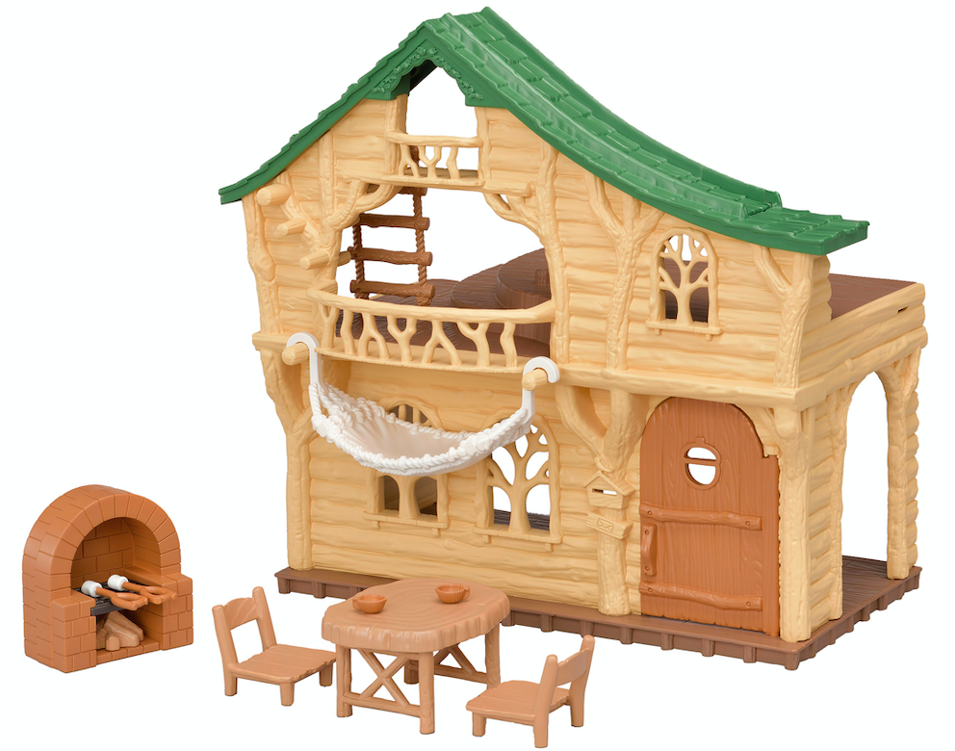
Kids can take their Calico Critters on a special Family Trip to eat, sleep and play at the Lakeside Lodge. The two-level home is furnished with a rustic dining table, two chairs, a brick oven, marshmallow sticks, 2 cups, a hammock to relax, and secret slide on the rooftop and rope ladder for the little critters to play. The playset comes with Poppy Yellow Labrador baby ready to play in the new environment and truly bring Nature, Family and love to children’s homes. Collect and connect with the Adventure Tree House for even more fun!

Adventure Tree House Gift Set, Ages 3+/ $59.99 each/Available Autumn-Winter 2020
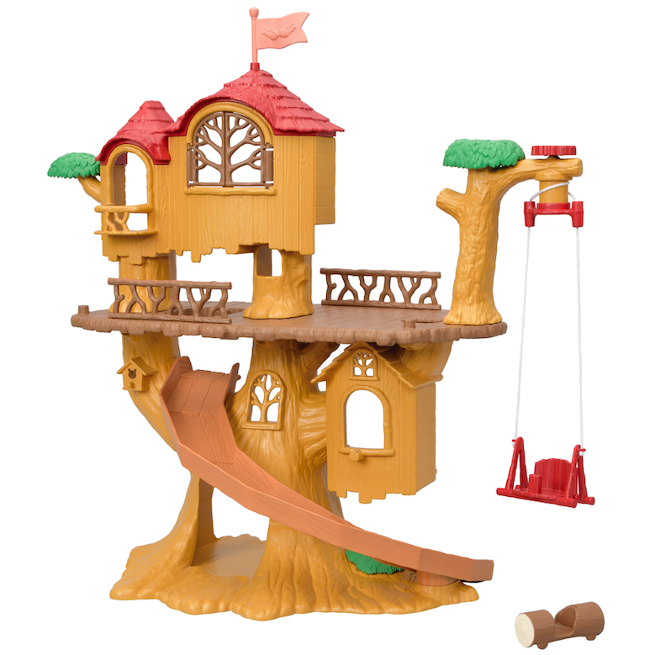
Set your critters out on an adventure and climb up the Adventure Tree House to enjoy the great outdoors. The Adventure Tree House Gift Set brings your favorite children and nursery critters together for a fun-filled day of play. With four rooms, a twirling swing, a slide to ride down on a log, hide and go seek spots and tunnels there is fun for everyone. The play set comes with Adelaide Outback Koala baby ready to play in the new environment. Collect and connect with the Lakeside Lodge and Baby Ropeway Park for even more fun!

Trolls World Tour Playset, Ages 4+/ $24.99
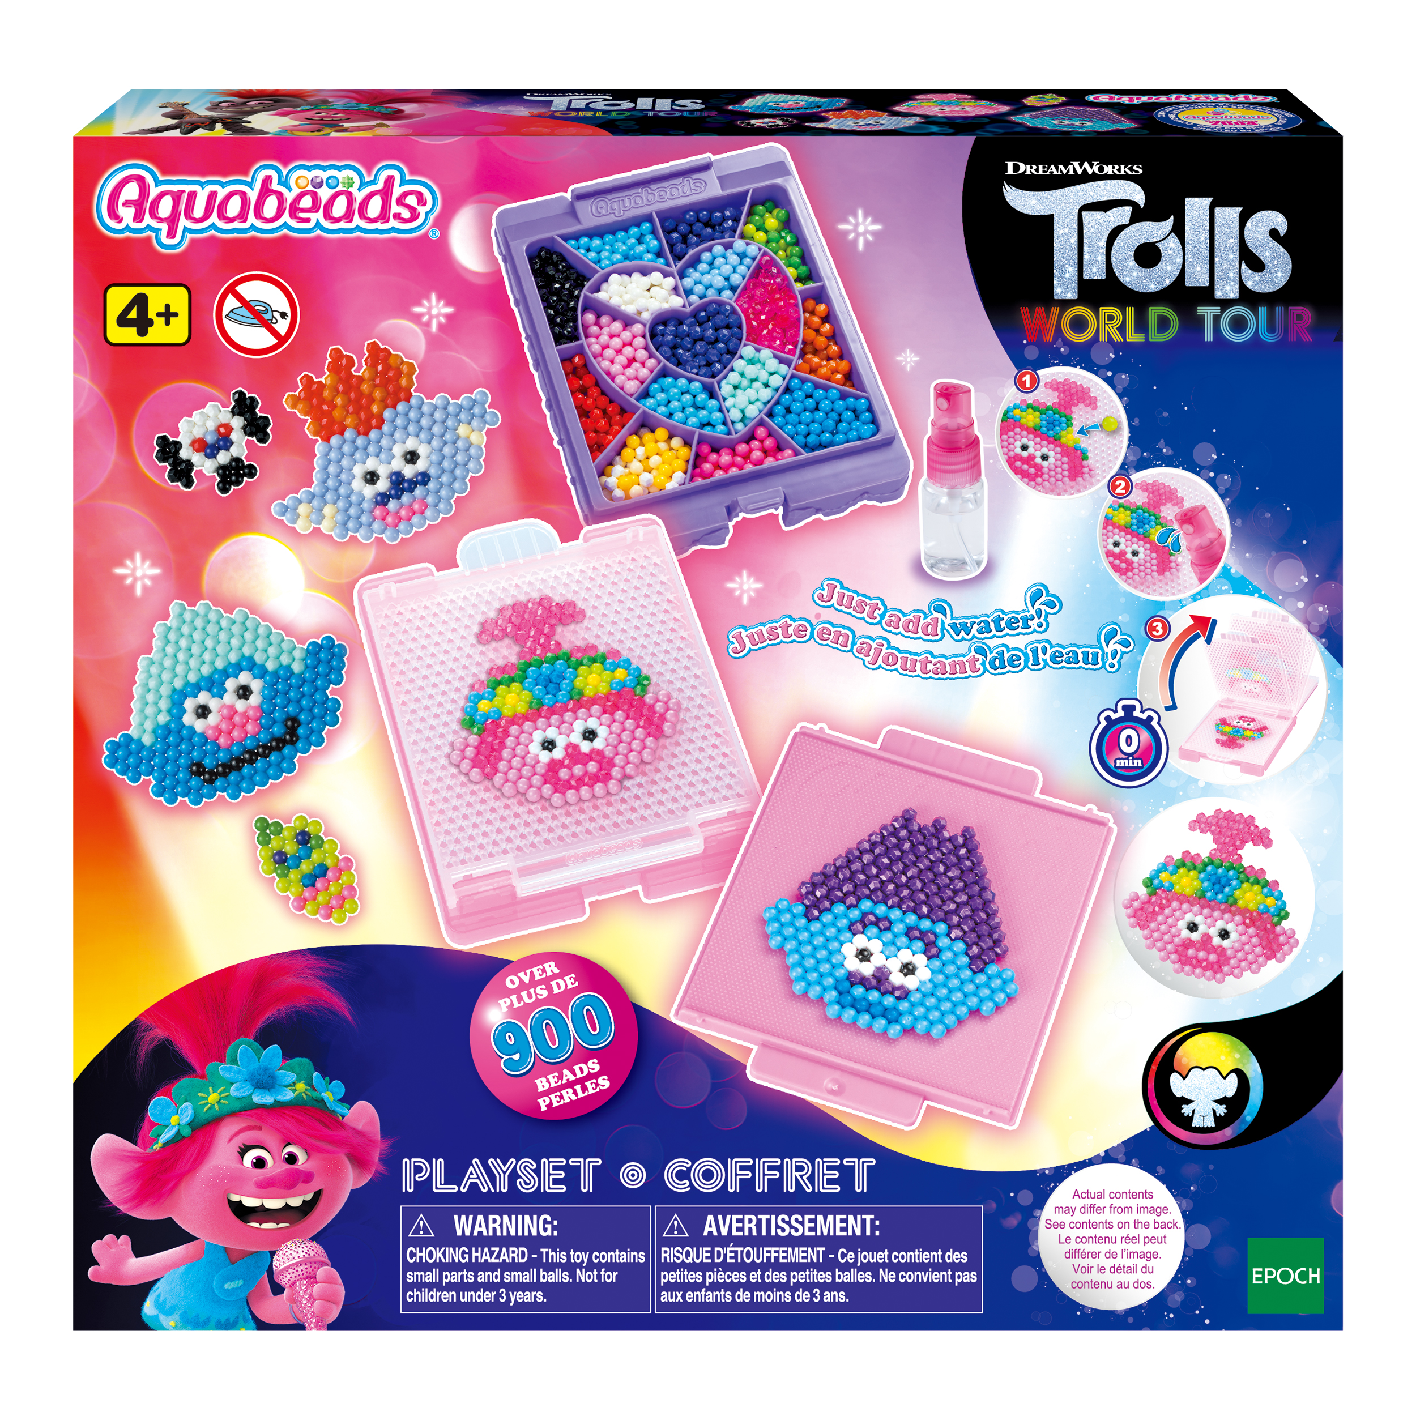
Ready, set, ROCK! Kids can craft their favorite Trolls World Tour characters, including Poppy, Branch and a few new characters, and bring their colorful artwork to life as they place and fuse the beads over the provided template. Help unite the Trolls and save diverse melodies with this fun playset that includes more than 800 jewels & solid beads, case, flip tray set, template sheet, sprayer and instructions to add to the creations. Bead pen sold separately.

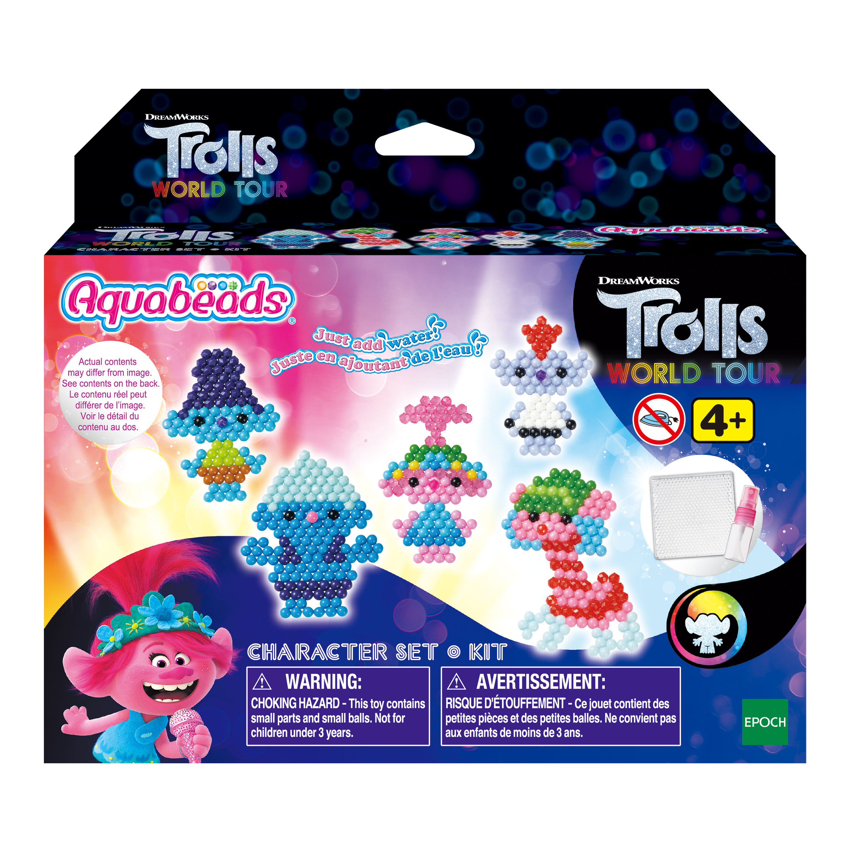
Trolls World Tour Character Set, Ages 4+/ $12.99/ Available at Target

Children can create their favorite Trolls World Tour characters and bring their colorful artwork to life as they place and fuse the beads over the provided template. This set includes more than 600 jewels & solid beads, template sheet, sprayer and instructions to add to the creations. Bead pen sold separately.

Super Mario Balancing Game Assortment, Ages 4+/ $12.99
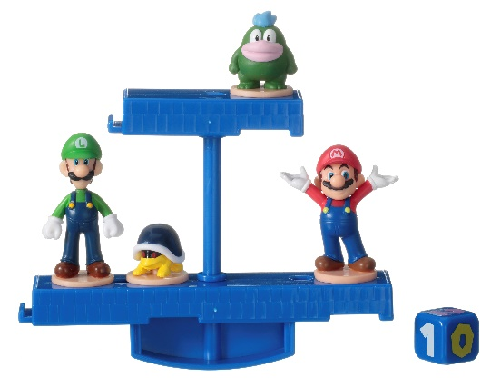
Enter the world of Super Mario with one of three Nintendo Super Mario Balancing Games! Each game includes a balancing stage, die, and 4 characters, including favorites like Mario, Princess Peach, Boo, and Yoshi. When it’s your turn, roll the die and make the stage shake. If the characters fall off, you lose! Characters are collectible and interchangeable across different sets.

Freeman Public Relations
Maxine Aviles
973-470-0400 ext. 20
maviles@freemanpr.com

Freeman Public Relations
Deena Rosenberg
201-280-1937
drosenberg@freemanpr.com

