PLAYFUL PANDAS

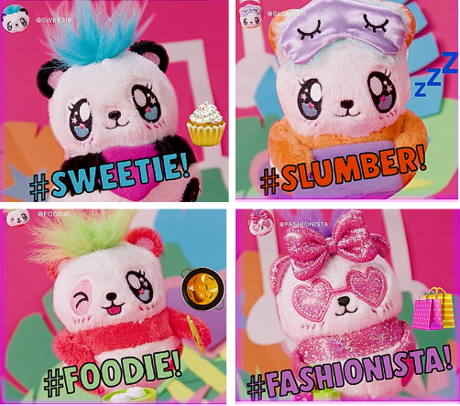
What: Playful Pandas are musical, magical, Pandorable friends with limitless responses. Kids can sing any song to their Panda and she’ll sing back in her own Panda language! Playful Pandas come in four styles including Sweetie, Slumber, Foodie and Fashionista each with her own personality and signature song. And, when kids collect two or more Pandas they will sing in harmony. For even more fun, each Panda responds to a child’s touch – tickle her belly, kiss her nose or pat her head and the Panda will laugh, move and respond! Playful Pandas come in four different styles for kids ages 4+.

Where: Playful Pandas will be available in October at Target for approximately $14.99.

Who: Far Out Toys Inc. is a rapidly growing force in the global toy marketplace, with a mission to innovate to the outer reaches. With fully integrated manufacturing, distribution and marketing capabilities, Far Out Toys leverages its expertise and extensive relationships with inventors, IP holders and mass retailers to launch new brands in every toy category - including vehicles, arts & crafts, games, licensed collectibles, electronic toys and fashion dolls. For more information, visit Far Out Toys.

Media Contact: Lisa McKendall
McKendall Communications
310-641-1556
lisa@mckendall.com

