NASCAR CRASH CIRCUIT
Fact Sheet
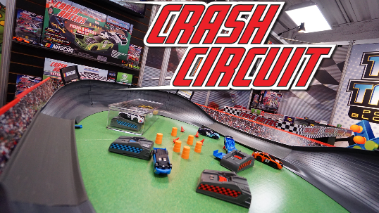
What: Last year, Far Out Toys launched the highly successful line of NASCAR Crash Racers including partnerships with NASCAR race tracks, with top YouTube influencers and supporting in-store programs at Walmart. In 2020, the high-speed vehicle and track set line will expand with new NASCAR branded sets, all compatible with their unique “blue groove” track system. In addition, Far Out Toys has expanded their relationship with NASCAR driver Natalie Decker and established a new partnership with 5-year-old race car driver Brexton Busch, son of NASCAR cup series champion Kyle Busch.
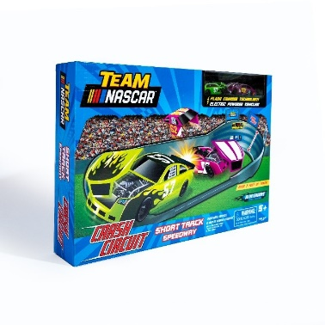
The NASCAR Crash Circuit Road Course with Winner’s Circle will bring the excitement of NASCAR home with this one of a kind “Roval” track. With cars that break apart upon impact, players must race around steep turns at insane speeds and pass their competition or risk getting wrecked. The set even comes with a Winner’s Circle that really spins! The Road Course with Winner’s Circle comes with four motorized race cars, four flash chargers, pit crew figurines and more. It is recommended for ages 5+.

The new NASCAR Crash Circuit Short Track Speedway lets kids test the limits on speed by ripping around triple-wide turns for unpredictable racing and passing action. The Short Track set comes with two motorized race cars, two flash chargers, pit crew figures and more and is recommended for ages 5+.

Learn more about NASCAR Crash Circuit products.

Where: NASCAR Crash Circuit Road Course with Winner's Circle is available now on Amazon, bundled with an additional 4-car collector pack for $49.99. The NASCAR Crash Circuit Short Track Speedway is available on Amazon for approximately $24.99.

Who: Far Out Toys Inc. is a rapidly growing force in the global toy marketplace, with a mission to innovate to the outer reaches. With fully integrated manufacturing, distribution and marketing capabilities, Far Out Toys leverages its expertise and extensive relationships with inventors, IP holders and mass retailers to launch new brands in every toy category - including vehicles, arts & crafts, games, licensed collectibles, electronic toys and fashion dolls. For more information, visit Far Out Toys.
Media Contact: Lisa McKendall
McKendall Communications
310-641-1556
lisa@mckendall.com

