Far Out Toys Speeds into Holiday of Play
New Products Featured at Holiday Event Bring the
Excitement and Fun of Racing Home

El Segundo, CA – Holiday of Play is the ideal backdrop to put focus on the exciting, high-speed fun of NASCAR racing toys from Far Out Toys. Along with demonstrations of the newest track sets, Far Out Toys will host the Crash Circuit Speed Round for a chance to win a NASCAR track set bundle worth $100 and signed Hero Card from young driver Brexton Busch! The giveaway will take place at 1 pm EST at Booth 405 with a live trivia game with questions on a wide variety of topics. Three grand prizes and five participation prizes will be awarded!

In 2019, Far Out Toys established an on-going relationship with NASCAR driver Natalie Decker and this year established a new partnership with 5-year-old race car driver Brexton Busch, son of NASCAR cup series champion Kyle Busch.
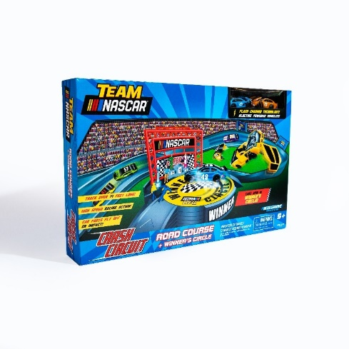
The NASCAR Crash Circuit Road Course with Winner’s Circle will bring the excitement of NASCAR home with this one of a kind “Roval” track. With cars that break apart upon impact, players must race around steep turns at insane speeds and pass their competition or risk getting wrecked. The set even comes with a Winner’s Circle that really spins! The Road Course with Winner’s Circle comes with four motorized race cars, four flash chargers, pit crew figurines and more. It is available now on Amazon for $49.99 and is recommended for ages 5+.
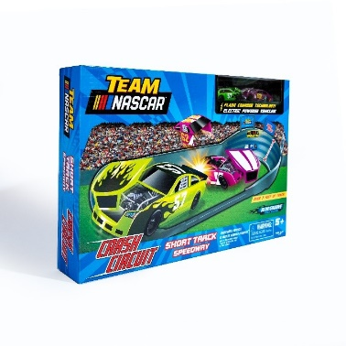
The new NASCAR Crash Circuit Short Track Speedway lets kids test the limits on speed by ripping around triple-wide turns for unpredictable racing and passing action. The Short Track set comes with two motorized race cars, two flash chargers, pit crew figures and more. The set is available now on Amazon for $24.99 and is recommended for ages 5+

About Far Out Toys
Far Out Toys Inc. is a rapidly growing force in the global toy marketplace, with a mission to innovate to the outer reaches. Far Out Toys leverages its expertise and extensive relationships with inventors, global distributors, IP holders and mass retailers to launch brands across categories - including vehicles, games, licensed collectibles, electronic toys and more. For more information, visit www.farouttoysinc.com.

####

FAR OUT TOYS MEDIA RELATIONS CONTACT:
Lisa McKendall lisa@mckendall.com
310-991-6737

