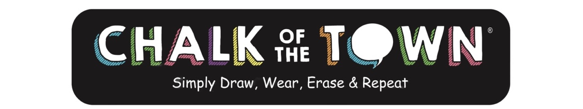
Chalk of the Town Snowman T-Shirt Kit
- Nurture creativity and stimulate kids’ imagination this winter with Chalk of the Town’s festive Snowman T-Shirt Kit!
- This high-quality t-shirt for kids features a unique “chalkboard” snowman on the front— the perfect frosty friend to decorate with a hat and gloves, a festive holiday design, or a personalized message.
- Draw right on the special chalkboard surface with the included chalk markers — and thanks to the patent-pending design, the creation won’t smudge or bleed.
- Ready for a new design? Just erase with a wet cloth and draw again. Shirts are reusable and machine-washable, so kids can let their creative imagination go wild throughout the holiday season.
- Snowman T-Shirt Kits come with a soft, 100% cotton Carolina Blue t-shirt; pink, white, and blue water-based chalk markers; and an erasing cloth. Available in youth sizes XS (2-4), S (6-8), M (10-12), L (14-16), & XL (18-20).
- Made by Moms – Designed and manufactured by people who understand the need for high quality, creative and engaging toys.
Age: 4-16 years | MSRP: $26.95 | Available: Amazon, Chalk of the Town
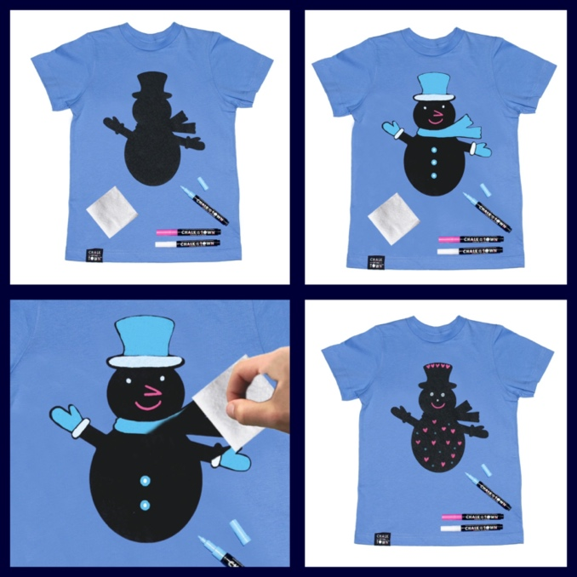
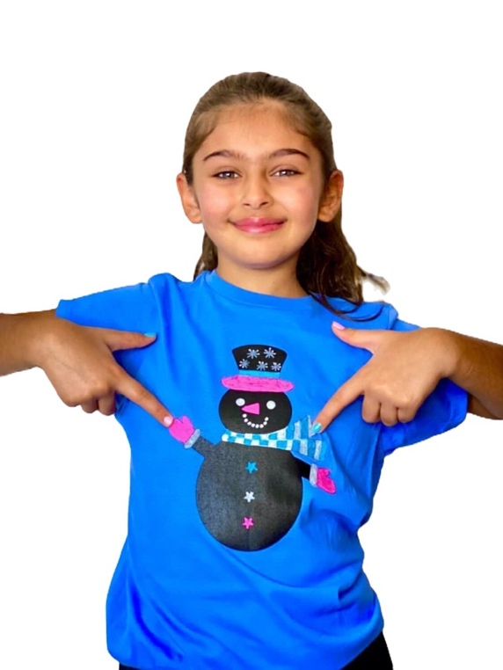

Chalk of the Town Christmas Tree T-Shirt Kit
- Ring in the holidays this year with Chalk of the Town’s new Christmas Tree T-Shirt Kit. This clever kit has everything a you to exercise your imagination and create a personalized, festive t-shirt.
- This shirt features a “chalkboard” Christmas tree on the front to decorate with the included chalk markers — and thanks to the patent-pending design, when you proudly wear your Christmas masterpiece, it won’t smudge or bleed.
- Gather your family to celebrate and craft together, again and again as Chalk of the Town shirts wipe clean with a damp cloth and are machine-washable, too.
- Christmas Tree T-Shirt Kits come with a 100% cotton, Kelly Green long-sleeve shirt; pink, green, & blue water-based chalk markers; & an erasing cloth. Available in youth sizes XS (2-4), S (6-8), M (10-12), L (14-16), & XL (18-20). Kits with Kelly Green short-sleeve shirts are available in adult sizes: S, M, L & XL

Age: 4-16 years | MSRP: $27.95 | Available: Amazon, Chalk of the Town

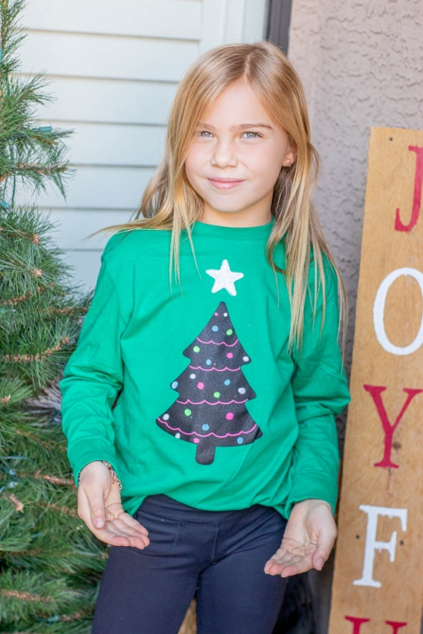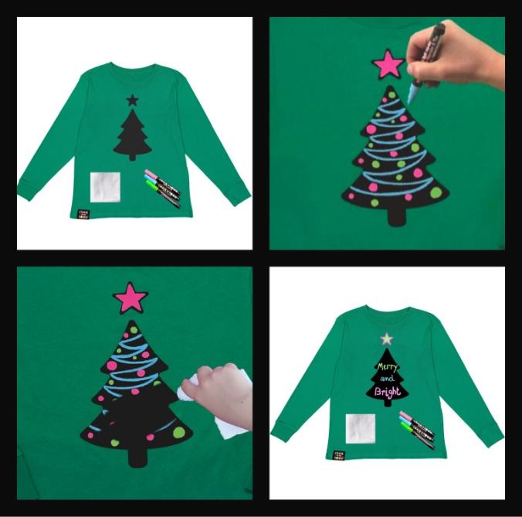
To keep up with what’s trending, follow them on social media
Facebook and Instagram @MyChalkOfTheTown, Twitter @ChalkOfTheTownT.
Buy or learn more at chalk-of-the-town.com

