BABY AMUSEMENT PARK
Step into a world of magic and adventure at the Calico Land Baby Amusement Park!

- Starring the favorited Nursery Series Critters, the interactive, colorful playset features four main attractions: Cosmo World with Rocket Ship Launcher Ride, Fantasy Land with Turreted Castle, Adventure World with Rocking Pirate Ship and Baby Go Karts, and Sweets World with Ferris Wheel.
- Features the adorable and restyled Pookie Panda Baby Clara, Sweetpea Rabbit Baby Henry and Persian Cat Baby Leah to delight in the interactive rides including a turn around the ferris wheel, riding around the Go Kart track to take in the views and launching high into the air to see the Calico Land magic!
- Turn the Amusement Park around to display your collection of Nursery Critters!
- Inspires imaginative and role play!

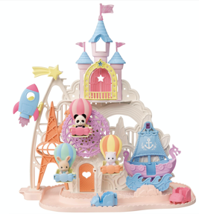
Age: 3+ | MSRP: $59.99 | Available: September 2021

Freeman Public Relations for Epoch
Maria Habermann, 973 470 0400 ex. 17, mhabermann@freemanpr.com

ROYAL CARRIAGE SET

Make way for the Royal Carriage Set and step inside the magical dressing room of
Hopscotch Rabbit Baby Grace.

- The elegant princess-inspired carriage is embellished with a beautiful pink bow adorning the top of the carriage and gold drapes, lanterns and wheels for a regal ride through the Baby Amusement Park!
- Includes Hopscotch Rabbit Baby Grace in a beautiful lace dress as she gets ready in her royal cabin with detailed furniture including a vanity set with a brush, crown, pink slippers and scepter, and cushioned couch.
- Collect with the Baby Amusement Park and Baby Star Carousel for even more amusement park fun!

Age: 3+ | MSRP: $24.99 | Available: September 2021
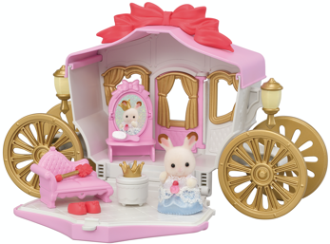

Freeman Public Relations for Epoch
Maria Habermann, 973 470 0400 ex. 17, mhabermann@freemanpr.com

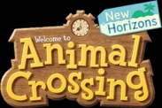

ANIMAL CROSSING: NEW HORIZONSTM AQUABEADS

Bring your favorite islanders to life with Animal Crossing: New HorizonsTM Aquabeads®!

- Create islanders from the game including Tom Nook (Raccoon), Isabelle (Dog), Peanut (Squirrel) and Bunnie (Rabbit) and more!
- Includes over 870 solid, 19 vibrant colors with jewel and NEW star beads that help create a life-like, flocked look to your furry creations.
- Included keychain hooks to wear your favorite islanders.
- Encourages fine motor skills, dexterity, and concentration.

Age: 4+| MSRP: $14.99 | Available: Now

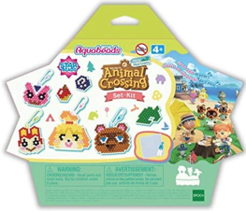
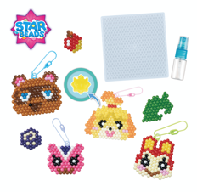

Freeman Public Relations for Epoch
Maria Habermann, 973 470 0400 ex. 17, mhabermann@freemanpr.com

FIRE MARIO STADIUM

Race Luigi to defeat the final boss, Bowser,
in the epic Super MarioTM Fire Mario Stadium game!

- Defeat Bowser in an epic tabletop action game, with classic Mario vs. Luigi competition.
- Use both paddles on each side of the game base to shoot fireballs at the spinning targets to advance your target closer to defeating Bowser to win! Play defense by shooting at your opponent’s target to send their spiraling target back to start.
- Includes game base with Bowser’s Tower, two double sided targets and Super Mario and Luigi collectible action figures.
- The collectible characters are interchangeable across all Epoch Super MarioTM Game sets. No two alike!

Age: 5+ | MSRP: $39.99 | Available: Fall ‘21

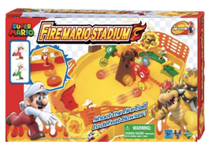
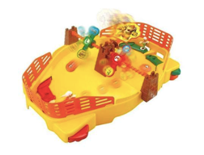

Freeman Public Relations for Epoch
Maria Habermann, 973 470 0400 ex. 17, mhabermann@freemanpr.com

