MUSICAL WHALE FOUNTAIN

The new Musical Whale Fountain brings innovation to bath and outdoor pool play. Offers five colorful whales that act as piano keys and creates a grand fountain display!

- As the leader in infant and toddler music, the fountain enables children to explore rhythm and sounds through fun waterplay! Press the crab themed start button and get ready for a mesmerizing water show display.
- This cool and fresh design features five colorful whales to teach color recognition.
- The fountain has two modes: playing each whale like a piano key or listening to one of the five various familiar preschool songs included. The water spouts at different heights based on the different song rhythms.
- Switch modes to push each whale like a piano key, with the Do, Re, Mi melodies.
- The fountain can be secured to any hard surface using the suction cups at the bottom of its base. It can be used in a tub or kiddie pool for indoor/outdoor play.
- Requires 4x AA batteries; not included.

Ages: 18 Months+ | MSRP: 34.99| Available: Amazon
Video link
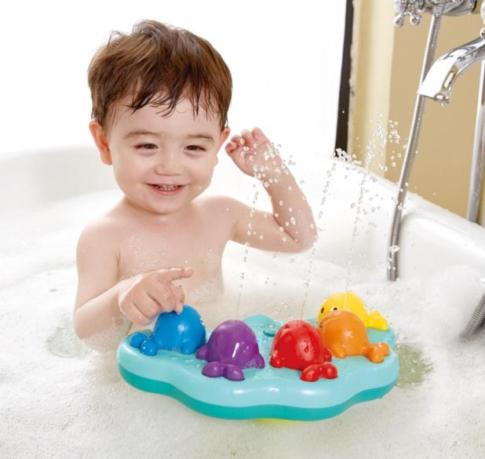

QUADRILLA SUPER SPIRALS

Quadrilla Super Spirals is the ultimate wooden marble-run set with
musical surprises and endless configurations for racing fun!

- Watch the marbles roll down the tracks and play a tune down the xylophone rail, the marbles will spin through the colorful -inspired spiral twists and find their way to the finish.
- This marble run is a 3D puzzle perfect for the young engineer!
- This is a hands-on building set, once the Quadrilla Set is built watch the marble race down the tracks. If the marble falls off the tracks you’ll need to figure out where the break in the track is. Retest until the marble flows from start to finish. This process applies critical thinking which encourages problem solving – a true STEAM item!
- This set encourages independent and traditional family playtime! Kids, friends and family can experience the fun of rebuilding the structure to new configurations and racing the marbles down their creation with keep them continuously engaged.
- Set includes 77 pieces, 50 marbles and unique wooden blocks that add to the constructing
fun.
- Compatible with all Hape Quadrilla sets.

Ages: 4+ | MSRP: $149.99 | Available NOW at Amazon.com
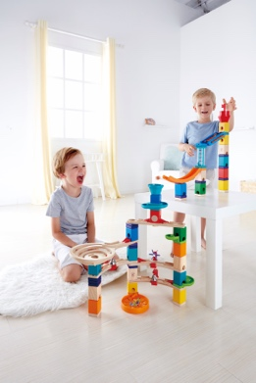
Video Link
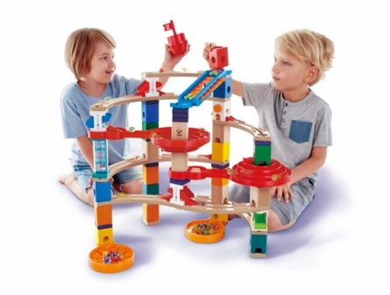

Play Tip: Check out Hape’s “Quadrilla Community” in the free Hape App for even more configurations and a fun community of builders to share configurations and post videos.

Celebrating 35 years of leading the industry in manufacturing affordable, high quality toys, Hape (“hah-pay”), represents the next generation of play, with all the products made with sustainability, education, innovation, and fun in mind. Hape toys are introduced at 0M to 4Y+ and are built to develop with your child as they grow and learn new skills.

DJ MIX AND SPIN STUDIO

DJ Mix and Spin Studio drops the fun beats while little ones
create their own funky music!

- As the leader in infant and toddler music, the DJ Mix and Spin Studio encourages rhythm and sound recognition as they explore each interactive button, knob and dial on the colorful, portable turntable and mixer unit.
- Step by Step actions of Play Pattern:
- For Beginners: Use the included music book and provided stickers to mark your piano keys! You can play by matching the color of the keys to those shown in the handy music book to make your very own sounds.
- Press the button in the middle to select one of five background tunes.
- Change the pitch and tempo of the melodies with the DJ slider.
- Create your own DJ mix by adding sound effects, or fun scratches, to the included background music!
- When you feel more confident, kids can play the keyboard solo by turning the knob to select one of four instrument sounds (including piano, bass, organ and drum!), or 18 fun sound effects!
- This set will help develop hand-eye coordination for your little one and inspire creativity and a love for music!
- 3 AA batteries are included.
- Check out the full collection of music-inspired items at Hape.com.

Ages: 12 Months+ | MSRP: $39.99 | Available Fall 2021

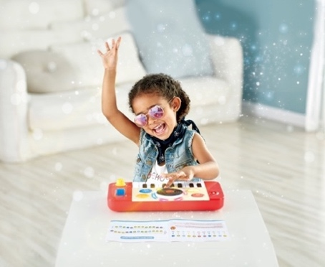
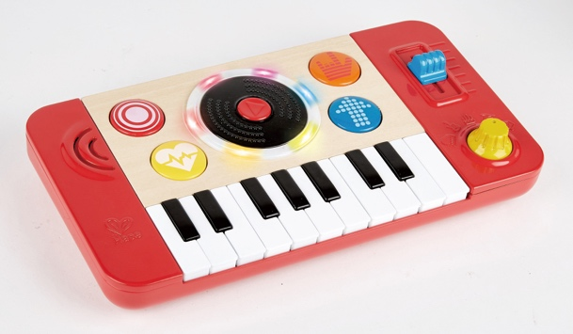

Celebrating 35 years of leading the industry in manufacturing affordable, high quality toys, Hape (“hah-pay”), represents the next generation of play, with all the products made with sustainability, education, innovation, and fun in mind. Hape toys are introduced at 0M to 4Y+ and are built to develop with your child as they grow and learn new skills.

GRAND STATION ADVENT CALENDAR

Hape’s first-ever advent calendar has arrived at the Grand Station for the holidays!

- The joy of the Christmas spirit and season is showcased in this bustling Grand Station advent calendar with shoppers, elves, travelers and Santa illustrated on the face of the seasonal calendar.
- The box set features 24 exciting days to open and discover beautifully crafted pieces to build a holiday railway scene.
  - 9 wooden railway tracks, 2 wooden trains, 3 figures (Station master, Passenger, Santa), 1 wooden snowman, 1 wooden Christmas tree, 1 wooden giftpack, 3 plastic traffic marks, 1 plastic bridge, 1 plastic connection, 1 plastic bag and 1 station master traffic sign.
- Once you’ve opened the entire advent calendar, the outside of the box unfolds and transforms into a bustling Christmas scene for children to play!
- The Grand Station calendar is a great introduction to and compatible with the wonderful wooden railway sets Hape is known for!

Age: Grand Station 3+ | MSRP: $29.99 | Available Winter 2021

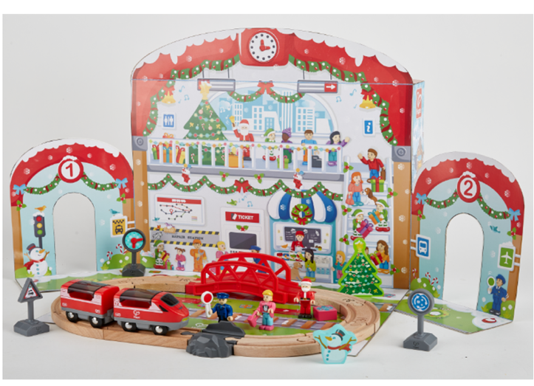
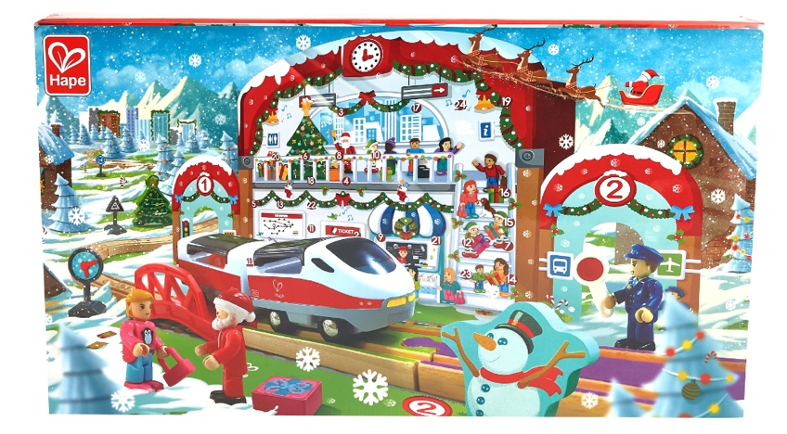

Celebrating 35 years of leading the industry in manufacturing affordable, high quality toys, Hape (“hah-pay”), represents the next generation of play, with all the products made with sustainability, education, innovation, and fun in mind. Hape toys are introduced at 0M to 4Y+ and are built to develop with your child as they grow and learn new skills.

