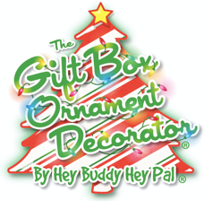

The Gift Box Ornament Decorator

- The Gift Box Ornament Decorator by Hey Buddy Hey Pal is the perfect DIY craft to embrace the holiday season, allowing both kids and adults to make perfect, hand-decorated ornaments for the tree!
- Place one of the three different ornaments included with the kit on top of the gift box-shaped decorator and let the fun begin!
- The machine holds and spins the ornaments, while the included markers are used to create bright colorful ornaments with stripes, lines and other designs!
- When craft time is over, simply place all of your supplies in the pull-out storage drawer until you’re ready to decorate again!
- Each kit comes with one decorator, three different ornaments, caps, hooks and eight colorful non-toxic markers.
- Requires three AA batteries; not included. Additional ornament refill pack sold separately.

Age: 4+ | MSRP: $24.99 | Available: Fall 2021 at Amazon
