HOLIDAY FACT SHEET
PLAYMOBIL Large City Zoo (70341)
Welcome to an exciting day at the Large City Zoo! Enjoy fun for the whole family as you explore the zoo and learn about different animals from all over the world. Pick up a map at the entrance so you know where to find your favorite animals and then cross under the brightly colored ‘ZOO’ arch to start your adventure. Walk to the penguin habitat, where you can watch the artic animals waddle around as the zookeeper brings them their lunch, before heading to the viewing platform for an up-close look at the giraffes as they much from the tall tree branches. Before you leave, purchase a souvenir to remember you fun day! Set includes six figures, one adult giraffe and one baby giraffe, two adult and four baby penguins, pelican, fish with bucket, bicycle with cart, postcards, cash register, camera, fencing, and tons of other accessories.

Available: Now Age: 4+
Retailer: Playmobil.us Retail Price: $69.99

PLAYMOBIL Dino Rise Dino Rock (70632)
Prepare for exciting adventures at Dino Rock! Join Ian and his team as they free the dinosaurs held captive at this dinosaur-shaped rock. Climb to the top of the mountain where you will discover a camp complete with rotating chair, functioning canons, and a hidden slide that can be used for a quick escape. Pay close attention to the other side of the rock, where the battle robots camp is located. Here, they plot to steal the energy stones with the included drilling rig. Once the dino team locates where the dinosaurs are held captive, place the energy stone inside the slingshot and insert it into the side of the mountain. The mountain shakes and the energy crystals glow as the dinosaur breaks through the wall to safety! Includes lights, sounds, and vibration effects. Requires 4 x AAA batteries. Set includes three figures, stegosaurus, scorpions, functioning canons, energy stones, and other accessories

Available: November 2021 Age: 5-12 years
Retailer: Playmobil.us Retail Price: $129.99

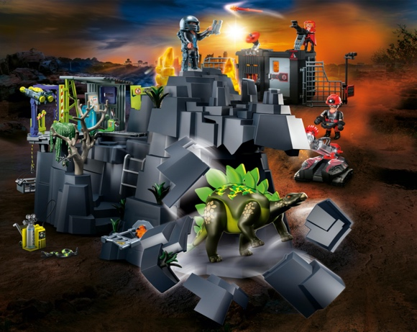

Freeman Public Relations for PLAYMOBIL
Linda D’Isa, 973 470 0400 ext. 20, ldisa@freemanpr.com

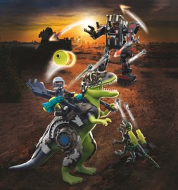
PLAYMOBIL Dino Rise T-Rex: Battle of the Giants (70624)
The T-Rex: Battle of the Giants has begun! A robot machine is on a destructive path and the dino-human team must stop them. Equipped with removable armor and functioning cannons, Ian rides on the back of the T-Rex to shoot down enemies and direct the dino to take down the robot machine. As the deinonychus fires its functioning cannons, the T-Rex uses its arm to catapult a barrel towards the robot. What an exciting battle! With interchangeable hairstyles and removable armor, hero figure can easily transform out of battle mode. Set includes two figures, T-Rex, deinonychus, robot machine, armor, functioning cannons, catapult, barrel, and other accessories.

Available: Now Age: 5-12 years
Retailer: Playmobil.us Retail Price: $69.99

PLAYMOBIL SCOOBY-DOO! Adventure with Snow Ghost (70706)
Race down the mountain in the SCOOBY-DOO! Adventure with Snow Ghost! Shaggy™ and Scooby-Doo™ hop on the snowmobile to escape from the wintery snow villain as he follows them on skis! Scooby stands on the back of the snowmobile with his snow hat on to keep his ears warm, while Shaggy frantically drives down the slope away from the ghost! Unmask the ghost to reveal his true identity, and collect his ghost card, which can be examined using the reader in the SCOOBY-DOO! Mystery Machine™ or SCOOBY-DOO! Adventure in the Mystery Mansion™ (70286 & 70361 - each sold separately). Set includes Scooby-Doo, Shaggy, Snow Ghost, snowmobile, ghost card and other wintery accessories.

Available: Now Age: 5-12 years
Retailer: Playmobil.us Retail Price: $24.99

Freeman Public Relations for PLAYMOBIL
Linda D’Isa, 973 470 0400 ext. 20, ldisa@freemanpr.com
Welcome to Adventures of Ayuma! Join the Forest Fairies, Crystal Fairies, and Knight Fairies, who side by side with their best friends, a good portion of courage, and the right soul animal, begin a heroic journey!

PLAYMOBIL Adventures of Ayuma Community Tree (70799)
Spend time with the fairies and their soul animals at the Community Tree. Inside this spacious tree house, you will see the soul animals taking shelter in the trunk as the fairies cook in the kitchen upstairs. Curl up with a good book in the common room before you keep watch for bat fairies in the observatory. When the day is done and night falls, the fairies spend time stargazing in the tower. Includes a cool projector that can create a starry sky on a child’s bedroom ceiling so both fairies and children are sure to have an enchanted sleep. For more magical adventures, combine this set with the rest of the PLAYMOBIL Adventures of Ayuma theme (#70799-70806 – sold separately)! Set includes three fairies, wolf, lynx, butterfly, tale stools, kitchen supplies, pillows, and other accessories. Requires 3 x AAA batteries.

Available: November 2021 Age: 7-12 years
Retailer: Playmobil.us Retail Price: $149.99

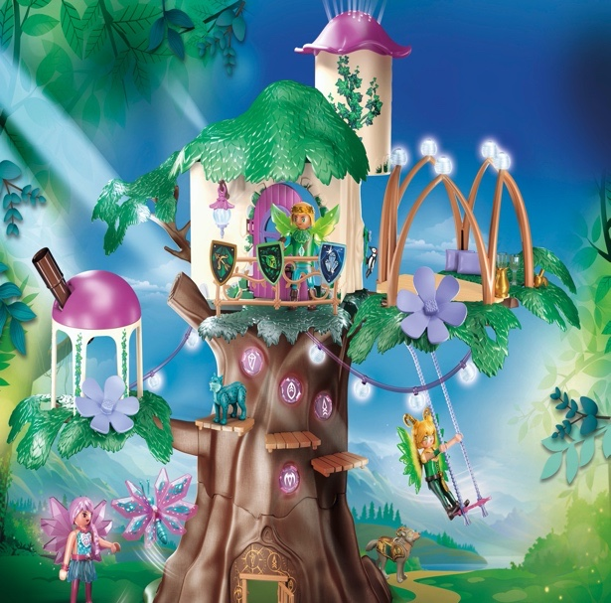

PLAYMOBIL Adventures of Ayuma Magical Energy Source (70800)
Visit the Magical Energy Source, a mystical lake that gives the fairy land its energy. Turn the water wheel and watch as the crystal plants start to grow and wafts of mist rise up, revealing the hidden key! Use this key to unlock a hiding place for the energy crystals. Watch as the water flows from the illuminated lake through the waterfall and down to the crystal flower meadow. Keep a close watch behind the cliff where there are secret pathways that allow the crystal thieves to slip past the watchful guards unnoticed. The weeping willow and several plants glow in the dark and create an enchanting atmosphere in a child’s bedroom at night. For more magical adventures, combine this set with the rest of the PLAYMOBIL Adventures of Ayuma theme (#70799-70806 – sold separately)! Set includes three fairies, dragonfly, salamander, Pegasus, key, flowers, and other accessories. Requires 4 x AA batteries.

Available: November 2021 Age: 7-12 years
Retailer: Playmobil.us Retail Price: $119.99

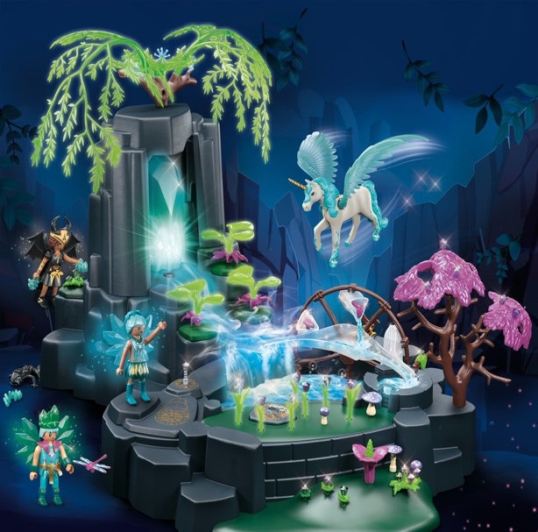

Freeman Public Relations for PLAYMOBIL
Linda D’Isa, 973 470 0400 ext. 20, ldisa@freemanpr.com
PLAYMOBIL Adventures of Ayuma Fairy Hut (70804)
Come on in to the cozy Fairy Hut. Open the round door to reveal a comfortable leafy bed for the fairy with a secret drawer underneath that stores all of the fairy’s accessories. Above the bed is a functioning flower lantern that glows and a mirror on the back of the door that the fairy can use to get ready for the day. Use the included hook to hang the house from the fairy Community Tree (#70799) or in a child’s bedroom. Decorate the outside of the hut with the included stickers, flowers, and butterfly for a magical look! For more magical adventures, combine this set with the rest of the PLAYMOBIL Adventures of Ayuma theme (#70799-70806 – sold separately)! Set includes one fairy, owl, pillow, blanket, stickers, and other accessories

Available: November 2021 Age: 7-12 years
Retailer: Playmobil.us Retail Price: $24.99

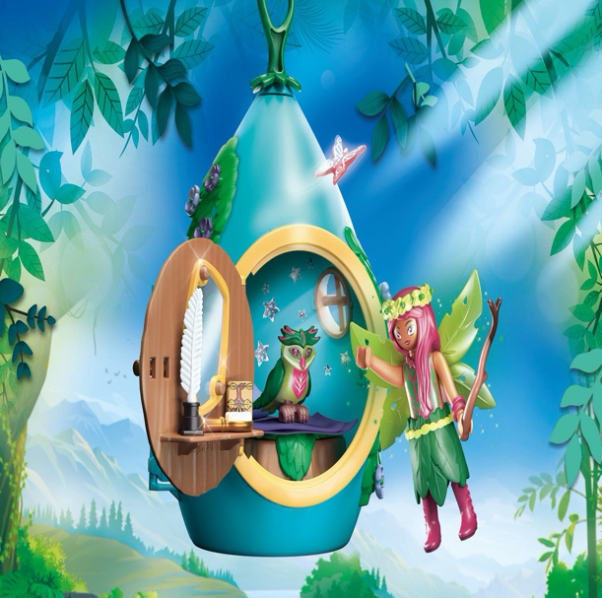

Freeman Public Relations for PLAYMOBIL
Linda D’Isa, 973 470 0400 ext. 20, ldisa@freemanpr.com

