Air Hunterz Wrist Bow
- Introducing the BRAND NEW AIR HUNTERZ WRIST BOW from Zing! Gear up for battle with this mini-arrow firing device with launching power of up to 30 feet – straight from your wrist!

- With the Air Hunterz Wrist Bow, battling with friends is in the power of your hands! The adjustable strap and wrist-fitting grip make it easy for anyone to slip this bow on and give it a try!

- The mini-arrows are soft and safe for indoor or outdoor play – and come with suction cups that can stick to nearly any flat surface!

- Simply unclip your arrow from your wrist, loop it through the bungees, grab the end of the arrow and fire away!

- Each Air Hunterz Wrist Bow package comes with 1 wrist bow (available in green or red), 3 mini suction cup arrows, and 1 wall target featured on the back of the package!

Ages: 8+ | MSRP: $14.99 | Available: Now at Amazon, Zing.store
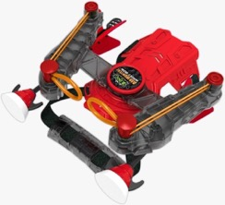

Freeman Public Relations for ZIng
Amy Friedland, 973 470 0400 ext. 25, afriedland@freemanpr.com
Emily Potrzuski, 973-470-0400 ext. 15, epotrzuski@freemanpr.com
Linda D’Isa, 973-470-0400 ext. 20, ldisa@freemanpr.com
Brendan Maguire, 973-470-0400 ext. 12, brendan@freemanpr.com
Go Go Bird Butterfly

- Zing continues to soar high following the launch of its iconic Go Go Bird –this time with the new Go Go Bird Butterfly! This elegant and intelligent flying butterfly is the perfect mix of traditional R/C and today’s trending drone toys.

- Go Go Bird Butterfly looks and flies just like a real butterfly, providing the most dynamic and unique remote-control aerial experience ever!

- Integrating a lightweight body design and a wireless remote control the Go Go Bird Butterfly is continuing Zing’s trend of bringing the tech toys category to new heights!

- With a six-axis sensor inside, the Go Go Bird Butterfly can achieve a smart take-off by hand to then fly through its environment!

- With flying distances of up to 100 feet in the air, watch your butterfly flutter high in the sky—you can also perform aerial tricks, or see who can land in the most unique places using its intuitive remote control.

- The Go Go Bird Butterfly in iconic “monarch” orange comes with one remote and one rechargeable battery.

Age: 8+ | MSRP: $29.99 | Available: Fall 2021 at Amazon, Target.com, Zing.store
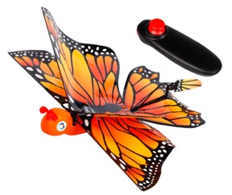

Freeman Public Relations for ZIng
Amy Friedland, 973 470 0400 ext. 25, afriedland@freemanpr.com
Emily Potrzuski, 973-470-0400 ext. 15, epotrzuski@freemanpr.com
Linda D’Isa, 973-470-0400 ext. 20, ldisa@freemanpr.com
Brendan Maguire, 973-470-0400 ext. 12, brendan@freemanpr.com
Go Go Bird Dragon

- Zing is soaring high with the launch of the new Go Go Bird Dragon! This thrilling and intelligent dragon is the perfect mix of traditional R/C and today’s trending drone toys.

- Go Go Bird Dragon soars high providing the most dynamic remote-control aerial experience you can have!

- Integrating a lightweight body design, infra-red sensing and a wireless remote control the Go Go Bird Dragon brings the tech toys category to new heights!

- With a six-axis sensor inside, the Go Go Bird Dragon can achieve a smart take-off by hand to then fly through its environment! PLUS: thanks to its integrated obstacle-avoiding technology the Go Go Bird Dragon will automatically turn around once six feet away from potential obstacles to avoid crashes!

- With flying distances of up to 100 feet in the air, you can challenge your friends to a race, perform aerial tricks, or see who can land in the most unique places using its intuitive remote control.

- The Go Go Bird Dragon is available in red or green and comes with one remote and a rechargeable battery.

Age: 8+ | MSRP: $39.99 | Available: Fall 2021 | Retail: Amazon, Zing.store
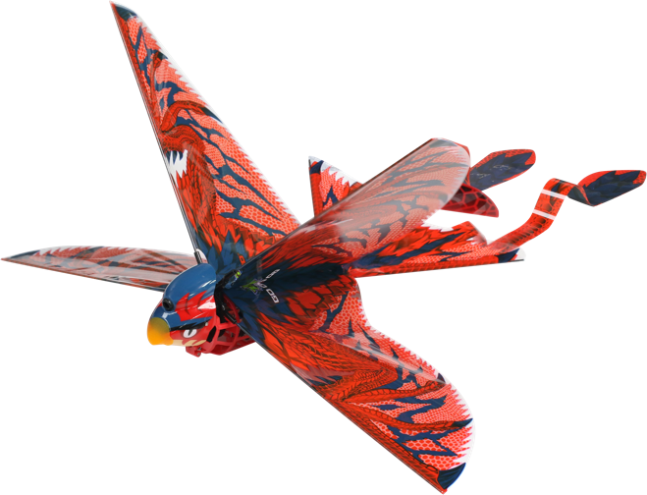

Freeman Public Relations for ZIng
Amy Friedland, 973 470 0400 ext. 25, afriedland@freemanpr.com
Emily Potrzuski, 973-470-0400 ext. 15, epotrzuski@freemanpr.com
Linda D’Isa, 973-470-0400 ext. 20, ldisa@freemanpr.com
Brendan Maguire, 973-470-0400 ext. 12, brendan@freemanpr.com

