MAGICUBE: LET THE MAGIC IN!

Geomagworld’s Magicube line has a whole host of new additions! The award-winning range that has revolutionised the Junior Construction category now offers two new themes: vehicles and insects
(Age: 1.5+)

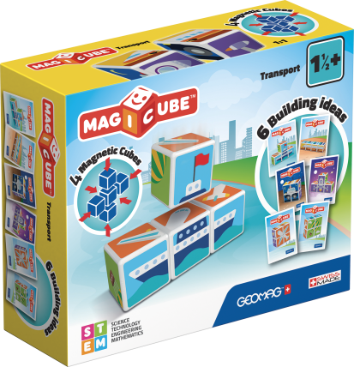
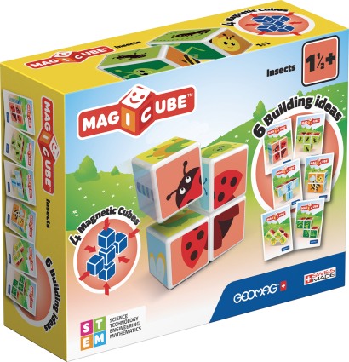

Novazzano (Switzerland), January 2019 - Geomagworld SA, a company whose aim is to use its innovative, high-quality, Swiss-Made products to develop creativity and encourage learning through play, is expanding the Magicube range with its new arrivals, Magicube Transport and Magicube Insects.
The world of this innovative play platform is getting bigger and bigger! Composed of 4 magnetic cubes, which stick together on all sides, the new themes of the Swiss-Made toy allow you to recreate vehicles and insects of all kinds, such as ships, cars, rockets, butterflies and ladybugs. Once all the combinations suggested by the six building cards have been made, Magicube lets young children’s imagination and creativity run wild, inventing new and futuristic vehicles along with fantastic insects by mixing the cubes together freely.
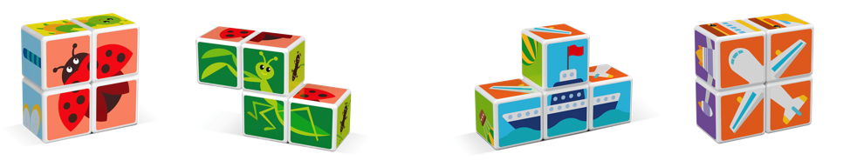

Magicube is the award-winning product line designed by Geomagworld that has revolutionised the Junior Construction category by reinterpreting the classic cube-based toys with a magnetic twist. Magicube has a patented system of magnets that allows the cubes to attach to each other on all sides.
The line is completed by products that can feed and stimulate the imagination through the concept of free building and giving children experience of the most important topics of early childhood/preschool age: animals, fruits, princesses and robots, but also castles and other buildings, covering all price ranges.
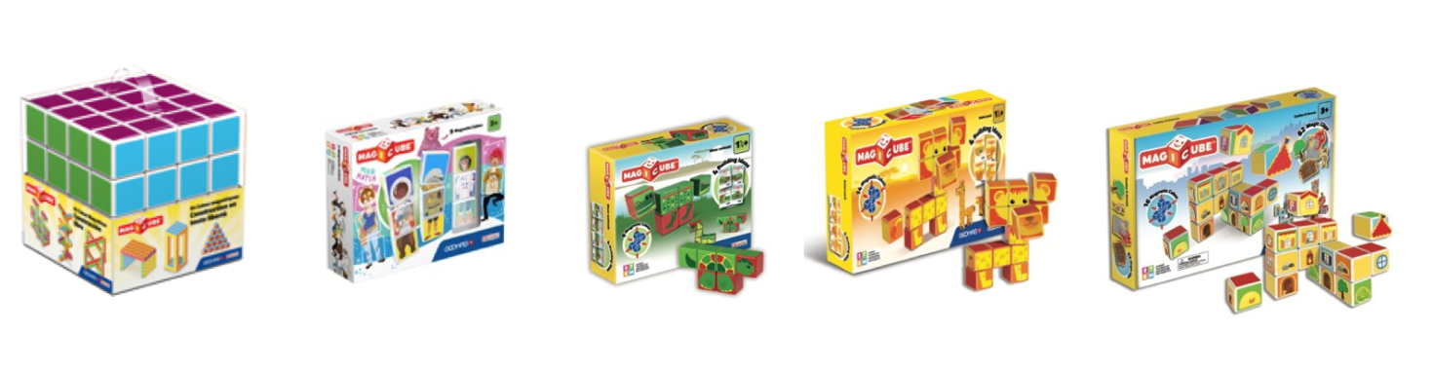
Geomagworld confirms its capacity for innovation and focuses on children’s imagination as the true stars of playtime. The Swiss company also boasts a wide range of new products suitable for all ages: from Magicube and KOR for young children, to the Classic and Mechanics lines, up to the Geomag Pro-L range for older, more experienced players.

Download the Geomagworld app on the iOS and Android stores or take a look at the web version, which offers interactive instructions for all the product lines and plenty of alternative ideas to create and share your new construction projects!

Geomagworld SA
Geomagworld SA is a company based in Switzerland where creativity and learning have been working side by side since 2008. Geomagworld products help children of all ages to develop and train their minds, imagination and curiosity through the science of magnetic construction. Every year, the company introduces innovative product lines and today it is famous all over the world. A success whose driver lies not just in the quality of the toys, but also in the founders’ ultimate aim, namely to create the best possible playtime experience for everyone. Over the years, Geomagworld has received numerous international awards confirming the quality and value of its toys, some highlights of which include: Dr. Toy “Best Classic Toys” and “Best Children’s Products” Award, Toy Retailer Association “Construction Toy of the Year”, Parents’ Choice Award, Nappa “Gold Winner”, Top Toy of the Year award, Oppenheim Toy Portfolio “Gold Seal”, Creative Child Magazine “Preferred Choice Award” “Top Toy of the Year”, “Creative Play of the Year”, the official award from Purdue University, “Mejor Juguete 2017” presented by the Spanish Toy Producers Association, and the gold medal in the Baby category at the “Independent Toy Awards 2017”, “PAL Award 2018” and “Mom’s Choice Award 2018”

Green Media Lab - Geomagworld SA Press Office
Via Savona, 97 - 20144, Milan
m. press@greenmedialab.com
t. +39 02 91320415
www.greenmedialab.com
Geomagworld SA
via Roncaglia 15 - 6883 Novazzano, Switzerland
www.geomagworld.com

