Hog Wild 2020 Holiday Fact Sheet

Hog Wild Toys is well known for its unique, on-trend and often irreverent novelty products, like its wildly popular squeezable POPPERS line!
The company is ready to amp things up in 2020 with not only a launch into the games aisle, but also making a larger footprint in the mass toy space.

PIZZA PARTY THROWDOWN
Pizza, PLEASE!
Hog Wild delivers with PIZZA PARTY THROWDOWN, the crazy new pizza toppings game! Players have 30 seconds to toss their “ingredients” onto the rotating pizza game board. It’s a rush against time to land your ingredients on the pizza before it finishes “baking!” Each player selects their color-coded ingredient – like pepperoni, peppers, mushrooms and of course, anchovies! Launch it onto the pizza using the special pizza chef launcher game piece.

Great for all ages! Three different challenges deliver various levels of difficulty, like trying to fill only half of your pizza, or land your ingredients on only one slice! Includes rotating pizza game board with built-in timer, four launchers and 32 ingredients.

You can check it out here!

For ages 6+
Available August 2020
Retailers: Amazon, Target
MSRP: $19.99

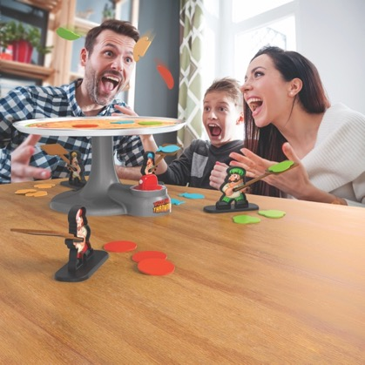

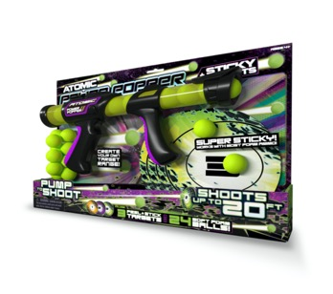
ATOMIC POWER POPPER WITH STICKY TARGETS
The classic Hog Wild ATOMIC POWER POPPER is back and better than ever – thanks to a flashy new design and cool new features! PLUS, it now comes complete with three super Sticky Targets you can use just about anywhere!

Stick ‘em on a wall or window – inside or out -- and create your own awesome customized target range! They’re moveable, so target practice can be virtually anywhere you want.

Watch your Power Popper rapid fire up to 20 feet, thanks to its newly designed, easy-to-use, pump-to-shoot handle! The ATOMIC POWER POPPER with STICKY TARGETS, now in a bright green design, comes with three sticky wall targets and 24 safe foam popper balls.

Watch the power of the pop here!

For ages 4+
Available August 2020
Retailers: Amazon, Target
MSRP: $14.99

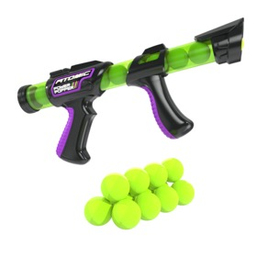

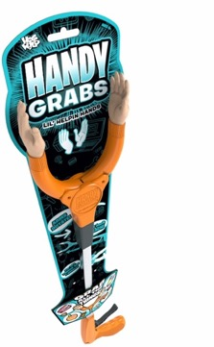
HANDY GRABS
Handy Grabs is the hilarious mini-sized gripper “tool," imaginatively designed with human-like hands to help do the grabbing! New from Hog Wild.
Handy Grabs can grip and grab just about any object! Reach for the remote control. Grab a sock on the floor. Be wildly entertained by grabbing a hold onto anything LITERALLY using this extra set of hands!
Designed like a classic grabber tool, try lifting, moving or pushing an item just for fun!
Whether it’s with the kids and family or adults, Handy Grabs are wacky fun for everyone. Classic design, simple action, hilarious result!

For ages 6+
Available August 2020
Retailer: Amazon
MSRP: $11.99

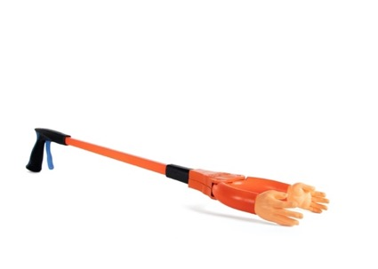

SCREAM-O’S
Inspired by the viral, yet oddly mesmerizing YouTube videos of “screaming” animals comes SCREAM-O’S, new from Hog Wild. These hysterical “screaming” animal videos are definitely having an Internet moment; who knew that when they opened their mouths and used their little animal voices they would sound oddly like humans? Screaming humans!

Squeeze a SCREAM-O and yes -- they’ll s-c-r-e-a-m too! Hog Wild’s new hyper-stylized collection of squeezable, hand-held animal SCREAM-O’S replicates that screaming sound popularized on these videos. The new SCREAM-O’S line includes a Mountain Goat, Donkey and Unicorn. Each features a pressure-activated sound chip that activates the scream when you squeeze them!

Listen to them here!

For ages 6+
Available September 2020
Retailers: Amazon
MSRP: $9.99 each

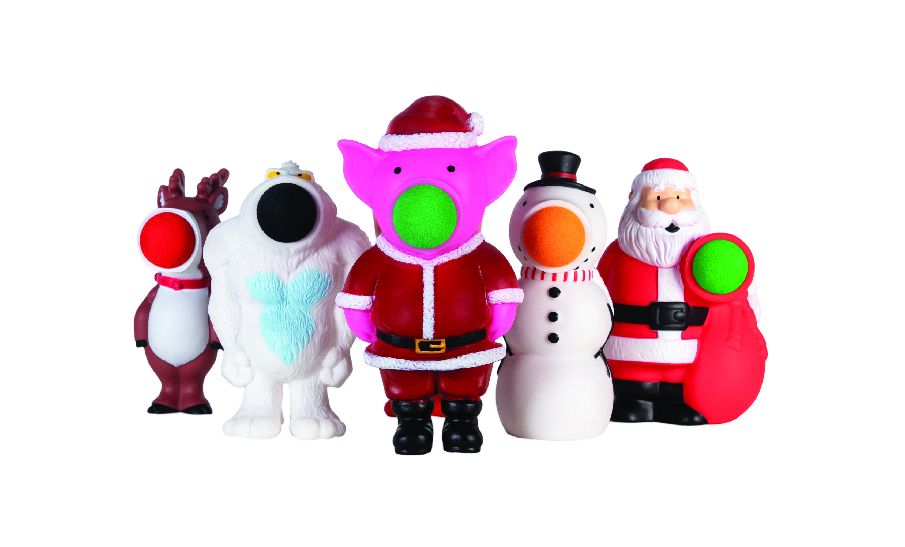
HOG WILD HOLIDAY POPPERS
Hog Wild brings you your Holiday Poppers as part of its POPular Poppers line!

Shoot mini foam balls up to 20 feet in the air by simply squeezing the Popper's belly. Available in multiple Holiday themes – ranging from a Yeti to a Snowman to more! Great to play with anywhere – whether it’s indoors or out. Includes popper and 5 soft foam baseballs.

For ages 4+
Available Now
Retailers: Amazon, other online retailers
MSRP: $9.99

For more information on Hog Wild, check out http://www.hogwildtoys.com
@HogWildToysLLC @hogwildtoys facebook.com/HogWildToys

Freeman PR for Hog Wild
Amy Friedland, 973-470-0400 ext. 25, AFriedland@freemanpr.com
Linda D’Isa, 973-470-0400, ext. 20, LDisa@freemanpr.com
Emily Potrzuski, 973-470-0400 ext.15, EPotrzuski@freemanpr.com
Brendan Maguire, 973-470-0400 ext. 12, Brendan@freemanpr.com

