Designed for Kind: Jada Toys Launches B-Kind, A New Line of Eco-Friendly Dolls

B-Kind Dolls Encourage Being Kind to the Environment, Animals & Each Other;
Feature DIY & Upcycling Play

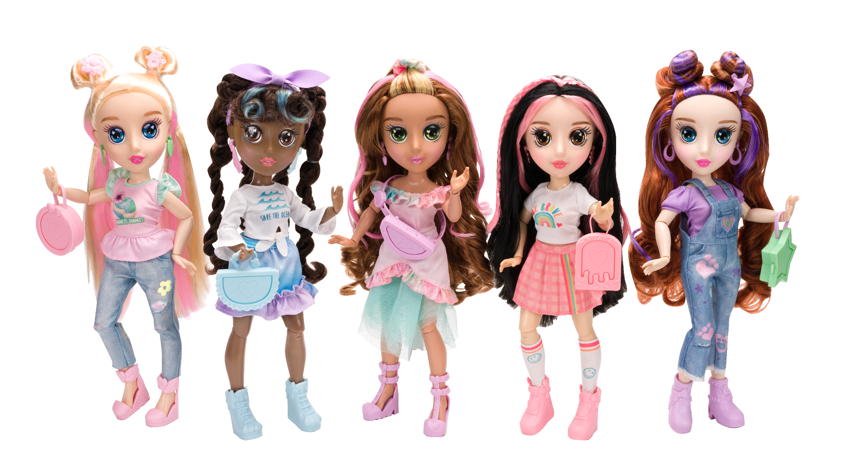
CITY OF INDUSTRY, CA - July 28, 2021 - Jada Toys, a leading global toy manufacturer, announced today the launch of their newest line, B-Kind, an eco-friendly doll line that promotes positive messages of kindness and inspires kids to be creative and compassionate. The line features five, 12.25-inch dolls - Brianna, Koral, Ivy, Nora, and Daisy - all of which are eco-friendly, from the recycled materials with which they are made, to the eco-fashions they wear, to the reusable packaging created from ink made from soybeans. The B-Kind dolls will make their debut online and on-shelves exclusively at Walmart.

Each B-Kind doll encourages creativity through DIY play that reflects the dolls’ unique passions. The dolls’ interests match those that today’s kids can relate to and range from going green, to saving the oceans, to ending bullying, all causes that teach valuable lessons on the importance of being kind to the environment, animals and to each other.

In line with the brand’s eco-centric mission, the B-Kind dolls come in reusable packaging made from recycled materials. A real, patterned ribbon serves as the box handle that can be used as a bracelet. Creative minds can use the packaging itself to construct their very own Kindness Board, a dedicated personal space to display and share kindness goals through drawings, photos, mission statements, and more. Kindness Boards also serve as a background play scene for the dolls.

Each B-Kind doll demonstrates her own passion and features an individual DIY craft such as making an upcycled outfit for the doll, creating a set of BFF bracelets, and more. The line features:
- Brianna - “There is No Planet B”: Brianna loves to help the environment and is passionate about being kind to others and to our planet. In her free time, she enjoys making fun crafts from recycled materials, and designing fashions. Brianna comes with DIY outfits for doll play (one to paint and decorate, one to make with fabrics from home), plus a DIY purse and Kindness Board.
- Koral - “Keep the Sea Plastic-Free”: Koral absolutely loves the ocean and all the amazing sea creatures that live in it. She is passionate about protecting sea life by keeping plastic waste out of the ocean. Koral comes with DIY reusable bags for doll play, plus a DIY purse and Kindness Board.
- Ivy - “Spread Love”: Ivy is passionate about ending bullying and being kind to each other. She believes that words go a long way and giving someone a compliment could make their day. Ivy comes with DIY BFF bracelets, 2 for doll play and 2 for your little designer to wear, plus a DIY purse and Kindness Board.
- Nora - “Be Brave”: Nora loves adventure, new places, foods, and activities. She feels it’s important to be brave and try new things. Nora believes in the importance of being yourself because you are wonderful just the way you are. Nora comes with a DIY hat for doll play, hair extensions for doll play and for your little designer to wear, plus a DIY purse and Kindness Board.
- Daisy - “Save the Paws of the World”: Daisy admires animals and loves to care for them. She knows that some animals are in danger and believes, together we can help them. Daisy comes with 2 DIY bean bags for doll play, plus a DIY purse and Kindness Board.

“Today’s kids and parents are more environmentally and socially conscious than ever before and we’re excited to introduce a line that truly embodies their values while providing a creative, fun play pattern that enables kids to create clothing and accessories for their dolls themselves,” said Bill Simons, CEO of Jada Toys. “We all strive to make a difference in this world and this doll line is giving us an opportunity to connect with and encourage parents, kids and collectors to spread kindness to each other, the environment and more. We believe this line will truly resonate with kids and parents alike, reinforcing messages of overall kindness that all parents are looking to instill.”

The B-Kind dolls are now available exclusively at Walmart and Walmart.com (MSRP: $29.97; Ages 6+). For more information, please visit BKindDolls.com or join the fun on social media by following B-Kind on Facebook, Instagram, Pinterest, TikTok, Twitter and YouTube. Kids and parents can also follow along with B-Kind’s weekly “Craftisodes” on YouTube which will feature a variety of new DIY and upcycling crafts.

About Jada Toys
Jada Toys is a privately held leading toy manufacturer. Founded in 1999, Jada has developed a worldwide presence at retail. Their strong focus on pop, trend, and car culture has grown their portfolio from die-cast vehicles and radio control to include collectible and action figures, dolls, preschool toys, and more. Partnering with best-in-class entertainment studios allows collaboration that has resulted in extensive lines of licensed product that appeals to collectors, kids, and families. Proprietary lines accompany the licensed product to round out Jada Toys’ offerings.

