Kid Trax
Sweet Suite @ Home Featured Products
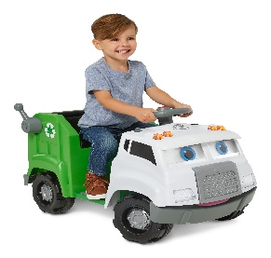

Real Rigs Recycling Truck by Kid Trax
(MSRP: $199/ Available Sept 2020/ Ages 18months – 4 years/ Available at Target, Amazon, and KidTraxToys.com)
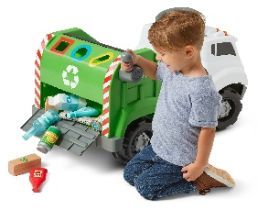
Help save the day and the earth with the interactive Recycling Truck ride-on toy by Kid Trax. This tot-sized recycling truck has a big personality, featuring over 100 voice lines, sound effects, songs, and expressions based on interactions with your child. Nine recyclable accessories are included for collection and sorting. The truck’s push button acceleration is easy for little hands to operate, while the top speed of 1.5 MPH provides the perfect blend of fun and safety. The Power Trax rubber traction strip tires keep the ride smooth and steady. And don’t forget, the Recycle Truck comes with a rechargeable 6-volt battery and wall charger so the fun never has to stop for long. Recycling has never been more fun! Make playtime meaningful with the Recycling Truck by Kid Trax.

Silly Skaters Unicorn Inflatable Ride-On Toy by Kid Trax
(MSRP: $39/ Available Sept 2020/ Ages 1-3 years/ Available at Target, Amazon, and KidTraxToys.com)
Make playtime fun and fanciful with the Silly Skaters Unicorn ride-on toy by Kid Trax. This soft, inflatable unicorn on roller skates is perfect for young children to ride or push along. For extra fun, the skates include motion activated LEDs so they light up as you roll. The unicorn is constructed of a soft, durable rubber material for long lasting use, and an air pump is included for easy inflation. Magical fun is on the way with the Silly Skaters Unicorn by Kid Trax.

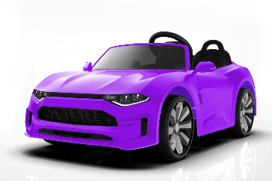
GT Coupe Ride-On Toy by Kid Trax
(MSRP: $279/ Available August 2020/ Ages 3-5 years/ Available at Walmart)
Grab your shades and shift playtime into gear with the GT Coupe Ride-On Toy by Kid Trax! This kid-sized ride is ready for driveway and sidewalk “road trips.” Working headlights, sound effects, FM radio and MP3 input all add to the playtime fun, while real foot pedal acceleration creates a lifelike driving experience. The GT Coupe has a top speed of 4 MPH for the perfect blend of fun and safety. Plus, Power Trax rubber traction strip tires keep the ride smooth and steady. When its time to stop for the day, just plug in the GT Coupe’s 12-volt battery with the One Step Direct Connect Charging System for easy, no-fuss charging. Rev up the fun with the GT Coupe Rid-On Toy by Kid Trax.

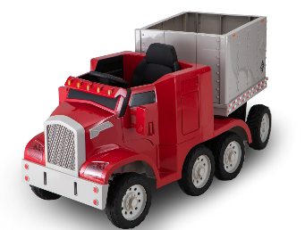
Semi-Truck & Trailer Ride-On Toy by Kid Trax
(MSRP: $349/ Available August 2020/ Ages 3-5 years/ Available at Walmart)
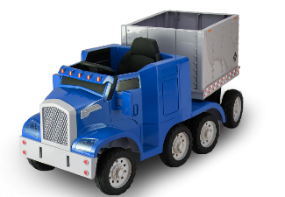
Haul in loads of fun with the Semi-Truck and Trailer Ride-On Toy by Kid Trax! Featuring a removable trailer with dual hinged opening trailer doors – just like a real semi-truck – this kid-sized ride is ready for driveway and sidewalk excursions. Working cab lights, PA system, and horn and engine sound effects add to the playtime fun, while real foot pedal acceleration creates a lifelike driving experience. The Semi-Truck and Trailer has a top speed of 4 MPH for the perfect blend of fun and safety. Plus, Power Trax rubber traction strip tires keep the ride smooth and steady. When it’s time to stop for the day, just plug in the Semi’s 12-vold battery with the One Step Direct Connect Charging System for easy, no-fuss charging. Major fun is on the way with the Semi-Truck and Trailer Ride-On Toy by Kid Trax.

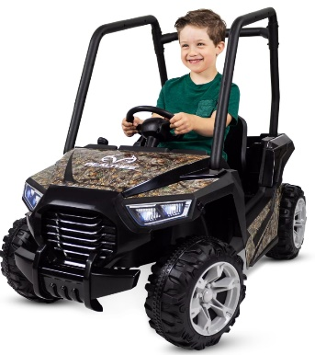
Realtree® Whipsaw UTV Ride-On Toy by Kid Trax
(MSRP: $179/ Available October 2020/ Ages 3-5 years/ Available at Walmart)
Get ready for grand adventures in the great outdoors with the Realtree® Whipsaw UTV Ride-On Toy by Kid Trax! Covered in Realtree Edge® camo, this toy UTV is ready for backyard and sidewalk excursions. Working LED headlights, sound effects, FM radio and MP3 input all add to the playtime fun; while real foot pedal acceleration creates a lifelike driving experience. The Realtree® Whipsaw has a top speed of 2.5 MPH for the perfect blend of fun and safety. Plus, Power Trax rubber traction strip tires keep the ride smooth and steady. When it’s time to stop for the day, just plug in the Realtree® Whipsaw’s 6-volt battery with the One Step Direct Connect Charging System for easy, no-fuss charging. Make playtime an adventure with the Realtree® Whipsaw UTV Ride-On Toy by Kid Trax.

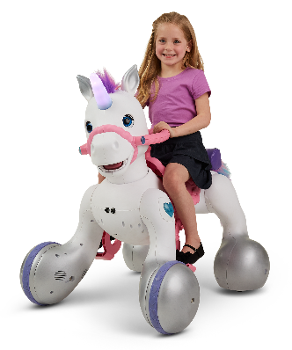
Rideamals Josie by Kid Trax
(MSRP: $399/ Available July 2020/ Ages 3-7 years/ Available At KidTraxToys.com and Amazon.com)
Meet Josie, a Rideamals toy from Kid Trax, and your child’s new unicorn pal! This enchanting unicorn combines the fun of a battery-powered ride-on toy with real interactive play. Josie comes to life with over 100 unique sounds and movements thanks to her fully motorized eyes, ears, head, and wheels. Kids can hear munching noises as they feed Josie a tasty treat or watch her ears move as they brush her mane. They can take her for a walk, dance with her, and of course, ride their very own unicorn! Josie has two forward speeds and one reverse speed. And to make it even more magical, songs and pony sounds play as your child rides. Josie comes with a grooming brush, cupcake, flowers, and saddlebag. The included rechargeable 12-volt battery and charger ensures the fun never has to stop for long, while the One Step Direct Connect system makes it super easy to recharge. Josie will create magical memories for your family.

Magical Forest Tent by Kid Trax
(MSRP: $39/ Available August 2020/ Ages 3-7 years/ Available at KidTraxToys.com and Amazon.com)
The Magical Forest Tent by Kid Trax makes a fabulous home for your child’s favorite unicorn friend! Large front and rear openings make it easy for your child and their ride-on unicorn to get in and out of the tent, while sparkly curtains add to the delightful, magical style. Plus, the tent comes with a convenient carrying case for easy storage and transport. Make playtime even more fun with the Magical Forest Tent by Kid Trax. Hi-res image availability is TBD.

