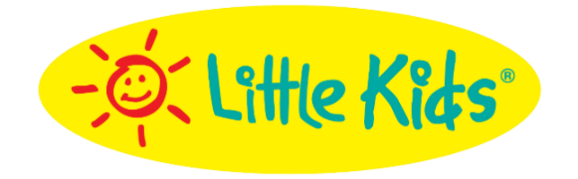
Bubble Category Leader Little Kids Inc.
Creates Backyard Fun with Bubble Favorites!

Fubbles Bubbles Keep Your Backyard Bursting with Bubbles!

SEEKONK, MA – July 22, 2020 – Looking for new ways to entertain your family this summer? Little Kids Inc. has got it covered! From our New! Birthday Cake Bubble Machine and Bubbles On-the-Go to™ our classic, tried-and-true No-Spill Bubbles, your backyard never looked so fun. Here are some product highlights:
Fubbles® Birthday Cake Bubble Machine (MSRP $29.99) 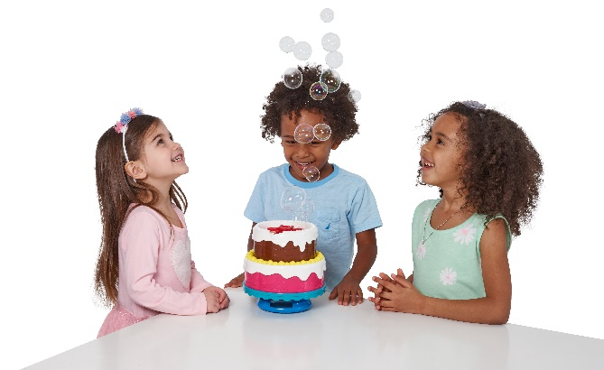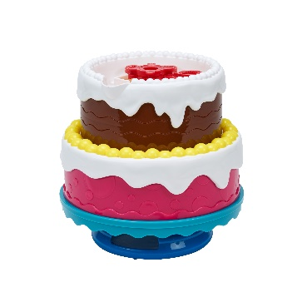

The Fubbles® Birthday Cake Bubble Machine is the perfect addition to any birthday party!
Designed with kids and toddlers in mind, this bubble cake is fun for all and perfect for birthday parties…streams of bubbles blow continuously in the air, the lights flash and the “Happy Birthday” song plays!
It’s simple to use, just pour the bubbles into the reservoir on top of the machine, switch the button to play the Happy Birthday song and watch the fun begin! Works with any refill solution, but we suggest our Fubbles® non-toxic premium solution for the best bubbles.
This set includes the Fubbles® Birthday Cake Bubble Machine and our Premium Fubbles® Non-Toxic Bubble Solution. Requires 4 AA batteries, NOT included.
Available only on Amazon.
Fubbles® Bubbles On- The- Go™ (MSRP $1.99 individual, 6pk $9.99, 12pk $14.99) Ages 3 & Up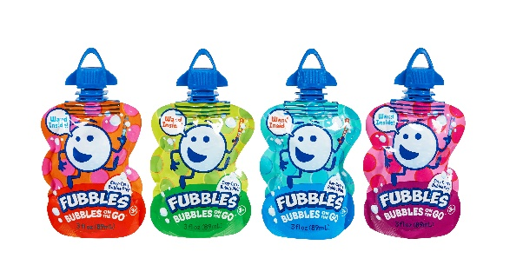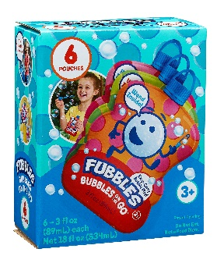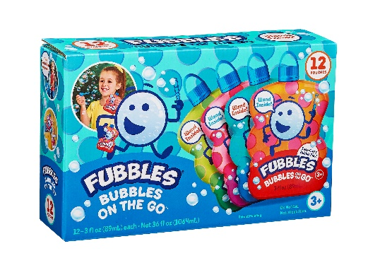
Perfectly sized for convenience! Take our Fubbles® Bubbles On- the- Go™ to the park, party, airport or play date! This perfect pouch also fits nicely inside diaper bags, pocketbooks, travel bags and even baby strollers! Celebrating a birthday? – Pick up our 6 pk or 12 pk to fill your party-favor bags! There are four different bright, graphic styles and each individual pouch includes 3 fl. oz. of bubbles and a wand. Available at Walgreens, Kohls, Meijer, BJs and on Amazon.

Fubbles® No-Spill® Bubble Tumbler® (MSRP $4.99) Ages 18 months & Up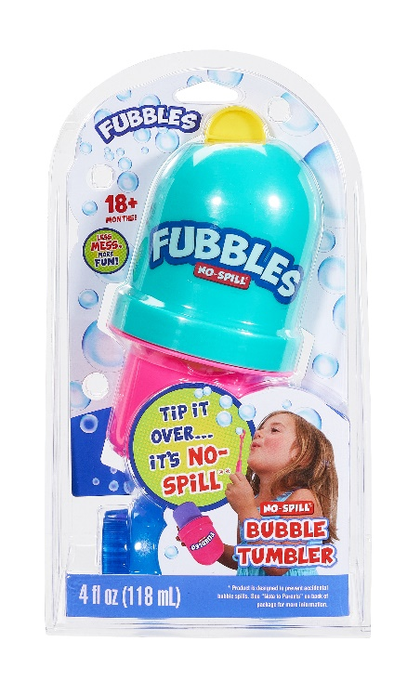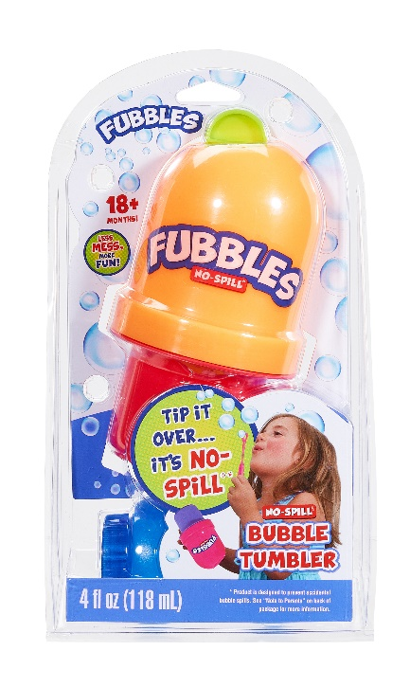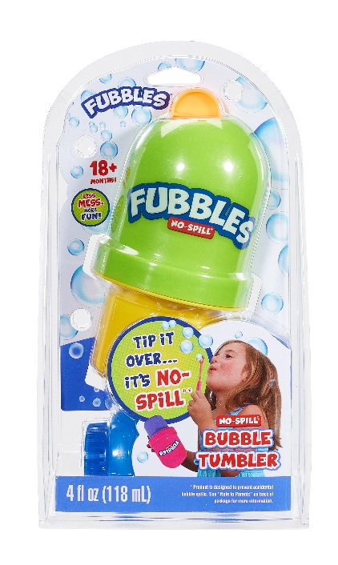
Our innovative, No-Spill design stops bubble spills, keeping Moms and kids happy and blowing bubbles longer! You can drop our No-Spill Bubble Tumbler, knock it over or turn it upside down…magically only the fun comes out!
Includes 4 fluid ounces of our Fubbles® non-toxic, premium solution. Works with any bubble solution, but we suggest our Fubbles® non-toxic premium solution for the best bubble experience.

Available at Kohls, Wegmans, Academy and Amazon.
Visit the LittleKidsInc.com for additional information.

About Little Kids Inc.
Little Kids® Inc. was founded in 1989 by toy industry leader and former Toy Industry Association Board Member, Jim Engle. Little Kids develops, manufactures and markets innovative and award-winning bubble, sports, novelty, and activity toys that promote thoughtful and creative play. Consumers recognize Little Kids toys for their high quality, value, and durability. Little Kids brands include Fubbles®, and No-Spill® Bubbles, a category the company created with its patented No-Spill® Bubble Tumbler® toy. Other Little Kids brands include Wicked Big Sports®, and Junk Ball® Sports. Little Kids' licensed toy portfolio includes Nickelodeon™ with brands such as PAW Patrol™, Bubble Guppies™ Slime™, bubble and water toys, as well as PJ MASKS, Peppa Pig™, Ryan’s World™, Sesame Street®, Jelly Belly® bubble toys and PEEPS®, bubble and novelty toys. Little Kids is privately owned enterprise headquartered in Seekonk, MA.
# # #

Media Contacts
Joyce Reid Keri Castro Tina Jichi
Little Kids Inc. Little Kids, Inc. Little Kids, Inc.
jreid@littlekidsinc.com kcastro@littlekidsinc.com tjichi@littlekidsinc.com
401-474-0770 401-241-4266 774-765-9070

