Wicked Big Sports Puts a Wicked Big Twist
On the Ultimate Party and Backyard Games

Great Family Fun For All Ages and Skill Levels!

Seekonk, MA – July 22, 2020 – Wicked big and wicked fun are the name of the game when it comes to Wicked Big Sports, the line that puts a wicked twist on classic backyard games. Perfect for graduations and summer-time fun, these games are bound to give your backyard party a much needed boost. Visit WickedBigSports.com to learn more!

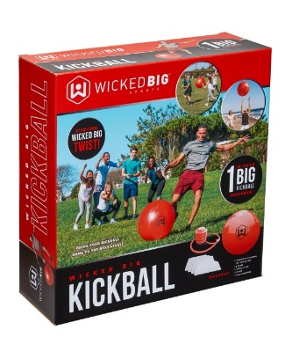
Our Wicked Big Sports® Kickball (MSRP $24.99) is traditional kickball on a grand scale! A great game to keep families outside and active, perfect for the backyard or bring along to the beach, or park! Each kickball inflates to 20” in diameter – over 3X the size of a traditional kickball! Each Wicked Big Sports Kickball set includes 1 oversized kickball, 3 bases, 1 home plate, 1 pump, 3 ball plugs, and 1 plug remover.
Available at Walmart, Dick’s Sporting Goods, and on Amazon.
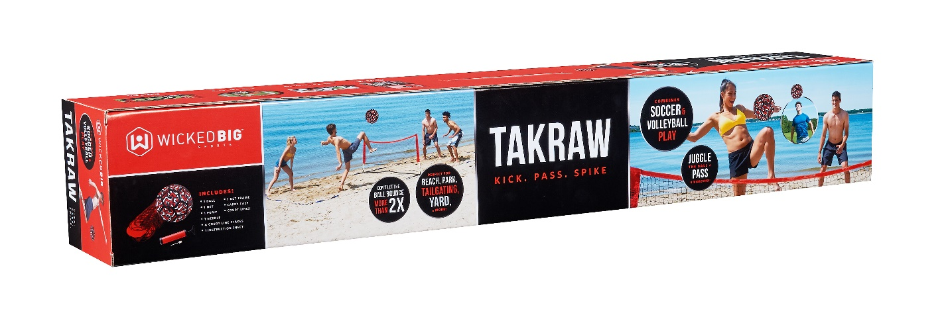
New for 2020, is Wicked Big Sports® Takraw (MSRP $99.99).
Kick. Pass. Spike. Takraw is a new game that combines soccer and volleyball play! The goal of the game is to pass the ball back and forth over the net – using anything except your arms and hands. Juggle the ball on your side of the court as many times as you want – but the ball can only bounce on the ground twice – or your opponent gets the point! Set includes net, net stand, court lines, stakes, ball, pump, instructions and carry case.

Available on Amazon.

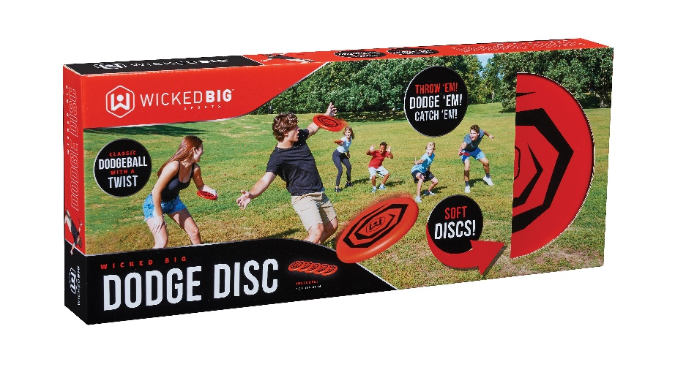

New for 2020, classic dodgeball meets its match – Wicked Big Sports® Dodge Disc (MSRP $19.99)! Dodge Disc features classic dodgeball game play, with soft, safe foam discs! Perfect for big gatherings and small family get-togethers, this game is sure to spruce up the afternoon. Each Dodge Disc set comes with 5 discs.

Available at Walmart.

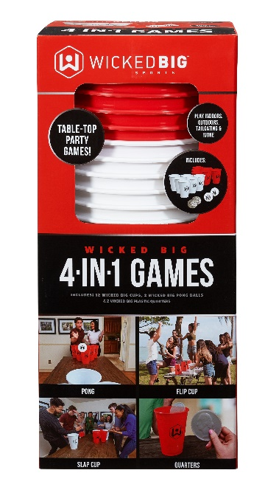

Tired of the same old party games? Try Wicked Big Sports® 4 in 1 Games (MSRP $29.99)! This set includes everything you need to play 4 different super-sized party games: Flip Cup, Quarters, Slap Cup and Pong! Includes 12 giant cups, 2 giant pong balls, and 2 giant quarters.

Available at Walmart and Meijer.
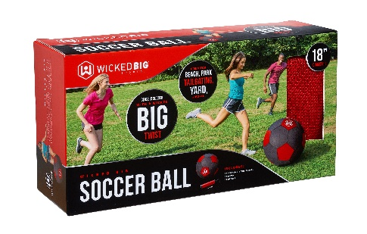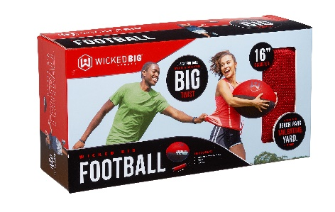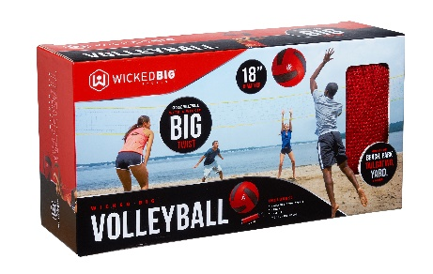
Our Wicked Big Sports® Sports Ball Assortment features fun, lightweight, jumbo versions of classic sports balls. Bump the volleyball back and forth at the beach, go for the goal with the soccer ball, and attempt a perfect spiral with the football. Each ball is soft, safe, and perfect for all skill levels. Each style is sold separately and includes pump and needle.

Available at Walmart, Meijer, and on Amazon.

Wicked Big Sports was created by Seekonk, MA-based toy company Little Kids, Inc.
# # #

Media Contacts
Joyce Reid Keri Castro Tina Jichi
Little Kids Inc. Little Kids, Inc. Little Kids, Inc.
jreid@littlekidsinc.com kcastro@littlekidsinc.com tjichi@littlekidsinc.com
401-474-0770 401-241-4266 774-765-9070

