Media contact:
Sarah Gumina or Ron Antonette
toys@rantonette.com

October 2020

FACT SHEET – BILLIE EILISH COLLECTIBLE FIGURES AND FASHION DOLLS

The new assortment of Officially Licensed Billie Eilish collectible figures and fashion dolls allow fans to reimagine scenes from her inventive music videos and bring them to life by placing them on highly detailed backdrop diorama’s. Each figure and doll come in sustainable packaging that transforms into dioramic displays.

AVAILABLE AT LAUNCH
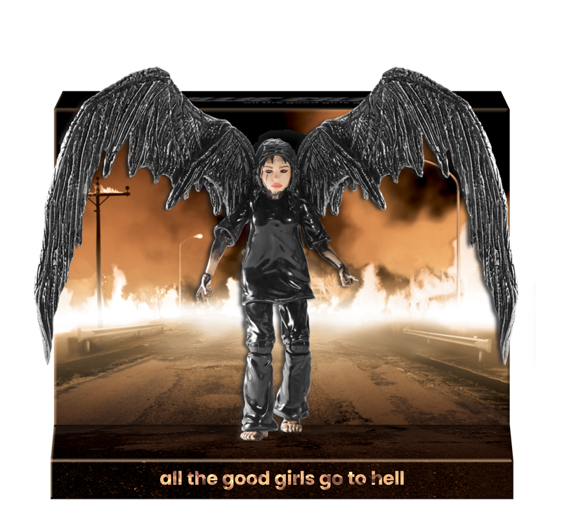

“All The Good Girls Go To Hell” 6” Collectible Figure – You can relive your favorite music video moments with this Billie Eilish collectible figure. Standing 6” tall, Billie is authentically decorated, highly detailed and fully poseable with 18 points of articulation and features removable, 3 point pivoting wings. Eco-friendly packaging transforms and provides an iconic backdrop from the music video to display the figure. Ages 8+ $19.99 SRP

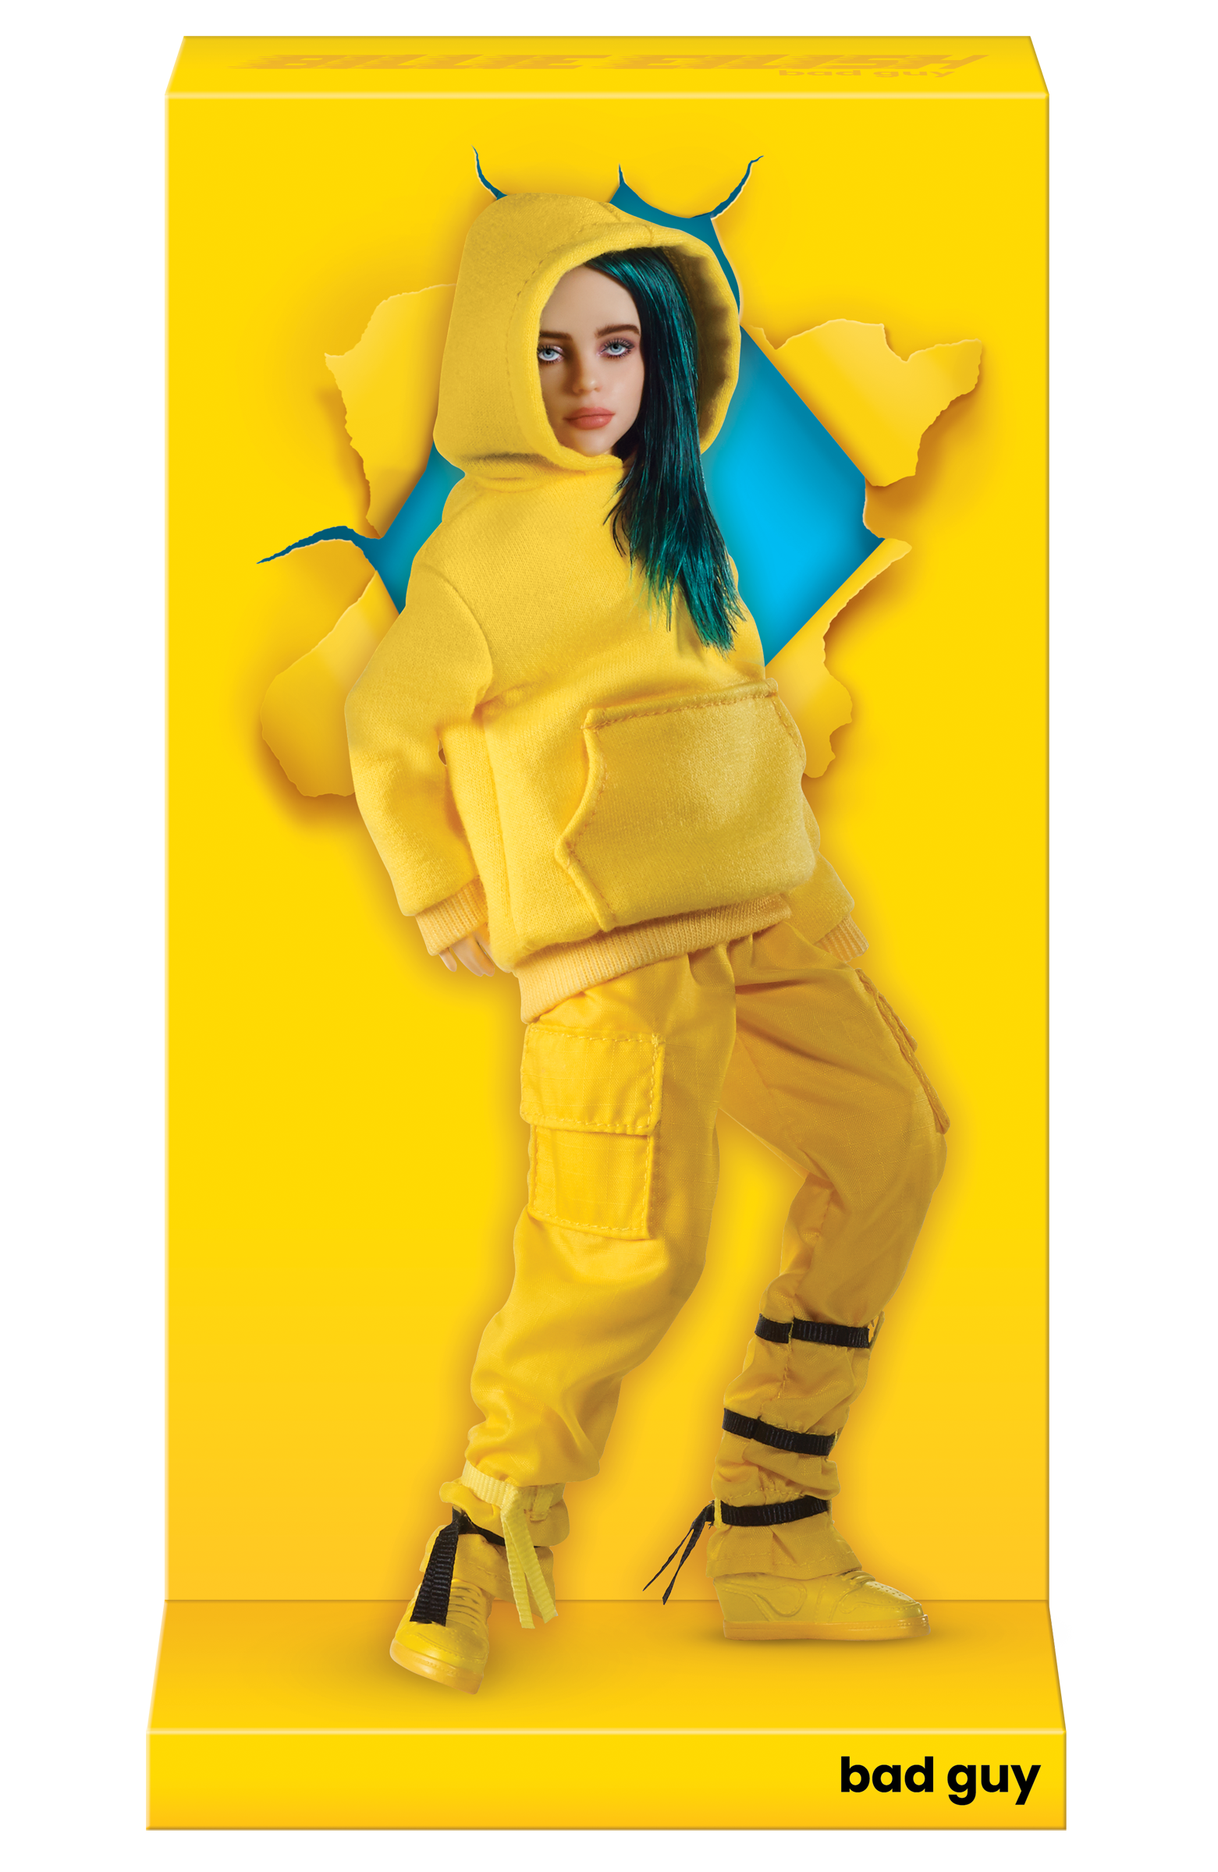

“Bad Guy” Fashion Doll – You can relive your favorite music video moments with this Billie Eilish fashion doll. Billie stand 10.5” tall, is highly detailed and fully poseable with 14 points of articulation and is dressed in her iconic yellow hooded sweatshirt and pants fashion. Billie comes packed out in an eco-friendly, transforming package that provides an iconic backdrop taken right from the music video to display the doll. Ages 8+ $29.99 SRP

AVAILABILITY
October 2020

###

October 2020

