Media contact:
Sarah Gumina or Ron Antonette
toys@rantonette.com

September 2020

ARE YOU ON TEAM GODZILLA … OR TEAM KONG?
SHOW YOUR ALLEGIANCE WITH PLAYMATES TOYS’ GODZILLA VS. KONG ACTION FIGURE LINE FROM PLAYMATES TOYS

Playmates Launches First Assortment of Themed Toys from Forthcoming Legendary Entertainment and Warner Bros. Pictures Release, In Cinemas Worldwide in 2021

New Movie Line Joins Toho’s Classic Monsters Popular Collectibles Now In Stores

It’s the ultimate showdown between pop culture’s biggest creature icons as the world’s two most powerful forces of nature go head-to-head in an epic toy vs. toy battle to the finish: Godzilla vs. Kong.

This thrilling clash pits Godzilla, King of the Monsters, with his heat ray attack and crushing presence, against the mammoth and unyielding protector of Skull Island, the mighty Kong. As featured in the forthcoming “Godzilla vs. Kong” epic action adventure, the monster battle between the two will rage across land, sea and air, and plunge into the depths of our world when the spectacular secret realm of the Titans, known as Hollow Earth, is discovered.

Now, as the first wave of Godzilla vs. Kong-themed action figures and collectibles hit store shelves, it’s time to choose sides.

Rolling out exclusively at Walmart, the new movie collection debuts this fall alongside Playmates’ line of Classic Monsters from Toho’s universe – including Godzilla, Gigan, Destoroyah, Mechagodzilla, King Ghidorah and others, which are now on shelves.

6-Inch Action Figures

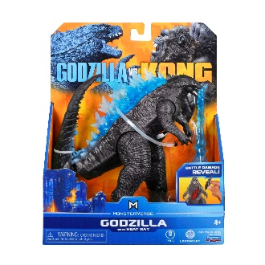
Godzilla vs. Kong
6" Basic Godzilla Heat Ray Figure – Harness the awesome power of Godzilla's thunderous roar and devastating tail-swipe as the King of the Monsters battles Kong to settle an ancient rivalry. This figure comes with a heat ray accessory and "battle damage" feature – remove to reveal the powerful impact of monster battles. $9.97.

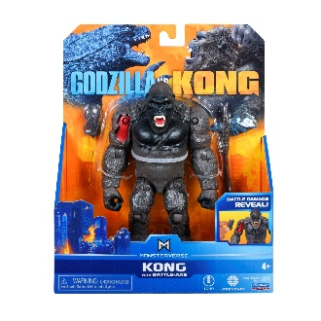
Godzilla vs. Kong
6" Basic Kong with Battle-Axe Figure – Feel the mighty strength of Kong as he enters the ultimate battle royale against Godzilla with bone-crushing primal strength and a legendary new weapon fit for a king. This figure comes with a Battle-Axe accessory and "battle damage" feature – remove to reveal the powerful impact of monster battles. $9.97.
11-Inch Giant Figures
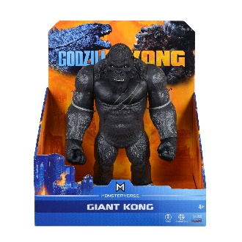
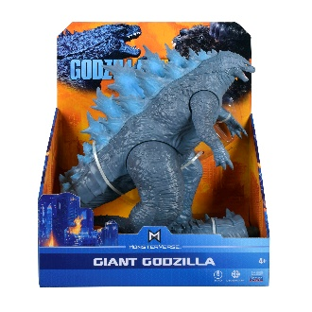
Godzilla vs. Kong
11" Giant Godzilla Figure – Designed and sculpted based on the 2021 action adventure movie. Bring the epic battle to life with these giant-sized figures! $19.97

Godzilla vs. Kong
11" Giant Kong Figure – Designed and sculpted based on the 2021 action adventure movie. Bring the epic battle to life with these giant-sized figures! $19.97

About Playmates Toys
With a history of over 50 years, Playmates Toys is today among the most well-respected and innovative marketing and distribution companies in the global toy industry, with a proven history in the creation of imaginative products as well as the development and management of profitable, long-term brand franchises. Key brands include Teenage Mutant Ninja Turtles, Power Players, and more. From its offices in Hong Kong and California, Playmates designs, develops, markets and distributes its products in over 80 countries worldwide. For more information, visit playmatestoys.com.

About Godzilla vs. Kong
On May 21, 2021, comes the next chapter of the Monsterverse, Godzilla vs. Kong, starring Alexander Skarsgård, Millie Bobby Brown, Rebecca Hall, Brian Tyree Henry, Shun Oguri, Eiza González, Jessica Henwick, Julian Dennison, Lance Reddick, with Kyle Chandler and Demián Bichir. The film is directed by Adam Wingard. Legends collide as Godzilla and Kong, the two most powerful forces of nature, clash on the big screen in a spectacular battle for the ages. As a squadron embarks on a perilous mission into fantastic uncharted terrain, unearthing clues to the Titans’ very origins and mankind’s survival, a conspiracy threatens to wipe the creatures, both good and bad, from the face of the earth forever. Fans can join the conversation by using the official hashtag #GodzillavsKong on social media.

About Legendary
Legendary Entertainment is a leading media company with film (Legendary Pictures), television and digital (Legendary Television and Digital Media) and comics (Legendary Comics) divisions dedicated to owning, producing and delivering content to worldwide audiences. Legendary has built a library of marquee media properties and has established itself as a trusted brand that consistently delivers high-quality commercial entertainment, including some of the world's most popular intellectual property. In aggregate, Legendary Pictures-associated productions have realized grosses of more than $17 billion worldwide at the box office. To learn more visit www.legendary.com.

About Toho
Toho Company, Limited, is a Japanese entertainment studio focused on the development, production, exhibition, and distribution of powerful content for motion pictures, television and theater. Founded in 1932, it remains a prominent force in bringing brands and original storytelling with versatile talents to audiences worldwide. Its subsidiaries include Toho Cinemas, the highest grossing exhibition company in Japan. To learn more, visit www.toho.co.jp/en/.

###

