RedwoodVentures Holiday 2020 Fact Sheet

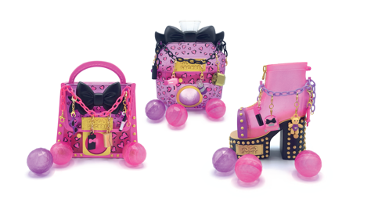
GoGo Gachas:
These fashionably charmed vending machines really work! Each is loaded with 4 surprise charms that are totally on trend. Just press the button to dispense one of the disco balls- then open it up to find out which scented fashion charm you gacha! Each scented charm is perfect for accessorizing on the included charm braclet. Now you’re ready for a glam squad dance party! Collect all 3 machines!

Available: July 2020 Age: 6+ MSRP: $9.99
Retailers: Amazon, Target
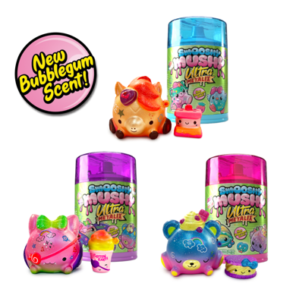
Smooshy Mushy Ultras:
Have you been searching for that special ultra rare, super rare, or exclusive Smooshy Mushy? Search no more! Every Smooshy Mushy Ultra set includes one rare pet and one rare bestie to complete your collection! Featuring special edition characters, adorned with radical colors and super cool street art graphics. Your collection will be the envy of all collectors! 8 to collect.

Available: August 2020 Age: 6+ MSRP: $9.99
Retailers: Amazon, Target

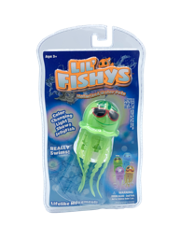
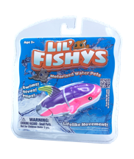
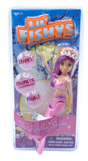
Lil’ Fishys:
Back by popular demand! Lil Fishys have amazing swimming action and can dive or perform stunts based on the customizable articulation of their tails. Lil Fishys can swim in playsets or along with you in a pool or tub, perfect for all kinds of aquatic fun!

Available: Fall 2020 Age: 6+ MSRP: $9.99
Retailers: Amazon, Target, Walmart

MEDIA CONTACT:
Freeman Public Relations
Amy Friedland 973 470 0400, afriedland@freemanpr.com
Maxine Aviles 973 470 0400 ext. 18, maviles@freemanpr.com

