FOR IMMEDIATE RELEASE
SKYROCKET LAUNCHES BLUME, THE HOTTEST NEW COLLECTIBLE DOLLS
WITH REVOLUTIONARY ‘BLUMING’ REVEAL

Retail Launch Kicked Off With ‘Blume Day’ Exclusive Influencer Unboxings;
Ranked #1 On Amazon’s Toys Movers And Shakers List

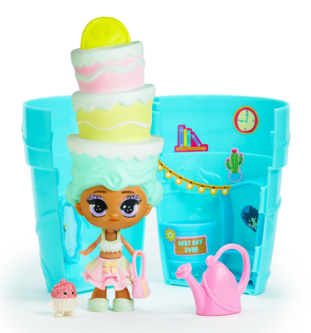
Los Angeles, CA – June 24, 2019 – Leading U.S. toy company, Skyrocket Toys, celebrated the retail launch of Blume, the company’s new collectible doll line featuring their revolutionary patent-pending reveal technology. To celebrate the launch of the product, Skyrocket engaged twenty-two popular YouTube influencers to produce videos all coordinated to go live on “Blume Day,” June 21, also known as the Summer Solstice.

Blume Day kicked off with an unveiling of the entire first collection of Blume dolls on Romper, a leading online destination for millennial moms, followed by in-depth unboxing videos created by top YouTube influencers. Throughout the day, the specially selected influencers posted a video highlighting one unique doll until all twenty-two dolls from the first collection were revealed. Top influencers include Mila & Emma, Everleigh Opens Toys, Life With Brothers, Naiah & Elli Toys Show and Ellie Sparkles, to name a few. All of the Blume Day videos are curated on the Blume Dolls YouTube channel.

“Blume dolls are anticipated to be this year’s hottest new collectible doll line with a ground-breaking and never-before-seen ‘bluming’ technology sparking endless play value,” said Lindsey Scheftic, Vice President of Marketing at Skyrocket. “We were very excited to work with our buzz-worthy influencers to unveil the world of Blume. We shipped each influencer an exclusively designed Blume box to heighten the air of mystery around their character and create content as unique and fun as the product itself.”

Scheftic continued, “Product has just started hitting retail shelves and sell-through numbers are already off the charts! Early forecasts are showing a red hot start for Blume.”

Blume was one of the Top 10 Toys on Amazon at launch, quickly rising to #1 on Amazon’s Toys Movers and Shakers list, which are the items with the biggest gains in sales rank over the past 24 hours.

A little bit of water uncovers a whole lot of magic in the outrageous world of Blume! The patent-pending Blume dolls mix sassy, over-the-top hairstyles with a surprising blooming effect for an unexpected toy reveal experience. Simply add water and watch as the Blume doll grows right out of her flowering pot! Twenty-two blind-packed dolls are in the first collection and range from “adorable to “rare” and “super rare” and one “mystical” doll. Each doll blooms bigger than her flower pot and comes with ten surprises to uncover including an outrageously-hip hairstyle, fashionable outfit and accessories, a cute mini friend and sticker book, for only $9.99. All pieces are part of the play with no unnecessary pieces or extra trash generated from the fun.

To compliment the Dolls, the Blume Secret Surprise Garden is hitting shelves this fall. The jumbo-sized flower pot playset opens up and features secret compartments filled with thirty hidden treasures and a rare Blume doll waiting to be discovered. Who grows and what’s inside is a total surprise! Best of all, the Blume doll can be ‘re-blumed’ multiple times in the playset. Collect all twenty-two dolls to mix and match hairstyles and outfits and build an entire Blume world!

Best known for top-selling and proprietary product lines including Pomsies, the #1 selling special feature plush in 2018 according to NPD, and the innovative Sky Viper Drones, Skyrocket plans to follow Blume Day with a robust marketing campaign including TV and digital ads and an interactive social media campaign.

About Skyrocket
Skyrocket is a leading toy and entertainment company defining the future of play. Leveraging the latest innovations in the industry, our groundbreaking product portfolio is changing the way consumers engage and interact across generations. Our team of entrepreneurs, product developers and design engineers pioneer new ideas in toys, retail and entertainment to elevate play and advance the industry.

With offices in Los Angeles, Hong Kong and the United Kingdom, Skyrocket creates products sold under major licenses as well as proprietary brands including Blume, Pomsies, Grumblies and Sky Viper Drones.

Skyrocket LLC Los Angeles, CA 90066 USA / Skyrocket is a trademark of Skyrocket LLC.

MEDIA CONTACT:
Anne-Marie Grill
Ren Beanie PR for Skyrocket
anne-marie@renbeanie.com
(818) 357-3696

