FOR IMMEDIATE RELEASE
SUNNY DAYS ENTERTAINMENT LAUNCHES NEW LINES LIL’ BLIZZARD FRIENDS AND COOL CATS AT SWEET SUITE

Surprise Toys Continue to be Top Toy Trend!

Simpsonville, SC (July 15, 2019) – Sunny Days Entertainment, known for its comprehensive toy line and traditional take on playtime, is prepared to debut two new lines – Lil’ Blizzard Friends and Cool Cats – at Toy Insider’s Sweet Suite. The Lil’ Blizzard Friends line features a collection of blind bag surprise dolls licensed by Dairy Queen Grille & Chill. Cool Cats are adorable, squishy ice cream cones that can be converted into a plush kitten. The company will also showcase Sweet Pups, its line of transforming plush pups. Sweet Suite will take place at Pier Sixty in New York City on July 24, 2019.
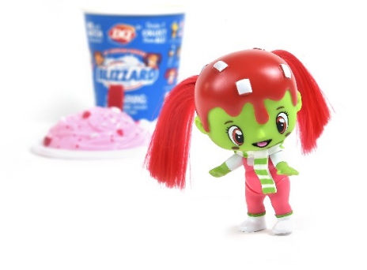
Introducing Lil’ Blizzard Friends, the dessert-themed cuties officially licensed by Dairy Queen Inc. Each Lil' Blizzard Friend is full of super sweet personality. With packaging designed to look like one of six iconic Dairy Queen Blizzard Treats, kids can open the Blizzard to discover a few blind packages inside. There are 24 different Lil' Blizzard Friends to collect, each with their own personality and accessories to mix and match! MSRP $9.99. Available Summer 2019.
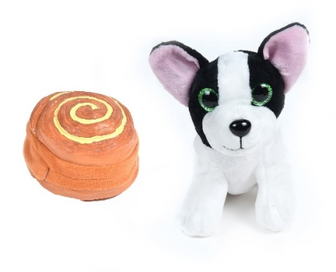
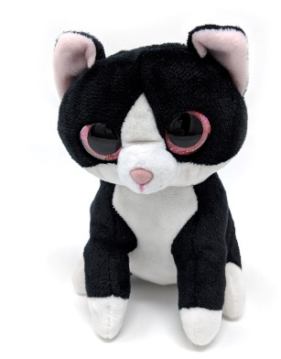
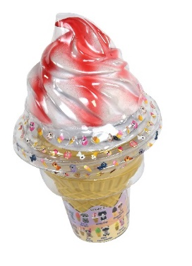
Become BFFs with the coolest cats around! Kids can transform Cool Cats from a soft and squishy ice cream cone into a cute, cuddly kitten. In addition to a realistic design and smiling face, each Cool Cat is delicious to smell! There are 7 sweet scents available: caramel, blueberry, mango, pistachio, strawberry, citrus, and chocolate. Collect and transform all 12 characters! MSRP $9.99. Available Summer 2019.
Thrill your little ones with freshly baked Sweet Pups that smell as good as they look! These squishy croissants, pastries, and sweet rolls transform into soft, cuddly puppies. Each pup is scented with one of four amazing smells; fresh baked bread, chocolate, cinnamon, or strawberry. Collect all 12 for a seriously sweet squad! MSRP $9.99. Available now.

Sunny Days Entertainment’s 2019 product lines are available on Amazon, at Target and Walmart, as well as some specialty retailers across North America.
About Sunny Days Entertainment
Established in 2012, Sunny Days Entertainment, LLC is a fully integrated toy company specializing in solving retailers’ problems while delivering ultra-fun, value-added toys to consumers. Our brands include Maxx Action, Blue Ribbon Champions, Elite Force, Sweet Pups and more! Visit us online at sunnydaysent.com.
Source: Sunny Days Entertainment, LLC
Media Contacts:
Sunny Days Entertainment, LLC
Emily Chaput, 864-962-3020 Ext. 307
emilychaput@sunnydaysent.com
###

