LeapFrog® Sweet Suite 2021
Learning Tools

LeapFrog®
On-the-Go Story Pal™  Ages: 3+ Years  MSRP: $27.99  The On-the-Go Story Pal™ player lets kids take story time wherever they go! Spark imagination through 70+ stories, poems, songs and lullabies. The narrators, character voices, sound effects and content encourage listening comprehension and build a foundation for a love of storytelling. This adorable, bunny-shaped player has easy-to-navigate controls and a headphone jack so kids can listen anywhere (headphones not included). Personalize the On-the-Go Story Pal™ by recording up to 10 minutes of your voice reading your child’s favorite story or create your own. Create a playlist of up to five stories, songs, poems or lullabies. A timer allows you to select a variety of stories, songs and lullabies to be played before the player shuts off. Easy-to-navigate controls make it kid-friendly and simple to use. Includes a carrying strap so kids can bring the player anywhere they want to go. Free additional content is available for download and features four packs of additional stories and music. Play happily ever after!  Availability: August 2021; Walmart, Target and Amazon | 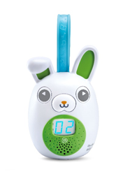
LeapReader® Learn-to-Read 10-Book Mega Pack™  Ages: 4 - 8 Years  MSRP: $54.99  Help your child on their learn-to-read journey with the LeapReader® Learn-to-Read 10-Book Mega Pack™. Ten special books help children progress at a reading pace that feels just right to them. Touch the LeapReader® stylus to the book icon in the included books to hear the story read aloud. Lively character voices enhance the stories as they’re read. Explore each word in the story by touching it with the stylus. In Say It mode, you’ll hear each word spoken. Switch to Sound It mode to hear words sounded out to build word-blending skills. Select Spell It mode to hear and see the spelling of words and reinforce letter recognition. Yellow highlights throughout the books introduce letter teams that make a single sound or words with irregular spelling patterns. Each book encourages a love of reading through activities and phonics games that reinforce what they’ve learned. Includes a Curricular Parent Guide that provides information on reading development along with activities that support children on their learn-to-read journey. Additional content can be downloaded from the LeapFrog App Center and includes popular audio books, sing-along songs, fun facts and trivia.  Availability: August 2021; Walmart and Target | 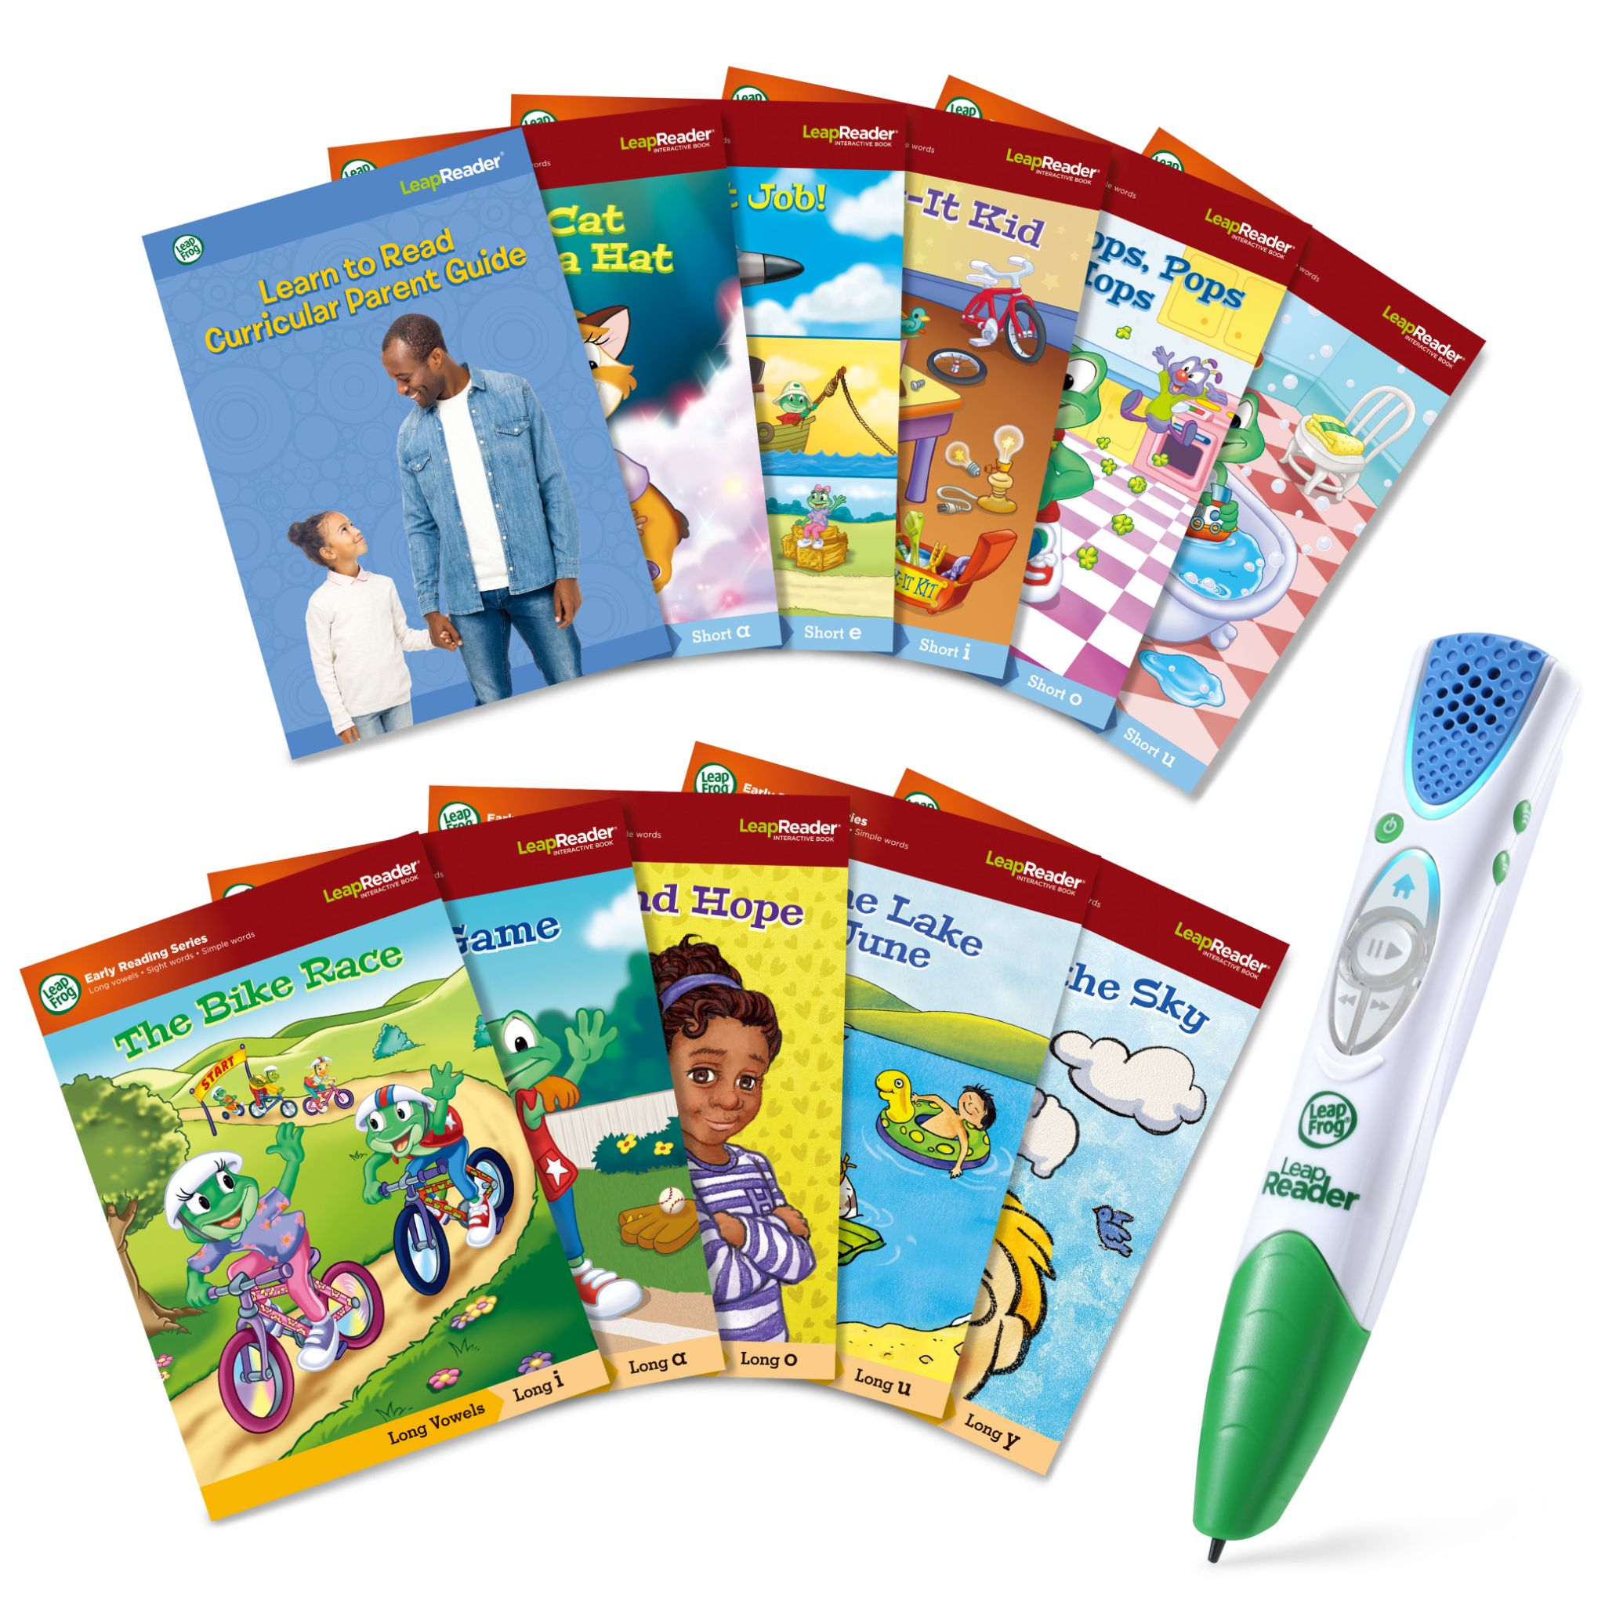
LeapStart® Learning Success Bundle™  Ages: 2 - 7 Years  MSRP: $44.99  Explore exciting new ways to learn with the LeapStart® Learning Success Bundle™ interactive system. This system with a sleek, new design grows with your child and gets them excited about learning with interactive touch-and-talk pages. Activities that include games, puzzles and creative challenges enhance learning to help kids build math, reading, problem-solving skills and more. The Go! Go! Cory Carson® Cory Carson Superhero School™ book, based on the popular animated series, and an additional activity book are included. The expansive LeapStart® library of books (sold separately) covers a variety of preschool through first grade subjects for 2–7-year-olds with more than 30 activities in every book. Many replayable activities have two levels with 50+ key skills per grade level, so kids can play and learn at the right level and move up when they’re ready. Included books are preloaded. The easy-to-hold stylus is comfortable for kids of all ages, promotes proper writing grip and neatly clicks into the cover for storage. Take it on the go using the carrying handle. A computer with an internet connection is required to load book content onto the LeapStart® system.  Availability: August 2021; Walmart and Target | 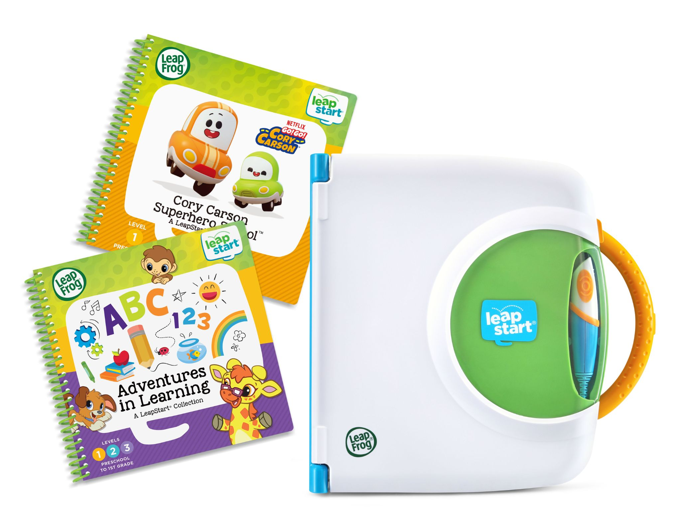
100 Words About Places I Go™  Ages: 18+ Months  MSRP: $19.99  Explore words about places kids love with the 100 Words About Places I Go™ bilingual learning book! Featuring age-appropriate words, this interactive book teaches about people and objects in 12 unique places in both English and Spanish. Go to the beach in any season and discover words in two languages about things to bring and surprises to find. The school, the park, the farm, the amusement park and more locations can light up your child’s world and spur their imagination. Ten touch-sensitive locations on each page teach about words, colors and counting in the context of 12 unique places. Inspire toddlers and preschoolers who are ready to go places!  Available at major retailers including Walmart, Amazon and Target | 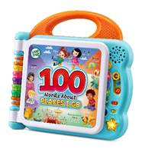  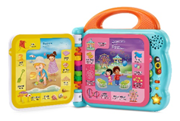

Contacts: Coyne PR
Lauren Fagan, lfagan@coynepr.com
Kaitlin Anilonis, kanilonis@coynepr.com

