VTech® & LeapFrog® Sweet Suite 2021
Eco-Friendly Products

VTech®
Sort & Recycle Ride-On Truck™  Ages: 1½ - 4 Years  MSRP: $37.99  When you get the Sort & Recycle Ride-On Truck™, you’re already doing your part to help the earth! This recycling truck is made from plastic that is 90% reclaimed. Using reclaimed plastic means less waste goes into landfills. Beginner recyclers will love hopping on this lean, green recycling machine and driving around while learning about recycling things like plastic and reusing everyday objects. Load up the red heart, yellow hexagon and blue circle play pieces that represent plastic, metal and paper. Sort them into the correct bin, just like at home. Kids can also explore ways to repurpose everyday items or take a quiz to reinforce what they’re learning. Reuse and remix the included melodies by inserting a block in a bin to add sound effects that make each melody sound new. Blocks store inside the truck for easy cleanup.  Availability: August 2021; Walmart, Target and Amazon | 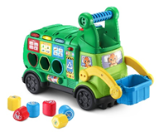
Go! Go! Smart Wheels® Earth Buddies™ Recycling Truck  Ages: 1 - 5 Years  MSRP: $8.99  Reduce, reuse and recycle with the Go! Go! Smart Wheels® Earth Buddies™ Recycling Truck! Reese the Recycling Truck is just the right size for little hands. He features a friendly, light-up windshield button that plays three sing-along songs and six melodies. Pretend to pick up recyclables during imaginative play with Reese. Open and close the tailgate to see the recyclables inside and encourage fine-motor skills. Push the Recycling Truck around to trigger role-play sound effects. Take Reese the Recycling Truck for a ride on Go! Go! Smart Wheels® playsets (sold separately) and discover more phrases, songs, sound and lights as he drives over the SmartPoint® locations. The plastic used to make this product is 85% plant based. Plant-based plastic is made from renewable sources.  Availability: September 2021; Amazon | 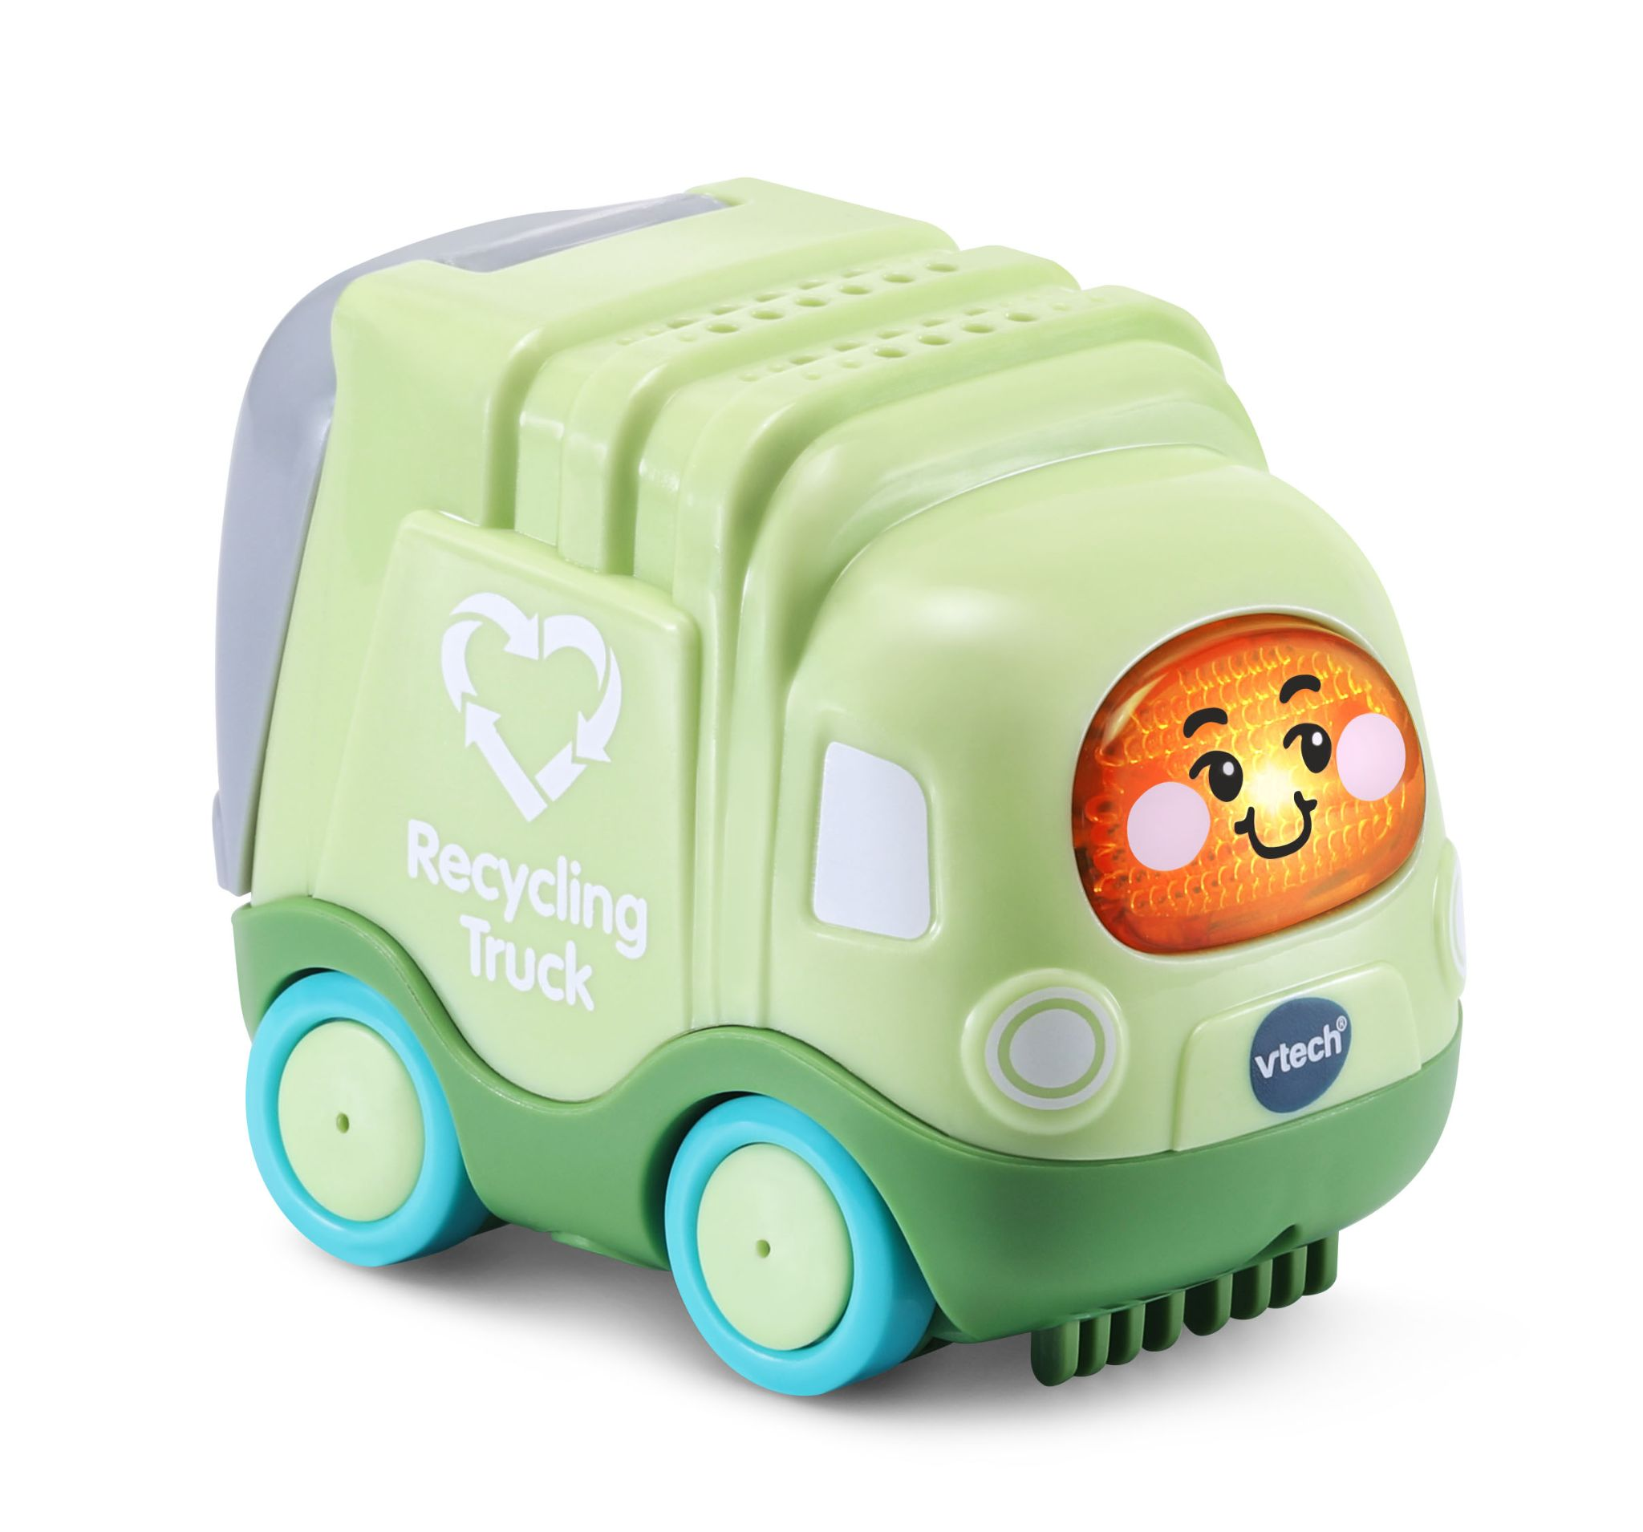
Go! Go! Smart Wheels® Earth Buddies™ Fire Truck  Ages: 1 - 5 Years  MSRP: $8.99  Sound the alarm for the Go! Go! Smart Wheels® Earth Buddies™ Fire Truck! Foster the Fire Truck is just the right size for little hands. He features a friendly, light-up windshield button that plays three sing-along songs and six melodies. Be a fire fighter during imaginative play with Foster. Move the ladder up and down to save the day and encourage fine-motor skills. Push the Fire Truck around to trigger role-play sound effects. Take Foster the Fire Truck for a ride on Go! Go! Smart Wheels® playsets (sold separately) and discover more phrases, songs, sounds and lights as he drives over the SmartPoint® locations. The plastic used to make this product is 85% plant based. Plant-based plastic is made from renewable sources.  Availability: August 2021; Amazon | 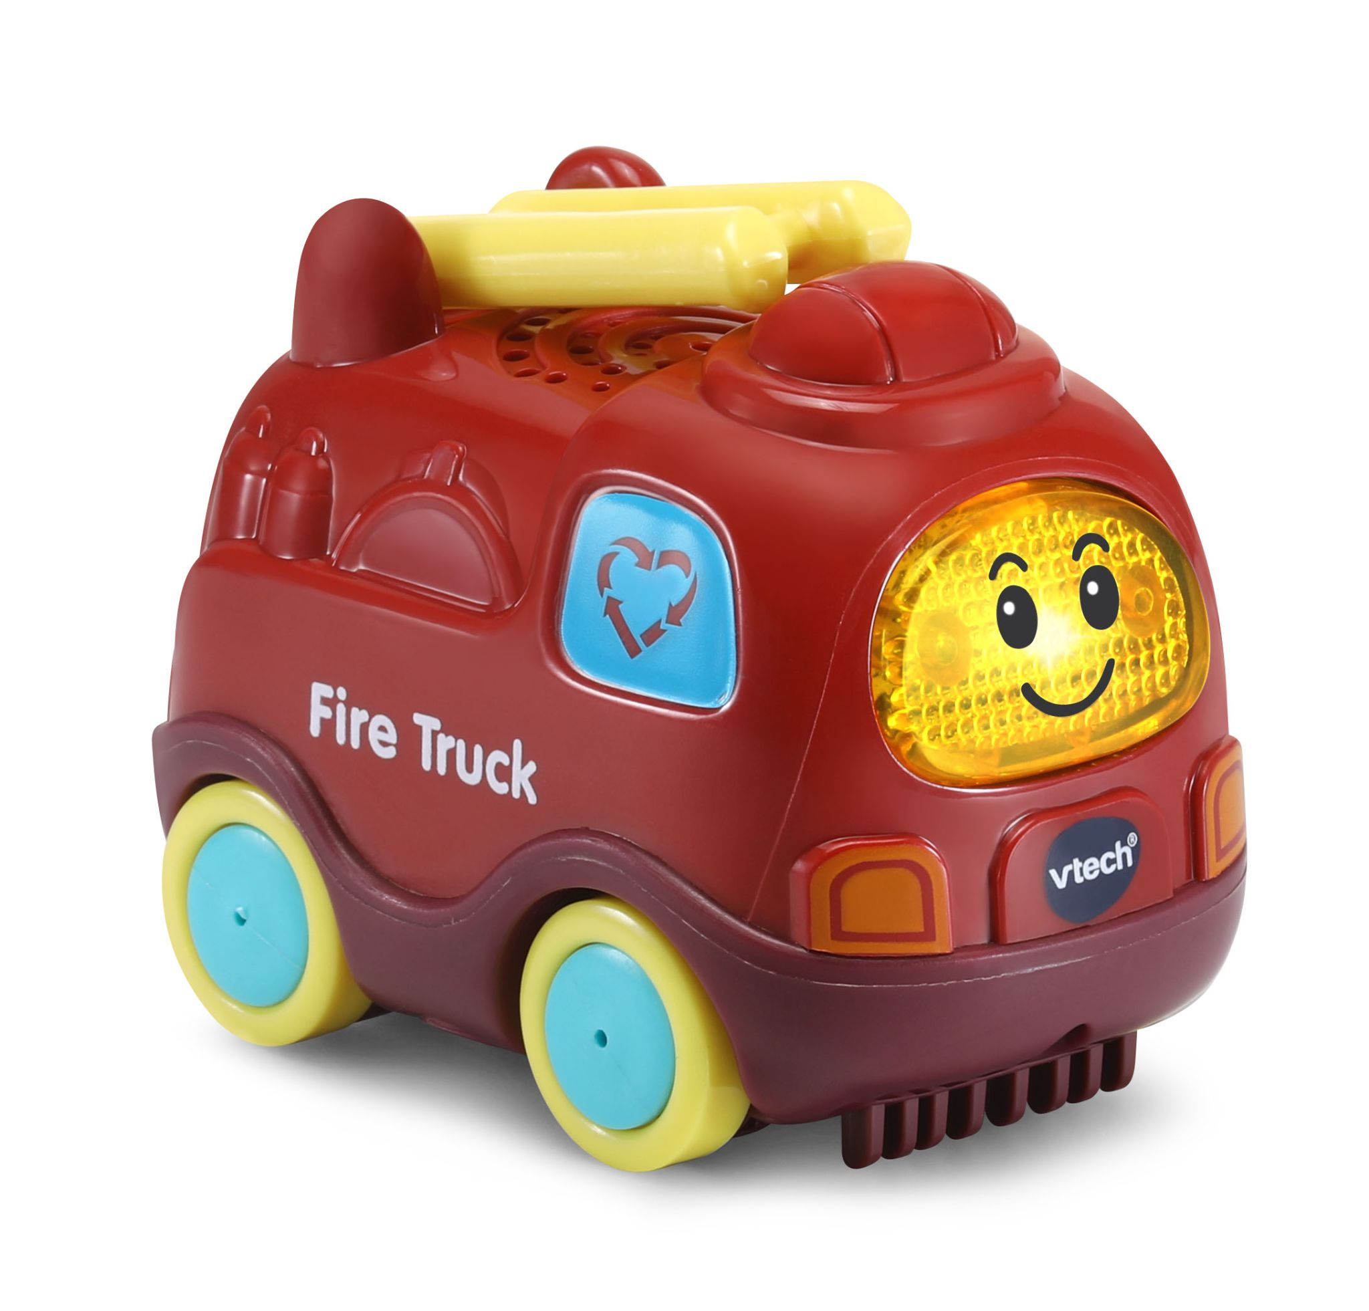
Go! Go! Smart Wheels® Earth Buddies™ Helicopter  Ages: 1 - 5 Years  MSRP: $8.99  Get ready to fly with the Go! Go! Smart Wheels® Earth Buddies™ Helicopter! Harley the Helicopter is just the right size for little hands. He features a friendly, light-up windshield button that plays three sing-along songs and six melodies. Be a pilot during imaginative play with Harley. Spin the rotor blades to pretend to fly and encourage fine-motor skills. Push the Helicopter around to trigger role-play sound effects. Take Harley the Helicopter for a ride on Go! Go! Smart Wheels® playsets (sold separately) and discover more phrases, songs, sounds and lights as he drives over the SmartPoint® locations. The plastic used to make this product is 85% plant based. Plant-based plastic is made from renewable sources.  Availability: August 2021; Amazon | 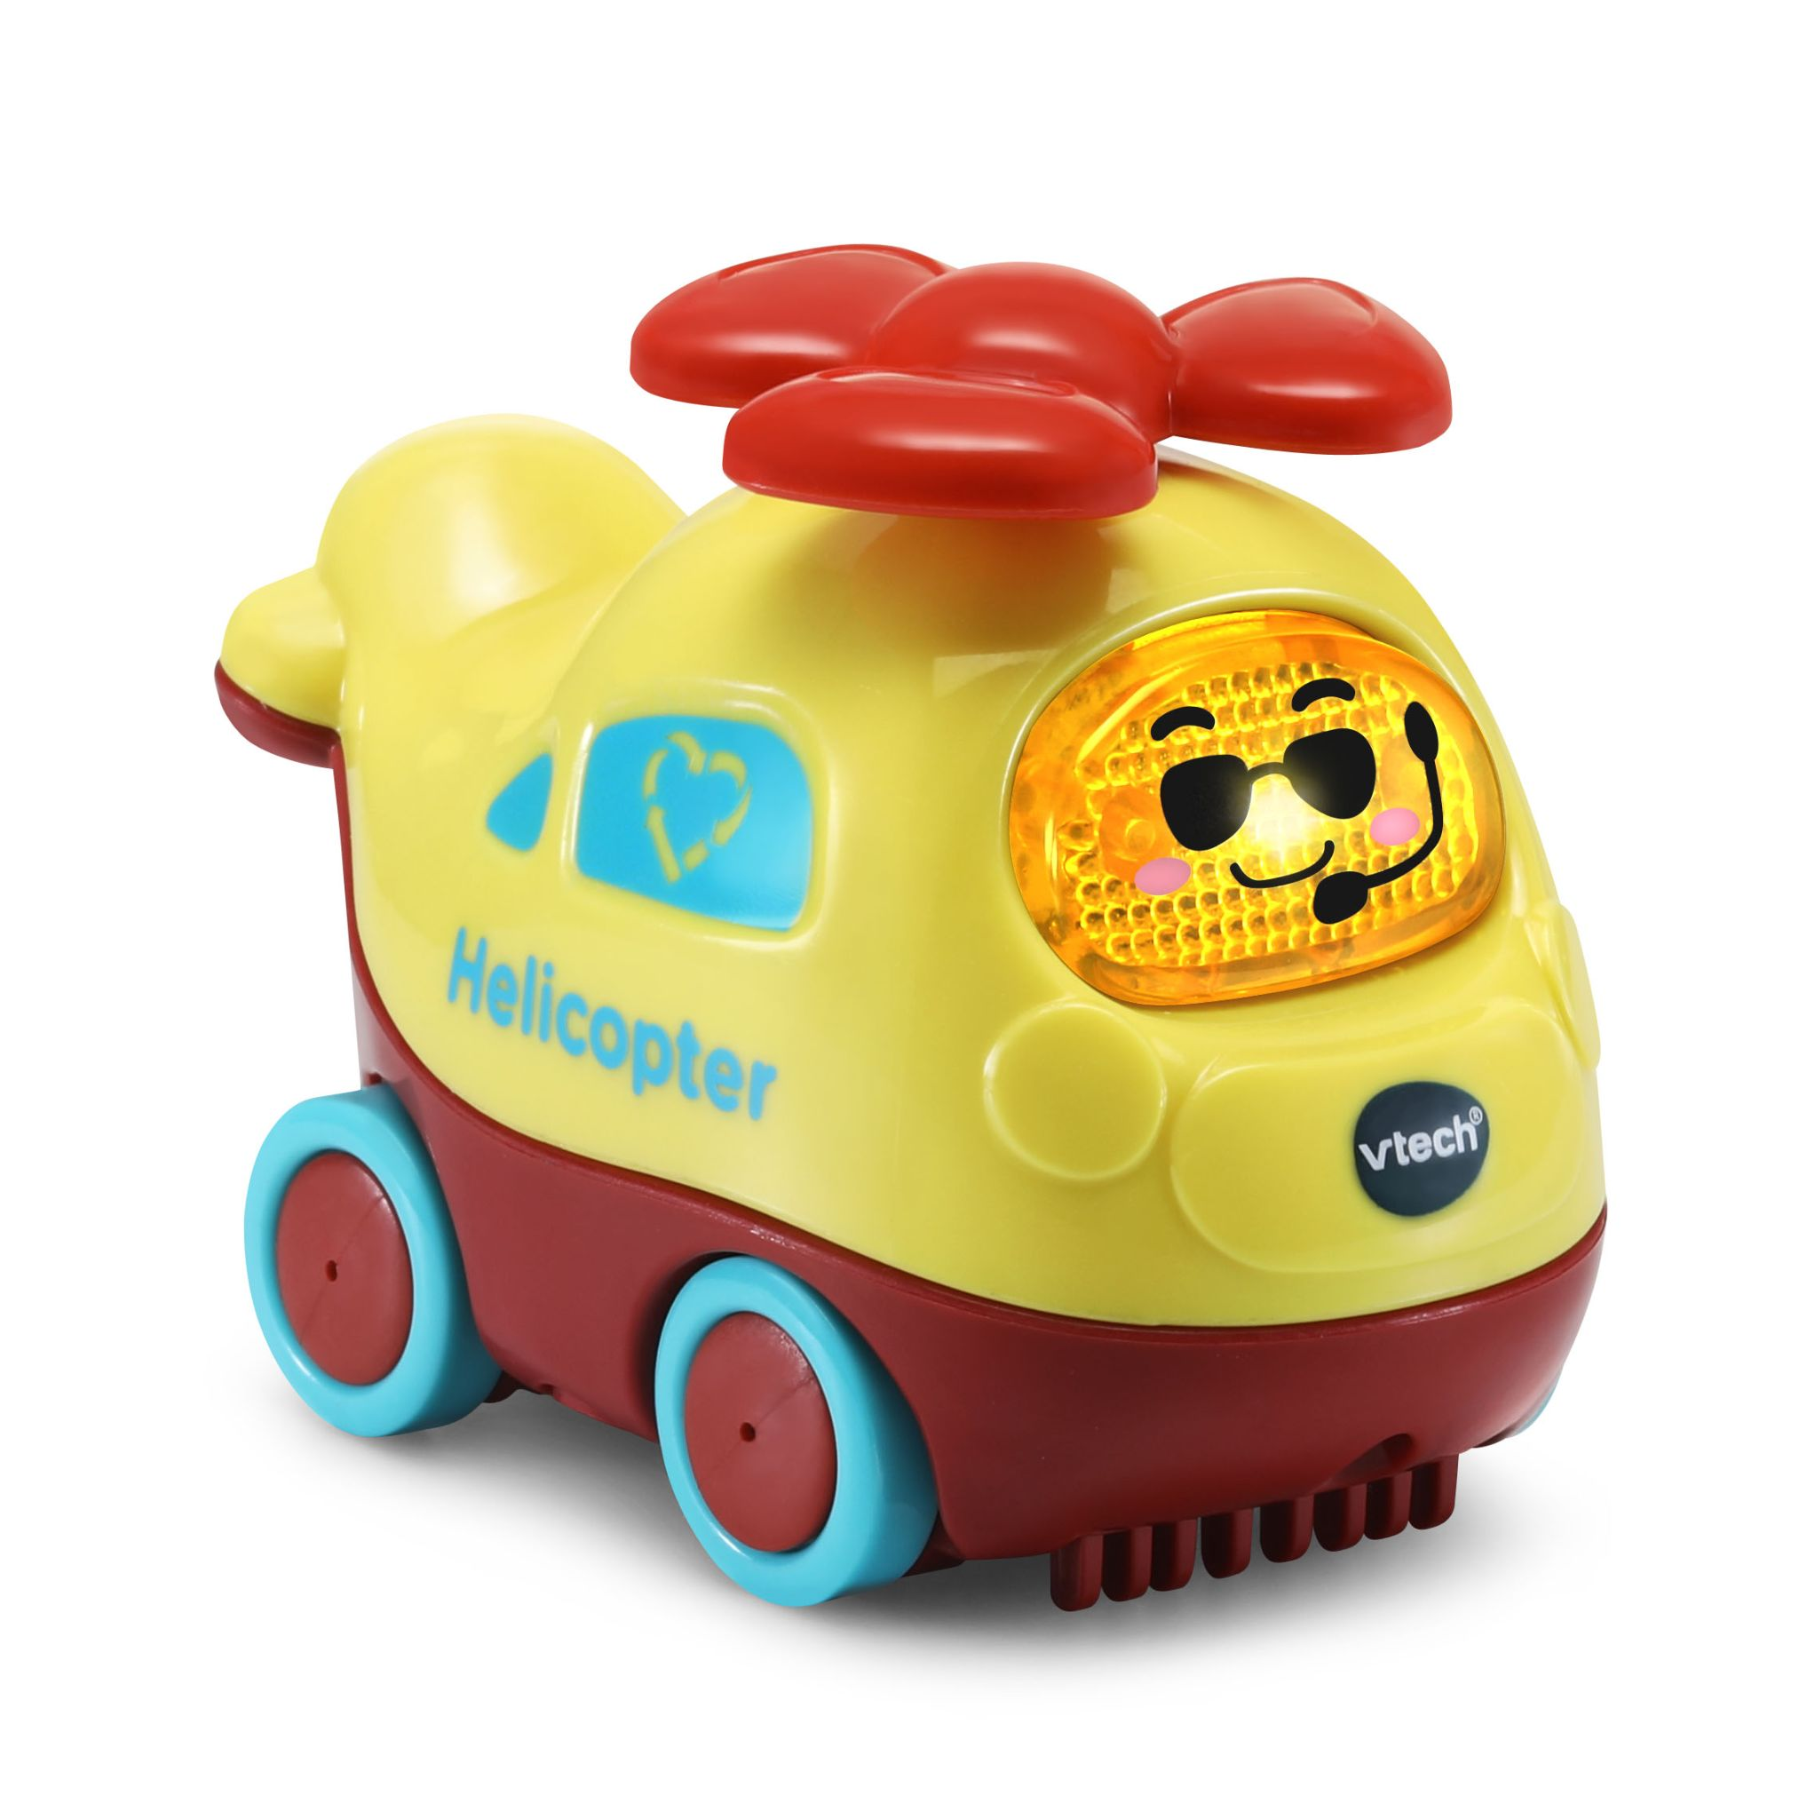
Go! Go! Smart Wheels® Earth Buddies™ Gardening Truck  Ages: 1 - 5 Years  MSRP: $8.99  Grow your imagination with the Go! Go! Smart Wheels® Earth Buddies™ Gardening Truck! Gerry the Gardening Truck is just the right size for little hands. He features a friendly, light-up windshield button that plays three sing-along songs and six melodies. Be a gardener during imaginative play with Gerry. Raise the bed of the truck up and down to pretend to unload dirt and encourage fine-motor skills. Push the Gardening Truck around to trigger role-play sound effects. Take Gerry the Gardening Truck for a ride on Go! Go! Smart Wheels® playsets (sold separately) and discover more phrases, songs, sounds and lights as he drives over the SmartPoint® locations. The plastic used to make this product is 85% plant based. Plant-based plastic is made from renewable sources.  Availability: October 2021; Amazon | 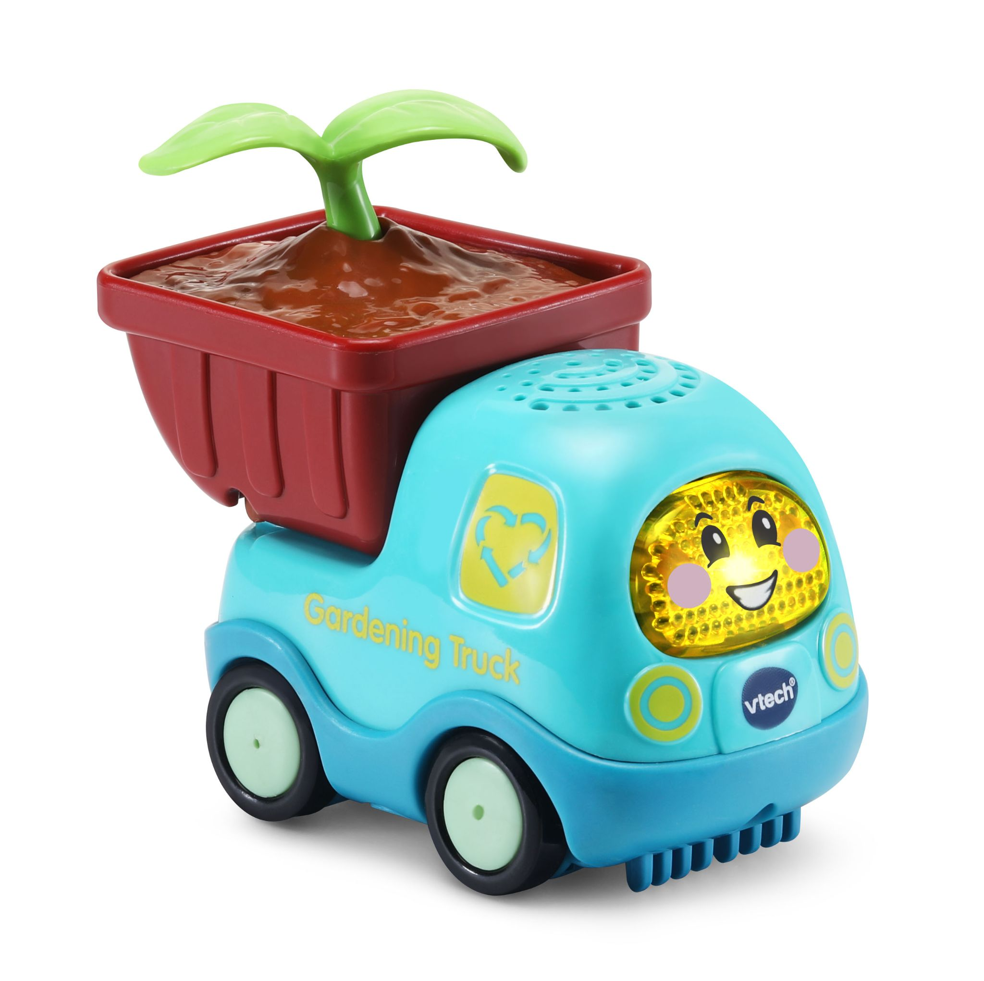

LeapFrog®
Touch & Learn Nature ABC Board™  Ages: 18+ Months  MSRP: $24.99  Bring a love of nature into the world of learning with the Touch & Learn Nature ABC Board™. With a touch-sensitive wooden board and an animated light-up LED screen, this toy tablet teaches letters, letter sounds and counting. Explore 26 animal/letter buttons, a music button and more. Touch the animals one by one to count to ten! Add an appreciation for nature with activities and phrases about weather, nature sounds, animals and conservation. Let's learn to reduce, reuse and recycle! Nine interactive activities such as Animal Band, Sound Detective and Weather Report reinforce learning with playful activities. Learn with a touch of nature! Wood is 100% FSC Certified. Plastic is 90% Reclaimed.  Availability: August 2021; Walmart, Target and Amazon | 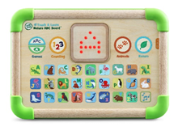
Choppin’ Fun Learning Pot™  Ages: 12+ Months  MSRP: $21.99  Prepare a recipe for learning with the Choppin’ Fun Learning Pot™! Children love to pretend to cook. Prepare broccoli, corn, a tomato and a carrot with snap-apart veggies, a play knife and cutting board. Hear the pot respond with encouraging phrases as kids add veggies to the pot. Let’s make spaghetti sauce! Follow five step-by-step recipes to encourage learning with play. Chop the food and set the temperature dial. Now press a food button and stir the pot to make spaghetti sauce, rainbow soup, corn on the cob, carrot soup and broccoli with cheese! Watch the pot “boil” with pretend water in the front panel. Hear the pot count to 10 and talk about colors as you play. Serve up your creation in the bowl, pick up the spoon, and dig in! All the pieces store in or on the pot for easy cleanup when playtime is done. Soup-tastic!  Availability: August 2021; Walmart, Target and Amazon | 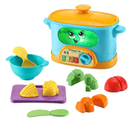
Interactive Wooden Animal Puzzle™  Ages: 2+ Years  MSRP: $17.99  The Interactive Wooden Animal Puzzle™ is a perfect fit for playtime! With four interactive play modes, this puzzle is full of delightful surprises. Match six animal puzzle pieces by shape and color border. Kids will hear different responses when they place or remove each piece in every mode. Animal names and sounds, colors and fun facts are featured in Animals mode. In Numbers mode, count the objects hidden under the animals. There are three eggs under the blue parrot! Enhance playtime with Spanish mode. Listen to words in Spanish, then hear them repeated in English. Questions about animals, colors and numbers help reinforce the learning. Add musical notes and animal sounds to background beats in Music mode. Hear an animal symphony when you take out all the pieces at once. Go wild for puzzles! This product is made with 100% FSC-certified wood that comes from well-managed forests. The plastic used to make is product is 90% reclaimed.  Availability: August 2021; Walmart, Target and Amazon | 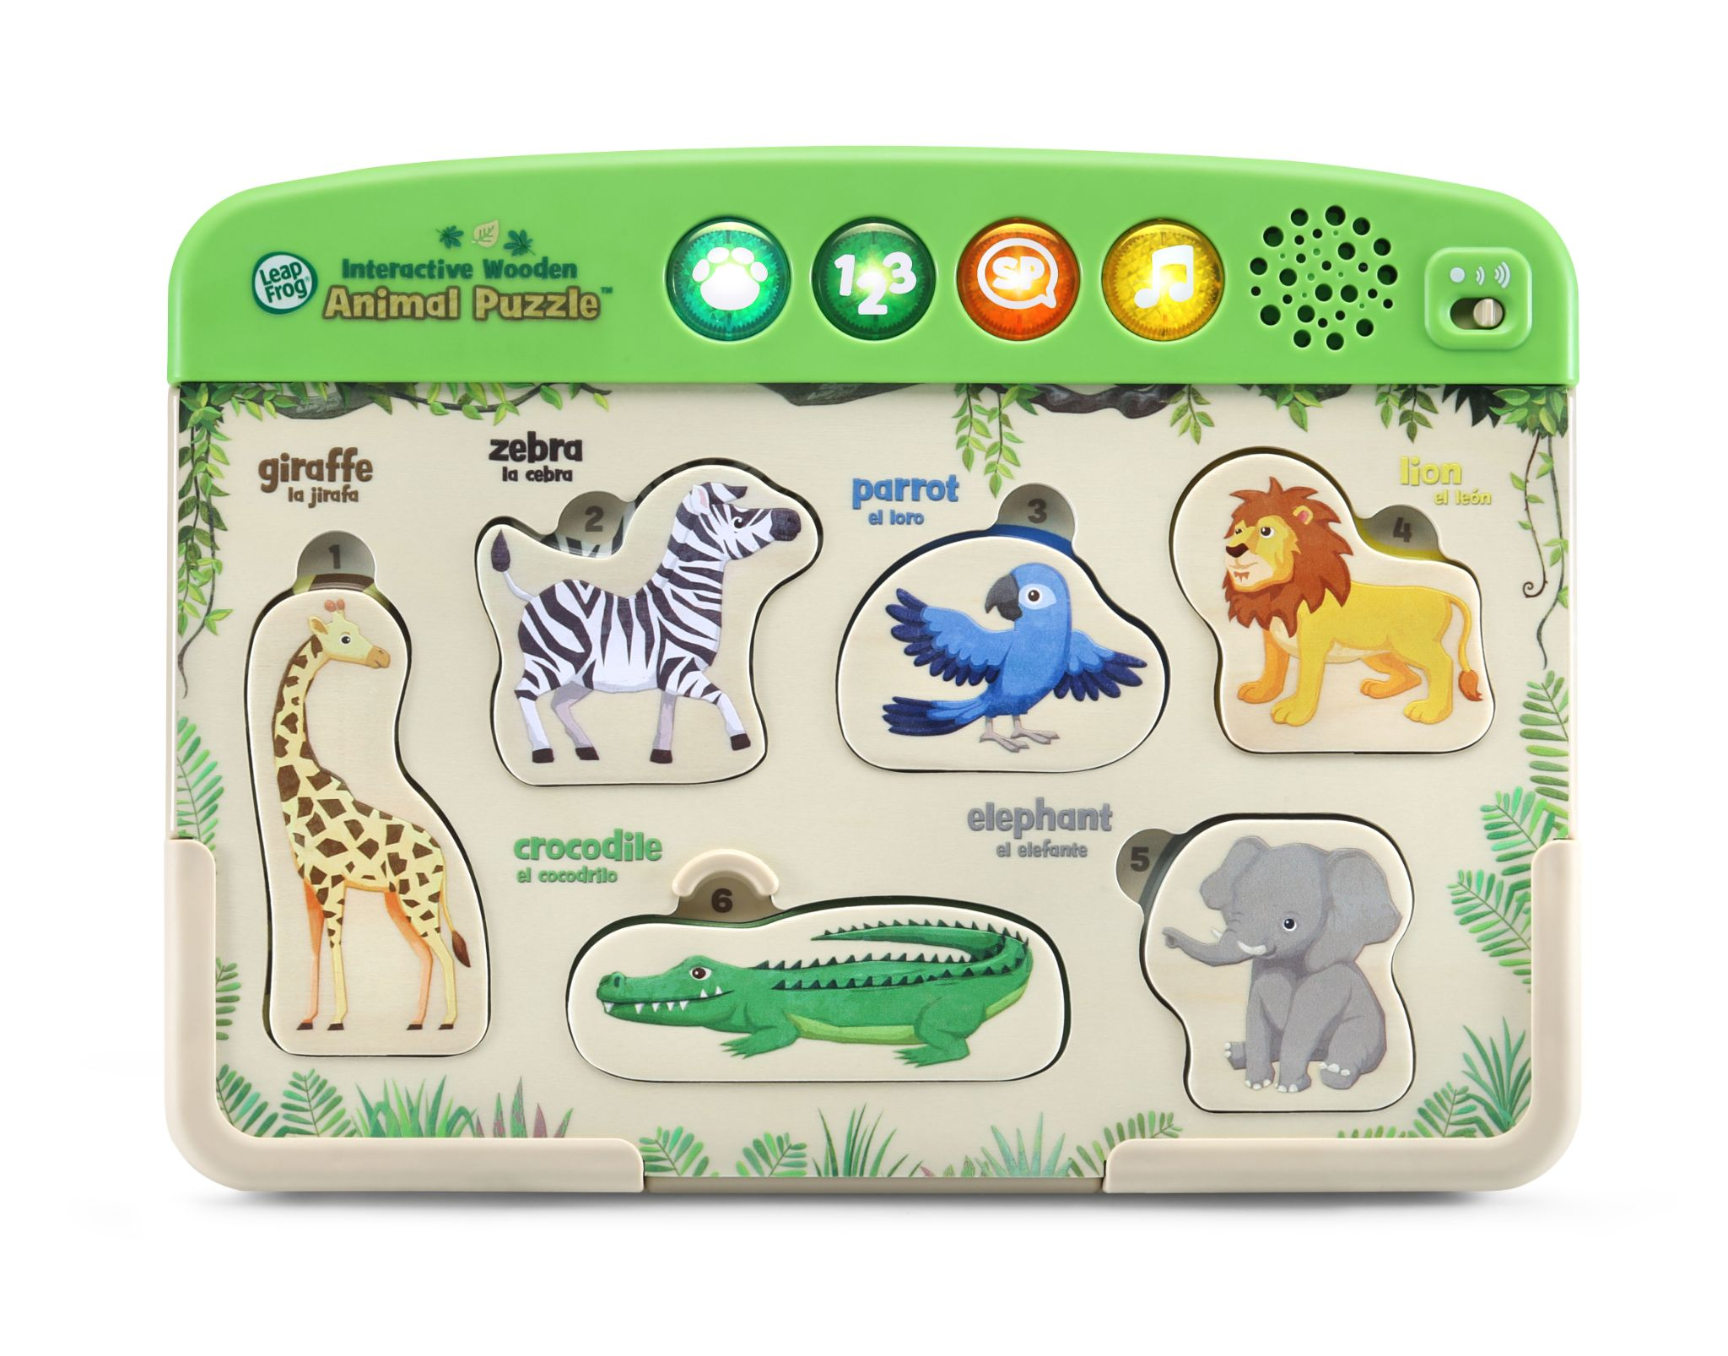

Contacts: Coyne PR
Lauren Fagan, lfagan@coynepr.com
Kaitlin Anilonis, kanilonis@coynepr.com

