LeapFrog® Sweet Suite 2021
Let’s Pretend!

LeapFrog®
Choppin’ Fun Learning Pot™  Ages: 12+ Months  MSRP: $21.99  Prepare a recipe for learning with the Choppin’ Fun Learning Pot™! Children love to pretend to cook. Prepare broccoli, corn, a tomato and a carrot with snap-apart veggies, a play knife and cutting board. Hear the pot respond with encouraging phrases as kids add veggies to the pot. Let’s make spaghetti sauce! Follow five step-by-step recipes to encourage learning with play. Chop the food and set the temperature dial. Now press a food button and stir the pot to make spaghetti sauce, rainbow soup, corn on the cob, carrot soup and broccoli with cheese! Watch the pot “boil” with pretend water in the front panel. Hear the pot count to 10 and talk about colors as you play. Serve up your creation in the bowl, pick up the spoon, and dig in! All the pieces store in or on the pot for easy cleanup when playtime is done. Soup-tastic!  Availability: August 2021; Walmart, Target and Amazon | 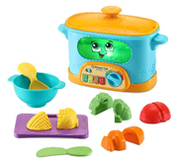
Count-Along Basket & Scanner™  Ages: 2+ Years  MSRP: $34.99  Y’all "bready" for this? Let’s shop with the Count-Along Basket & Scanner™ featuring play food, shopping lists, and an interactive scanner that recognizes each food piece. Carry the shopping basket or expand it into a rolling shopping cart. Shop the rainbow with eight play foods in a variety of food groups, colors, shapes and numbers. The fish, carrots, strawberries, cake, bread, broccoli and grapes show off their silly personalities with music and unique phrases when scanned. Ready for a veggie dance? Let's "brocc" and roll! Scan foods on the shopping lists to play activities like Food Group Feast and Shapes of the Day to hear encouraging phrases and songs. Three interactive play modes reinforce learning. In Learn mode, scan a food to find out its name, color and the number printed on it. Switch to Count mode to follow the scanner’s directions to scan foods up to ten times. Ready to play a game? The scanner gives clues for foods by name, number, color and shape in Game mode. Play pieces store in the basket.  Availability: August 2021; Walmart, Target and Amazon | 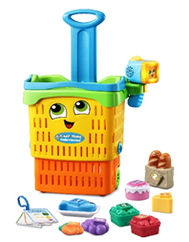
Fun-2-3 Instant Camera™  Ages: 12+ Months  MSRP: $17.99  Capture smiles and learning with the Fun-2-3 Instant Camera™! This pretend camera inspires imaginary play with picture-taking activities and pop-up animal pictures. Five double-sided photo cards feature two sides of play and learning. The first side includes early learning about animals, shapes, colors and numbers one through five. Flip to the second side for fun facts about animals and habitats. Help children practice what they're learning by searching cards for shapes and counting objects. Strengthen motor skills by grasping and pushing down the cards, turning the zoom lens and clicking the shutter button. Turn the viewfinder color wheel to see the world in yellow, blue or green! Learn about opposites by spinning the lens from day to night. When kids are done playing, easily slip the photo cards onto the included wrist strap for quick cleanup and storage. Imaginative play makes learning a snap!  Availability: July 2021; Walmart, Target and Amazon | 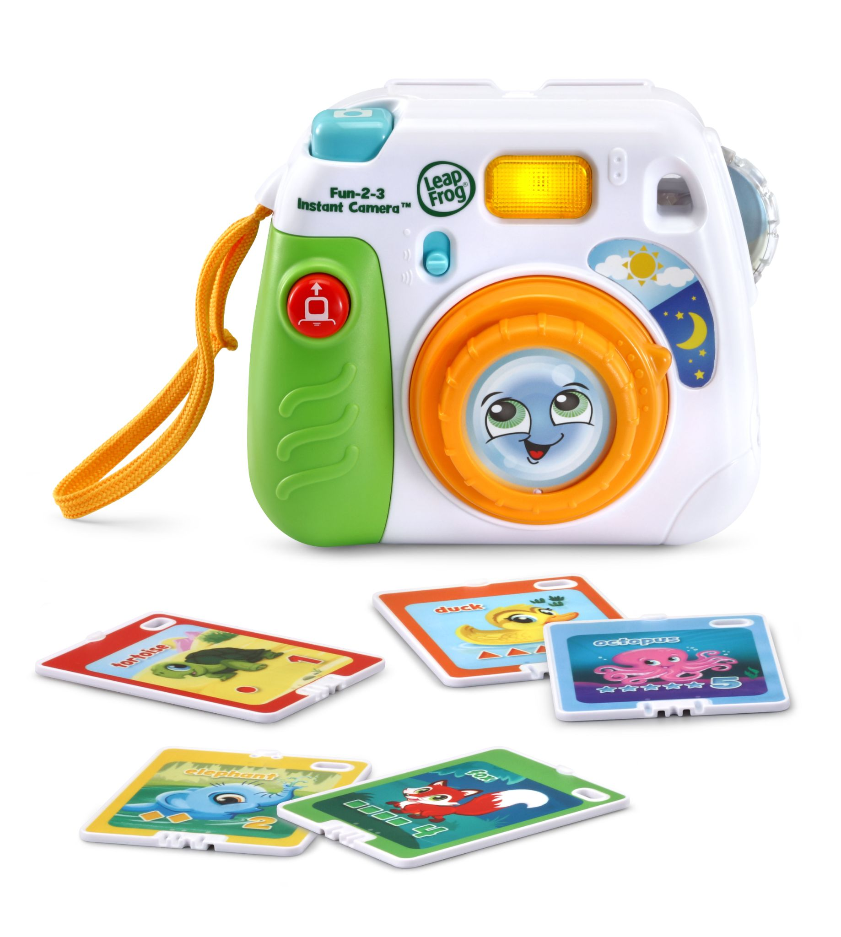  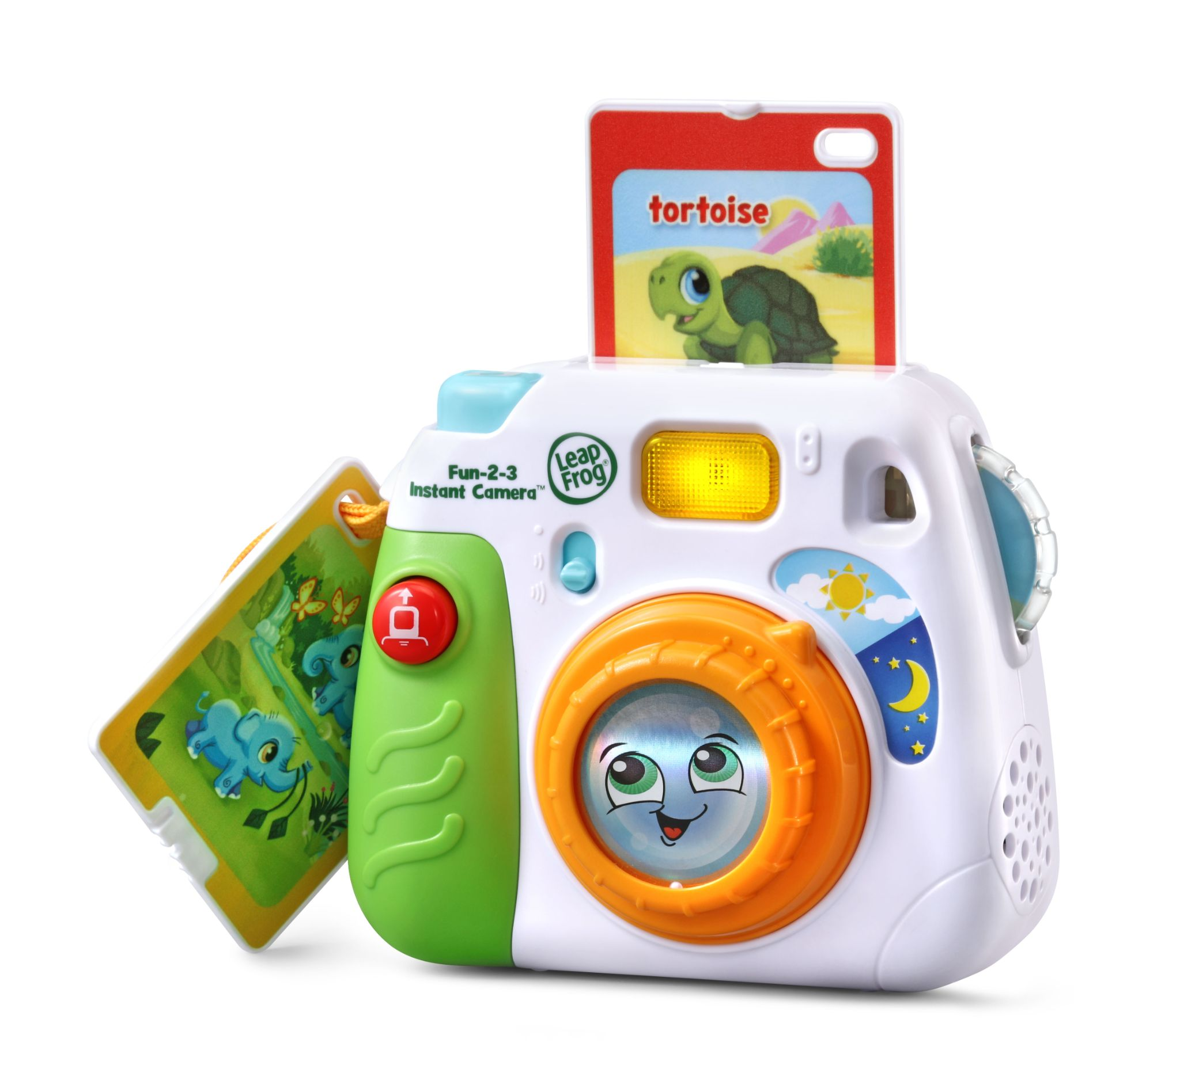
Pick Up & Count Vacuum™  Ages: 2+ Years  MSRP: $29.99  Count on picking up learning with the Pick Up & Count Vacuum™! This smart vacuum toy picks up ten play dust pieces as kids roll the vacuum over them, encouraging motor skills as they easily maneuver the pretend vacuum around the room. As the vacuum picks up the dust pieces, it recognizes each color and helps children with color recognition. Bouncing balls inside the spinning vacuum canister add excitement to pretend tidying. Three play modes teach colors, numbers and counting with six learning games. Five light-up panels illuminate to match the color of the piece the vacuum picks up, and the vacuum says the color name and counts the piece to reinforce learning. The tiltable handle adjusts to multiple heights, allowing this toy to grow with your child. A dust bin on the back collects and stores all ten dust pieces. Clean up on learning!  Available now at all major retailers, including Amazon, Walmart and Target | 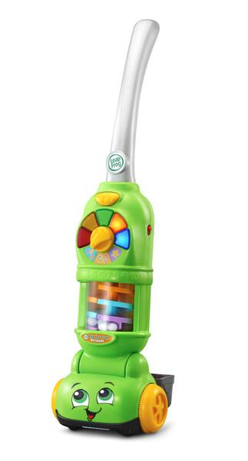
Scoop & Learn Ice Cream Cart™  Ages: 2+ Years  MSRP: $44.99  Learning is sweet when pretending to run your own ice cream cart! The Scoop & Learn Ice Cream Cart™ lets you create a variety of imaginative and tasty-looking ice cream combinations using four flavors of ice cream, three toppings and three syrup flavors. Use the magic scooper to scoop up the ice cream and toppings to build customer orders and it will recognize the colors and flavors. Then press the pump to add pretend syrup while counting to ten. Build memory and sequencing skills by choosing from six cute animal order cards and following the instructions. Ring the bell to let them know their order’s up! Playful phrases introduce colors, numbers, flavors and more while you explore the cart’s features and six activity cards. When you’re ready to move to a new location, place the accessories in the correct places or put them in the two storage drawers and push the cart around to hear upbeat songs and music.  Available at major retailers including Amazon, Walmart and Target | 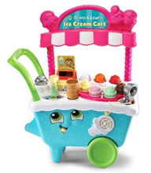
Shapes & Sharing Picnic Basket™  Ages: 6+ Months  MSRP: $24.99  Learn about colors, shapes, manners and more while on a pretend picnic with the Shapes & Sharing Picnic Basket™. Lift the lid to hear cheerful phrases and unpack the 15 play pieces, including colorful plates, forks, cups and food. The interactive shape sorter on the lid recognizes the food pieces and says the shape and color of each one. Hear polite food requests and delightful learning songs by pressing the butterfly button. Drop the correct food in the basket for rewarding responses that encourage good manners. Learning’s a picnic with this friendly basket!  Available now at all major retailers, including Walmart, Target and Amazon | 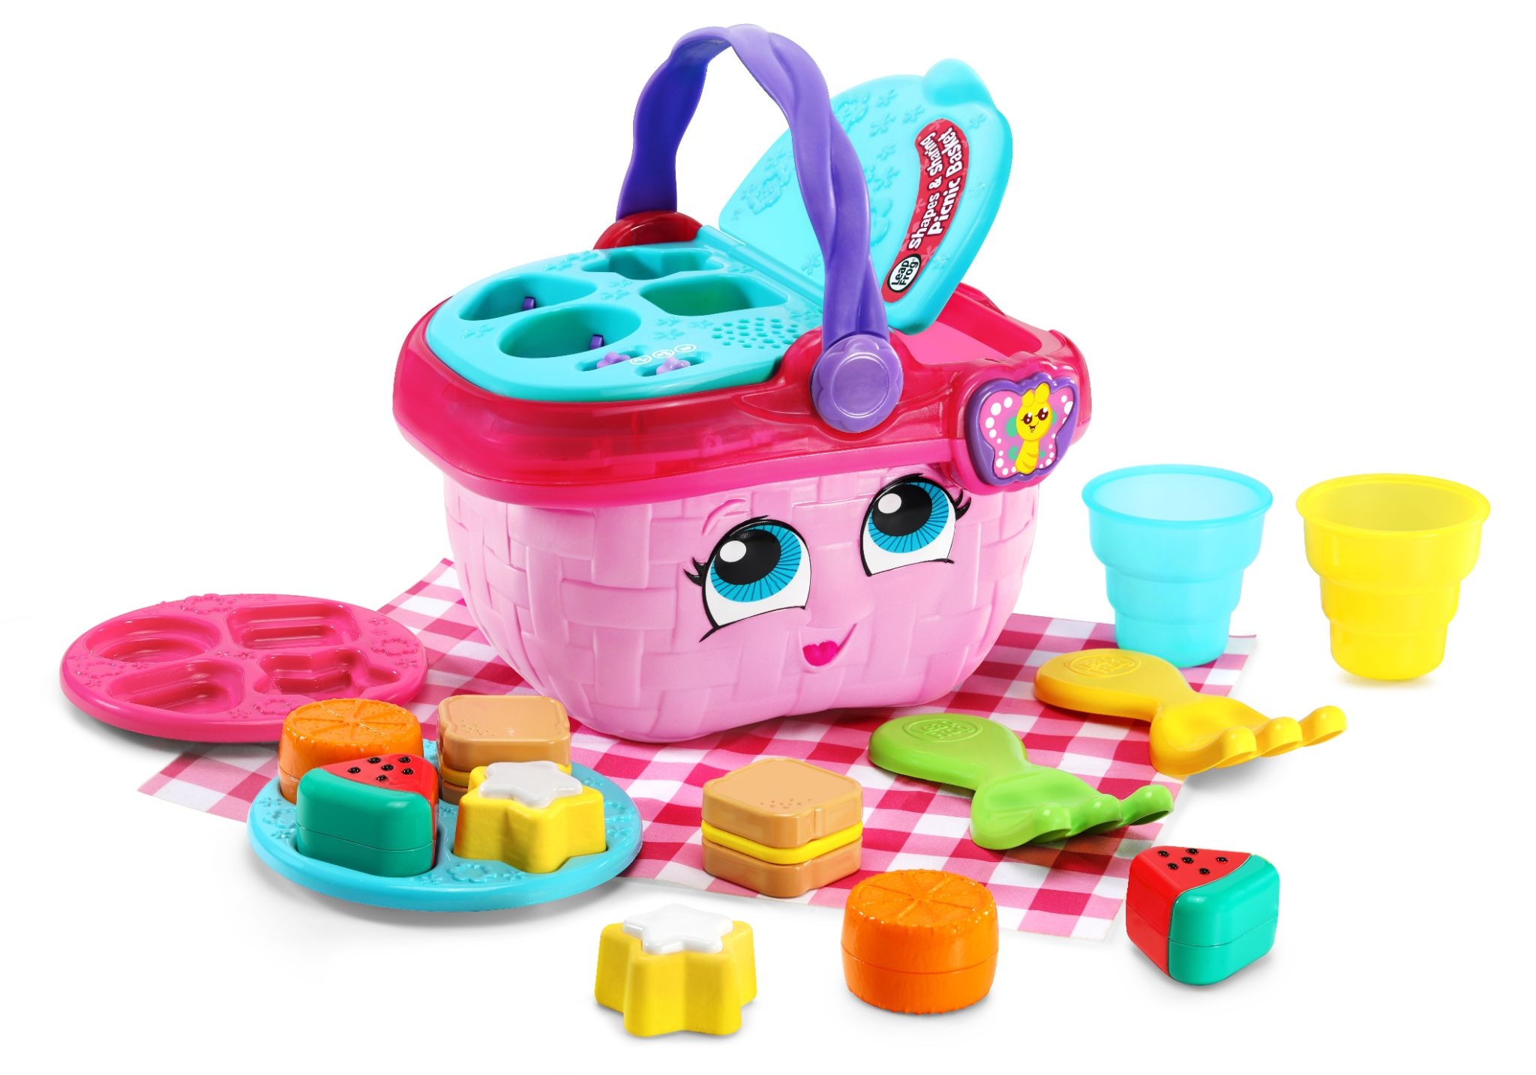

Contacts: Coyne PR
Lauren Fagan, lfagan@coynepr.com
Kaitlin Anilonis, kanilonis@coynepr.com

