VTech® Sweet Suite 2021
The Coolest Tech for Kids!

VTech®
KidiBuzz™ 3  Ages: $104.99  MSRP: 4 - 9 Years  Magnify the fun with the KidiBuzz™ 3 smart device that lets kids message parent-approved contacts, capture and share photos using the new MagLens, play games and more! This awesome device comes with built-in safeguards that provide peace of mind. Connect with approved contacts to send texts, photos and video clips over Wi-Fi to other KidiBuzz™ devices and iPhone or Android smartphones with the free KidiCom Chat™ app. Take close-up photos and videos with the MagLens on the 5 MP camera. Add live face filters and frames to photos and video clips to pump up the fun! Explore kid-friendly websites and 40+ interactive learning games that teach math, science and spelling. Download two free apps from hundreds of learning games in the Learning Lodge®. Access 2000+ games and activities with a free trial subscription to LeapFrog Academy®. Load and play your favorite music and movies for on-the-go entertainment. With parent controls to set daily time limits, this device keeps children engaged and parents at ease.  Availability: August 2021; Target and Walmart | 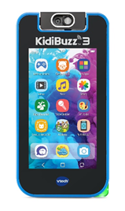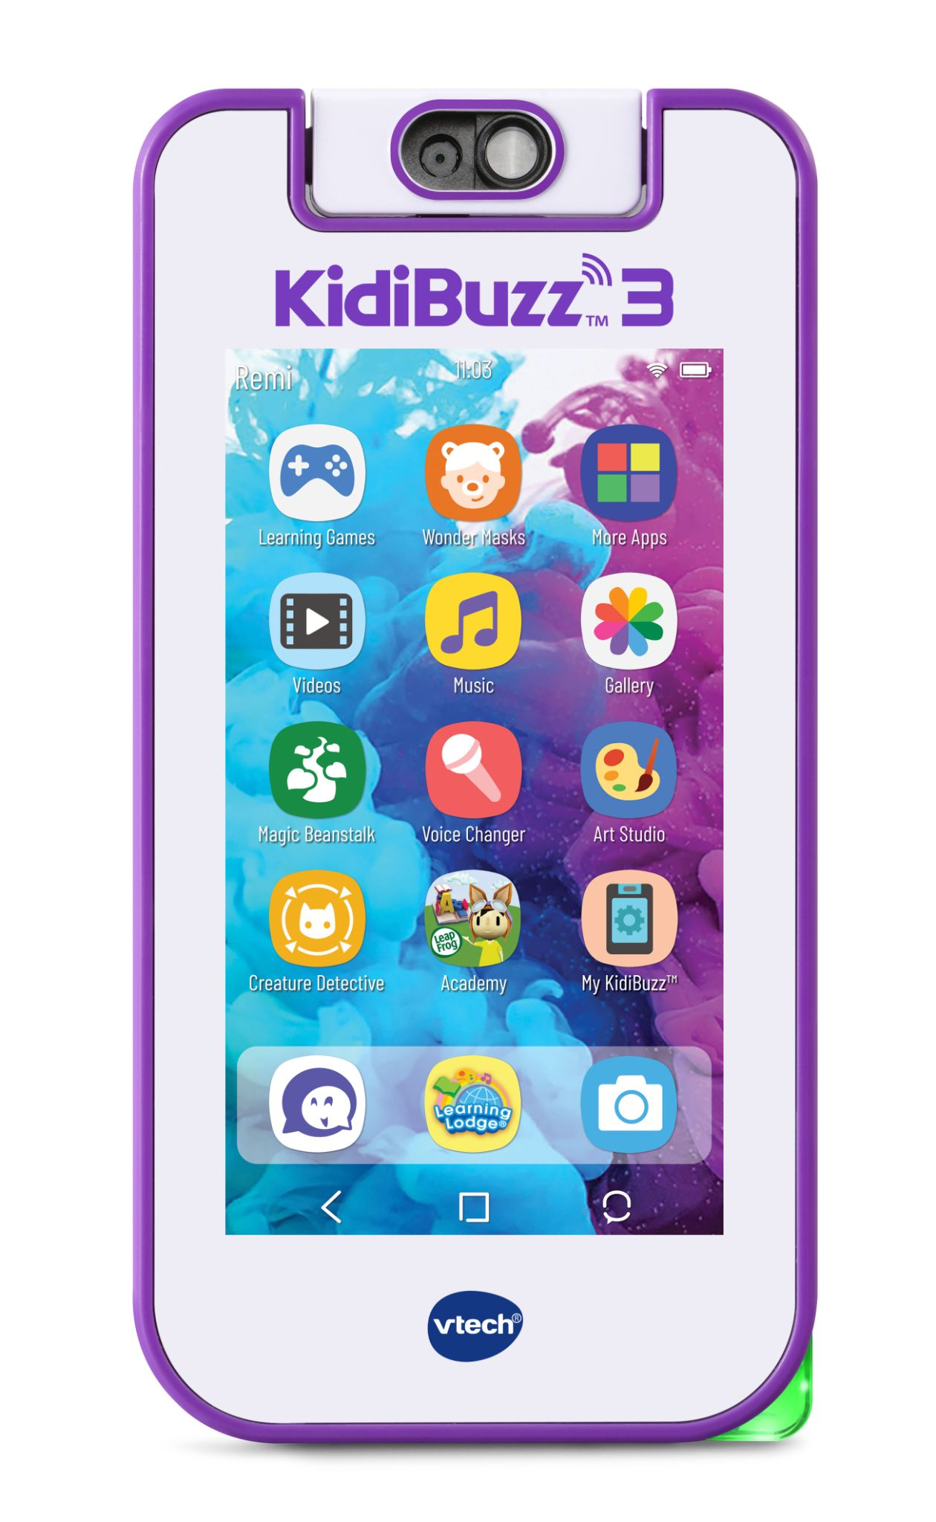
KidiStar DJ Mixer™  Ages: 5+ Years  MSRP: $54.99  Be the star of the show with the KidiStar DJ Mixer™! Scratch and jam to the music on the DJ turntable. Create custom mixes playing along with the 15 included songs or connect to your own music player, via BLUETOOTH® wireless technology or audio cable. Play with the sound grid to create 2000+ sound combinations! Record your own custom sound effects and tags with the internal mic. Dial in the effects with the sliders to get your remix just right. Add and remove vocals and effects, fine tune the mix, and record your mash-up. Use the headphone jack to listen, or play back your tracks for all your fans to hear through the built-in speaker. Get the crowd going with dazzling party lights on your DJ rig. Build your DJ skills by following the rhythms in a music game. Crank up the volume and get the party started! (Audio cable, headphones and external music player not included.)  Availability: August 2021; Walmart, Target and Amazon | 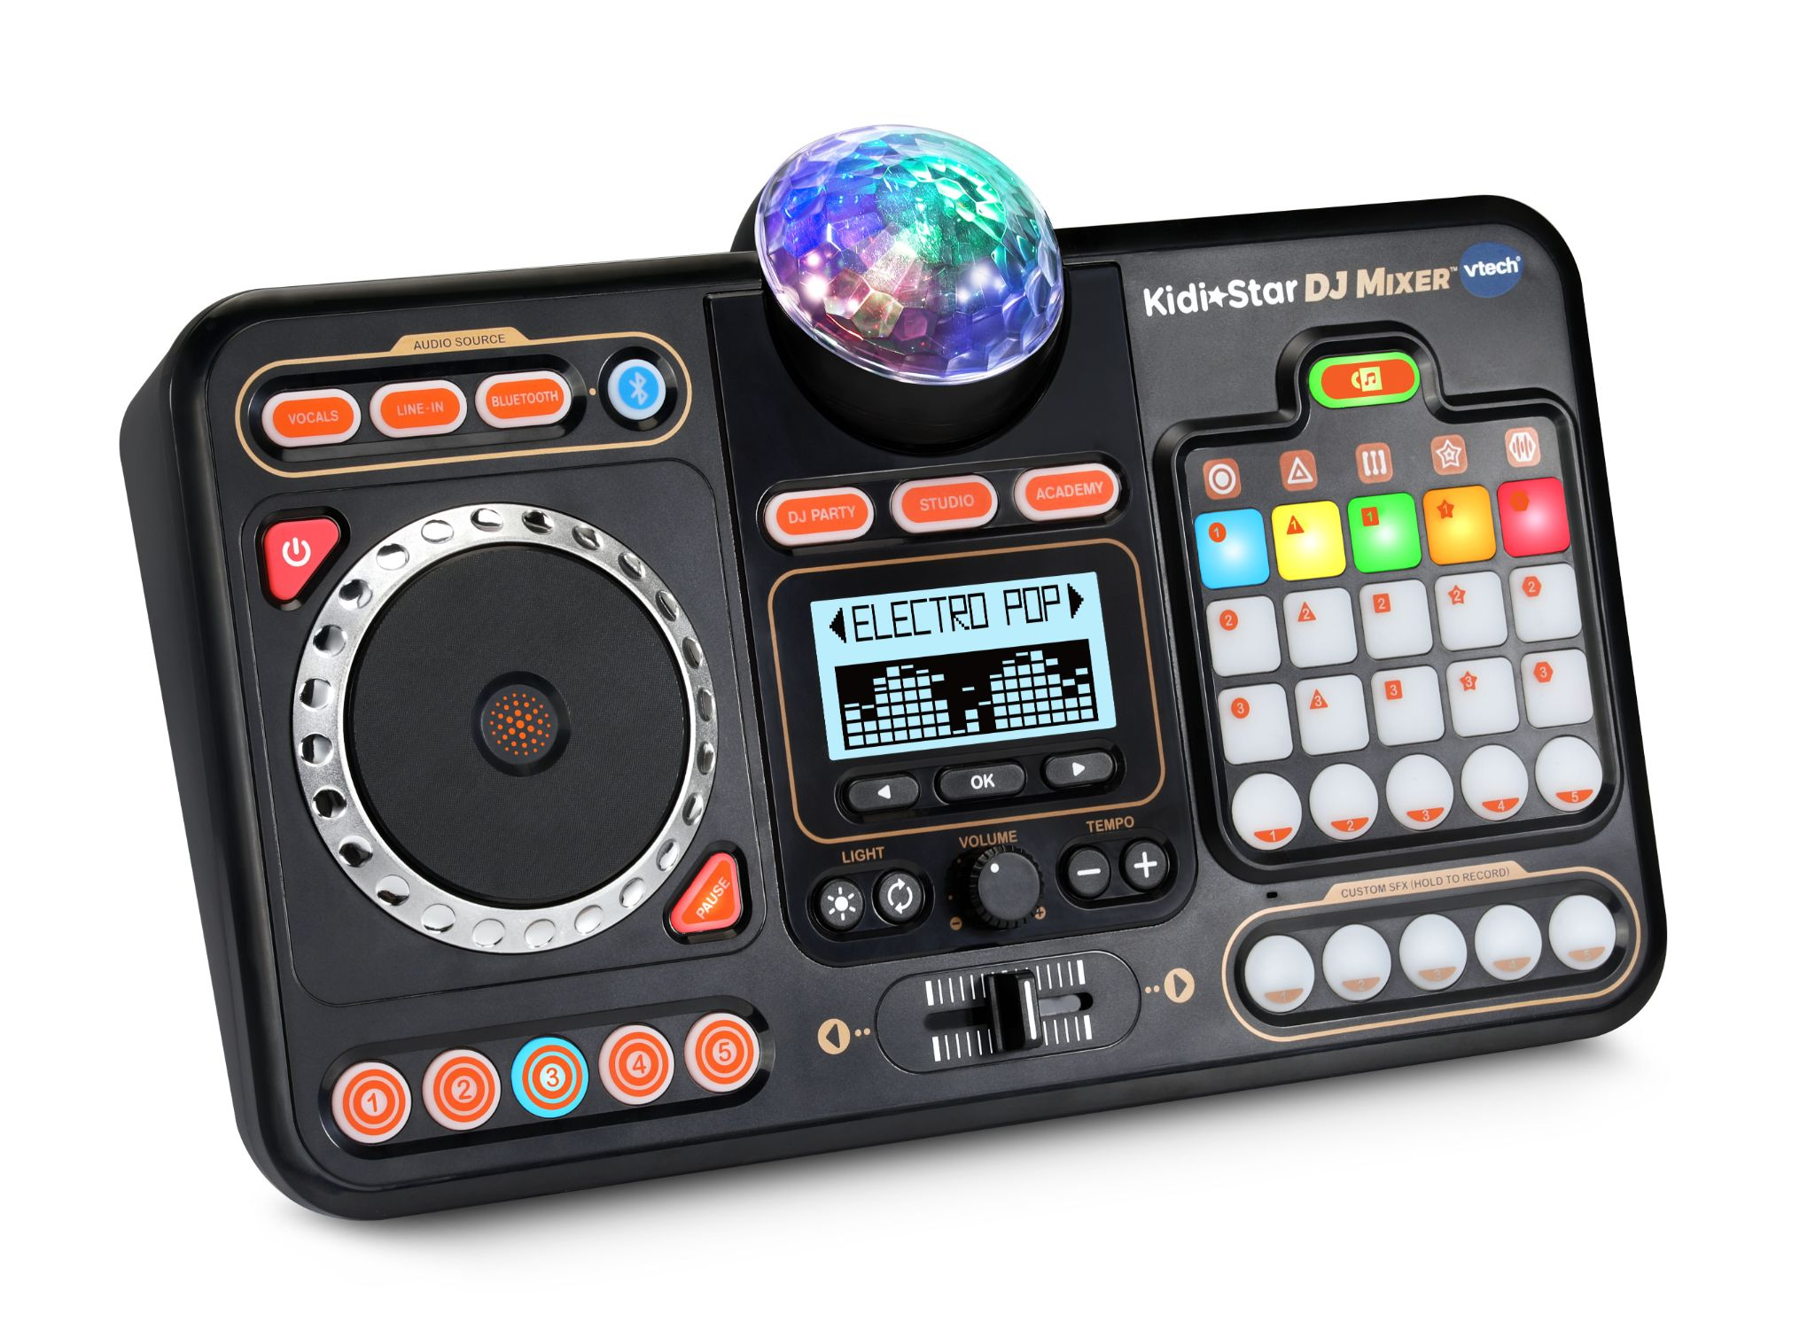
KidiZoom® PrintCam™  Ages: 4+ Years  MSRP: $74.99  Click and print instantly with the KidiZoom® PrintCam™. Preview your photos with the 2.4" color screen and print regular or panoramic photos in black and white right away. Flip up the lens to take selfies! The included paper roll prints up to 80 images—that’s a pennies per print value! When the paper’s gone, get the KidiZoom® PrintCam™ Paper Refill Pack (sold separately) for three more paper rolls and two rolls of adhesive paper to turn photos into stickers. Let your creativity loose and add stickers, filters and borders to any image or video. Turn photos into drawings you can color yourself. Browse 110+ templates and activities including small greeting cards, printable games and more. This kid-friendly camera takes videos, too! Backup your full-color photos and videos by transferring them to a computer using the included USB cable under adult supervision. Use the microSD card slot to increase storage up to 32GB with a memory card (not included). Three video games are included for playtime between photo shoots. Includes parent controls to set daily time and printing limits or turn off games.  Availability: August 2021; Walmart, Target and Amazon | 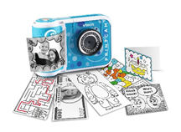
KidiZoom® PrintCam™ Paper Refill Pack  Ages: 4+ Years  MSRP: $9.99  Keep on printing with the KidiZoom® PrintCam™ Paper Refill Pack! Designed for use with the KidiZoom® PrintCam™, these ultra-affordable refill rolls are perfectly sized to fit the camera. The pack includes three regular thermal paper rolls and two thermal adhesive sticker-paper rolls. The adhesive roll is perfect for printing out your own stickers to stick anywhere! No ink required! Get up to 80 black-and-white photos per roll of regular paper and 20 per adhesive roll to color and share with family and friends.  Availability: August 2021; Walmart, Target and Amazon | 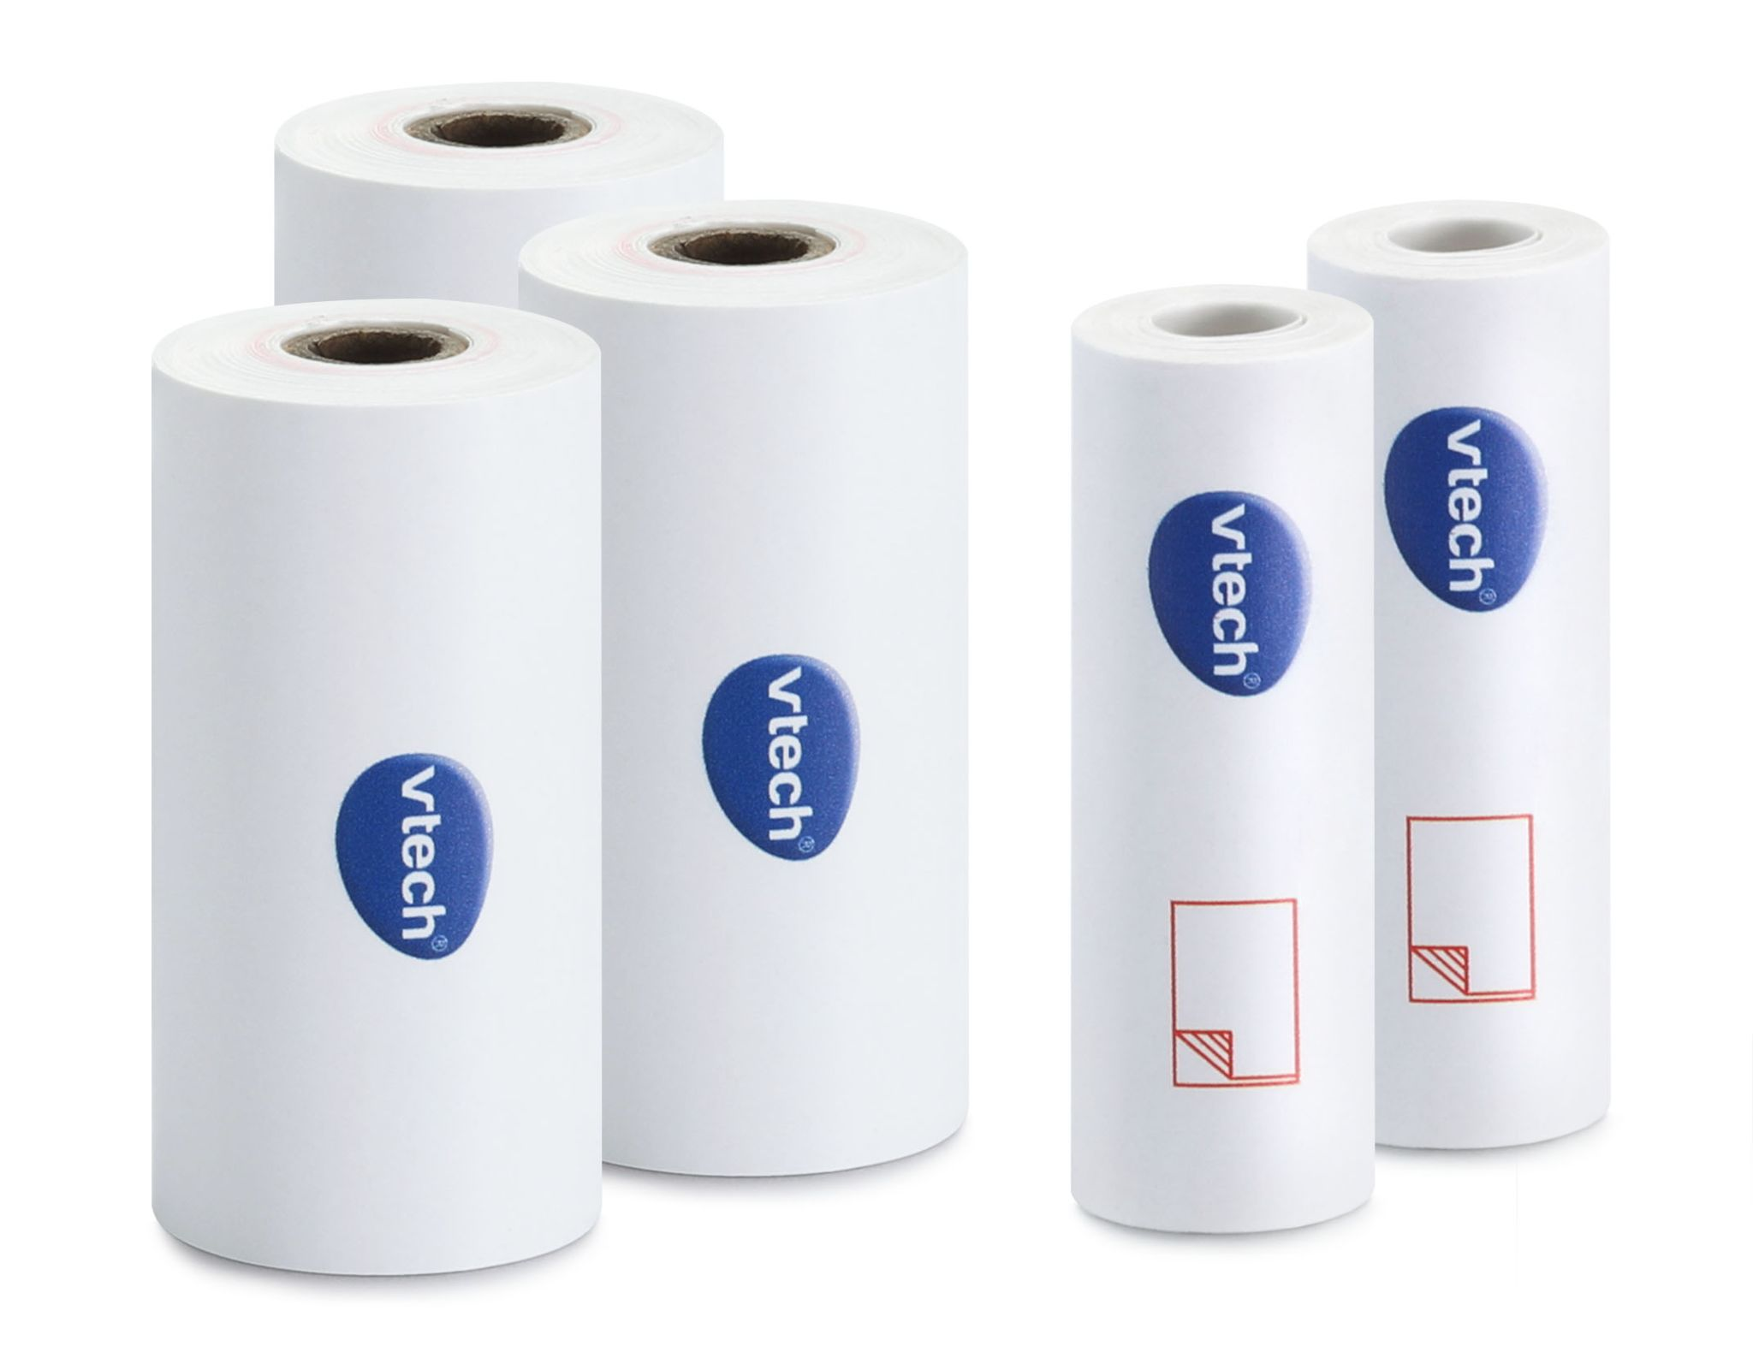
KidiZoom® Smartwatch DX3  Ages: 4+ Years  MSRP: $62.99  The coolest and best-selling kids' smartwatch brand is here—the KidiZoom® Smartwatch DX3. The kid-friendly DX3 features dual cameras for pictures, selfies and videos along with one- and two-player games, daily reminders and more. The light on the watch doubles as camera flash and flashlight. Create custom clockfaces from your own photos or swipe through 50+ animated faces to make time-telling exciting. Set Daily Reminders to help you stay on track, and switch to School mode when it’s time to limit the DX3 to a watch only. Play single-player games like Monster Catcher and find 80+ invisible creatures! Challenge yourself with movement games: Racing Run, Crazy Dance and Funky Jump. Pair up with a friend who has a DX3 to share preset messages or play Treasure Hunt, Find the Diamonds and Tic-Tac-Toe. Upcycle the top of the package and use it as a watch storage case! Download more free games, clockfaces and camera effects from Learning Lodge®.  Availability: August 2021; Walmart, Target and Amazon | 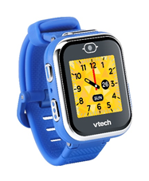  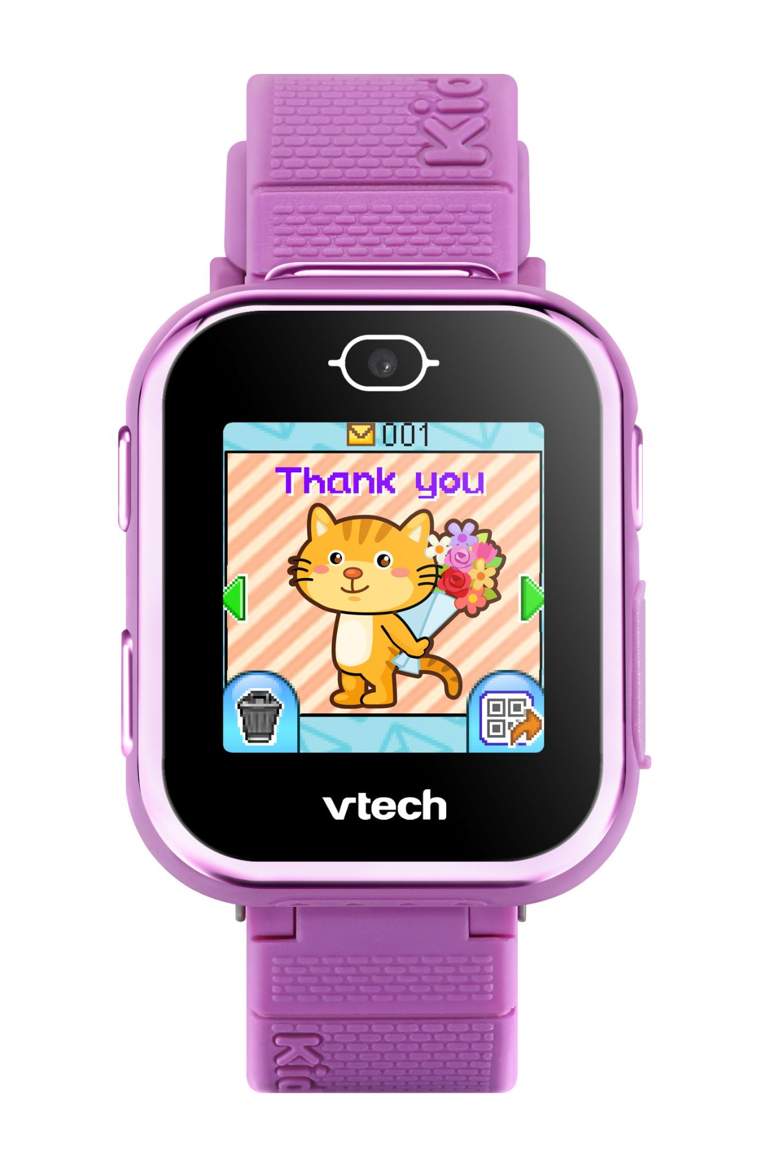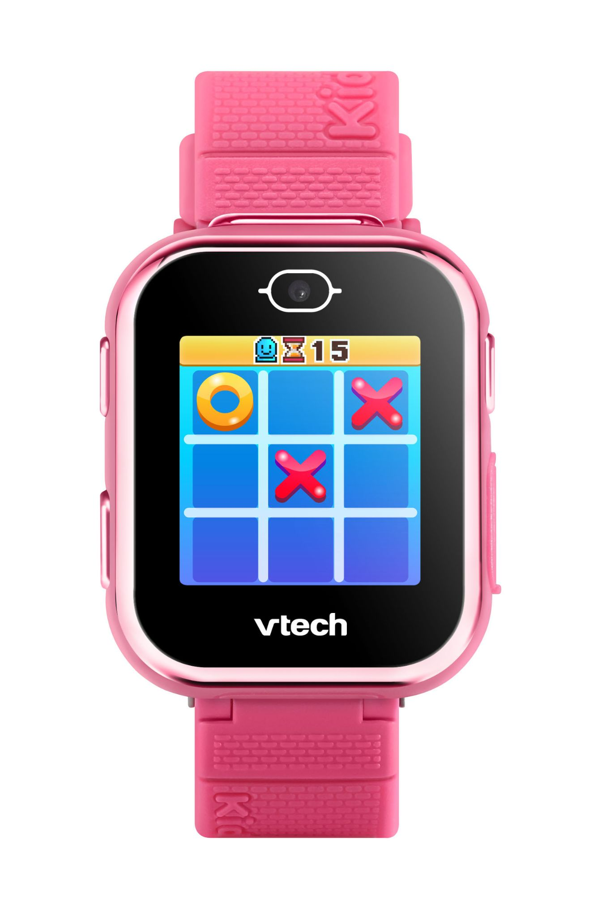
KidiZoom® Creator Cam  Ages: 5+ Years  MSRP: $64.99  Be a kid creator with the KidiZoom® Creator Cam digital camera! Create awesome videos with this high-definition video camera kit. Use the included green screen and 20+ animated backgrounds to get chased by a T-Rex, go to outer space or make yourself disappear! Set up your shot with the tabletop tripod/selfie stick and built-in microphone, then use the easy on-screen editing and creativity tools to create trick shots and time-lapse video. Intended for ages 5–10 years. Video can only be uploaded via included USB cable at parent's discretion. Green screen required for some special effects. Camera has a microSD card slot to increase storage up to 32 GB (card not included). Requires 3.7-volt lithium ion battery, included. Recharge battery with included USB cable.  Available now at all major retailers, including Amazon, Walmart and Target | 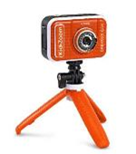

Contacts: Coyne PR
Lauren Fagan, lfagan@coynepr.com
Kaitlin Anilonis, kanilonis@coynepr.com

