VTech® Sweet Suite 2021
What’s New!

VTech®
Get Ready for School Learning Desk™  Ages: 2 - 5 Years  MSRP: $57.99  Inspire a love for learning with the Get Ready for School Learning Desk™! This 5-in-1 flexible learning center and stool includes an interactive desk top, projector, LED writing pad, chalkboard and art station. Discover 200+ touch-and-learn spots on five interactive activity pages. Explore the alphabet, numbers, counting, music, shapes, colors, the human body, clothes and weather. Use the unique projection system with the four color-coded projection reels to trace images and practice drawing or learn about shapes and the human body with the corresponding activity pages. Let’s write! Follow the lights to learn to write letters and numbers stroke by stroke with the interactive writing pad and attached stylus. Flip the desk top up to reveal a chalkboard and easel. Get creative! Add background music with the included music player featuring 30+ songs and melodies. Learning on a sunny Wednesday afternoon? Spin the roller to select the day of the week, then move the weather slider to sunshine. Set the hour hand on the desk top clock to explore and practice time concepts. It’s a good day for learning!  Availability: Fall 2021; Walmart | 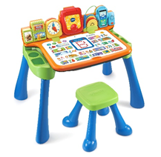
Ivy the Bloom Bright Unicorn™  Ages: 4+ Years  MSRP: $54.99  Make some magic with your new friend, Ivy the Bloom Bright Unicorn™. This robotic unicorn toy spreads her wings and sparkles with light when she talks and sings. Press the butterfly button on Ivy’s magic wand to choose a color and change her eyes, wings, or hair, horn and flower. Wave the wand to change all Ivy's colors at once. Accessorize Ivy's tail using her six hair clips to complete her look. Blow Ivy a kiss and watch the flower in her mane bloom and light up. It’s time to party! Play music for Ivy and she’ll dance and glow. Ask Ivy to play a song, then hear her sing eight different tunes. Sing along when you learn the songs! When it’s time to rest, tuck Ivy’s legs under her and boop her nose for cute and cuddly responses. She’ll then share her dreams and ask for a lullaby.  Availability: August 2021; Target | 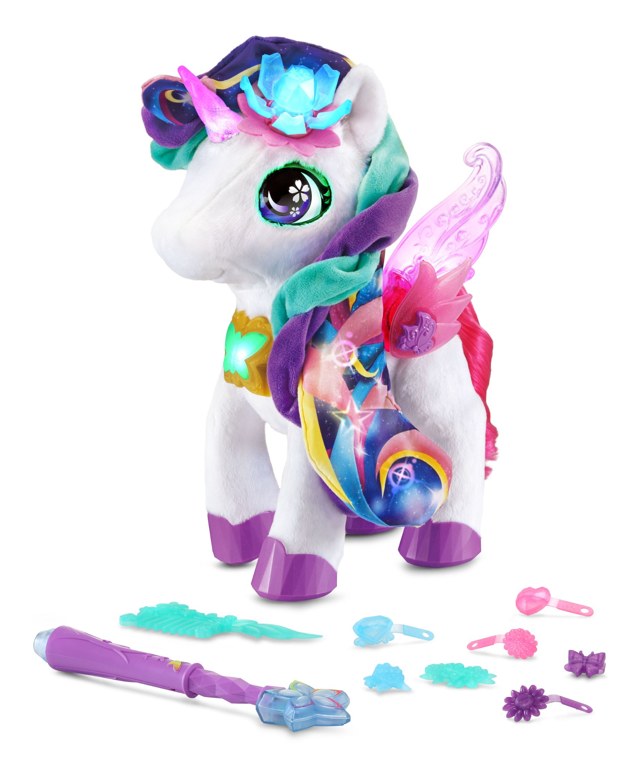
Glitter Me Kitten™  Ages: 4+ Years  MSRP: $34.99  Add some sparkle to your day with the Glitter Me Kitten™. Surprise! When this meow-gical kitten is happy or when you press her head, she will move her paw and place a glitter stamp on your hand to show she loves you. She includes a glittery ink bracelet with a surprise color you can put on her paw. The ink is safe and easily washes off with soap and water. Is the kitten hungry, sleepy, itchy or gassy? Watch her stripes change colors to show you how she’s feeling. Respond to her needs by scratching her head, patting her on the back until she falls asleep. When she's hungry, feed her with the bottle until she's happy again. Listen to the kitten purr and meow. Discover what she’s saying by pressing her tummy to translate her sounds into words!  Availability: August 2021; Walmart, Target and Amazon | IMAGE FORTHCOMING
Hope the Healing Husky™  Ages: 4+ Years  MSRP: $54.99  Hope the Healing Husky™ doesn’t feel well, but you can help! Hold the magic stethoscope to Hope’s chest, and she’ll switch from barks to words to tell you how she’s feeling. Future veterinarians are going to love using the four interactive accessories to check her temperature, give a healing shot, bandage her ouchie and more. Then put on her recovery collar to help her heal. Store all the accessories in the medical bag for quick clean-up. Explore nurturing role-play by interacting with Hope’s seven buttons and sensors that enable her to talk, bark and move. Hope will make different sounds to show if she’s hungry, has a cold or fever, has a hurt leg or feels itchy.  Availability: October 2021; Amazon | 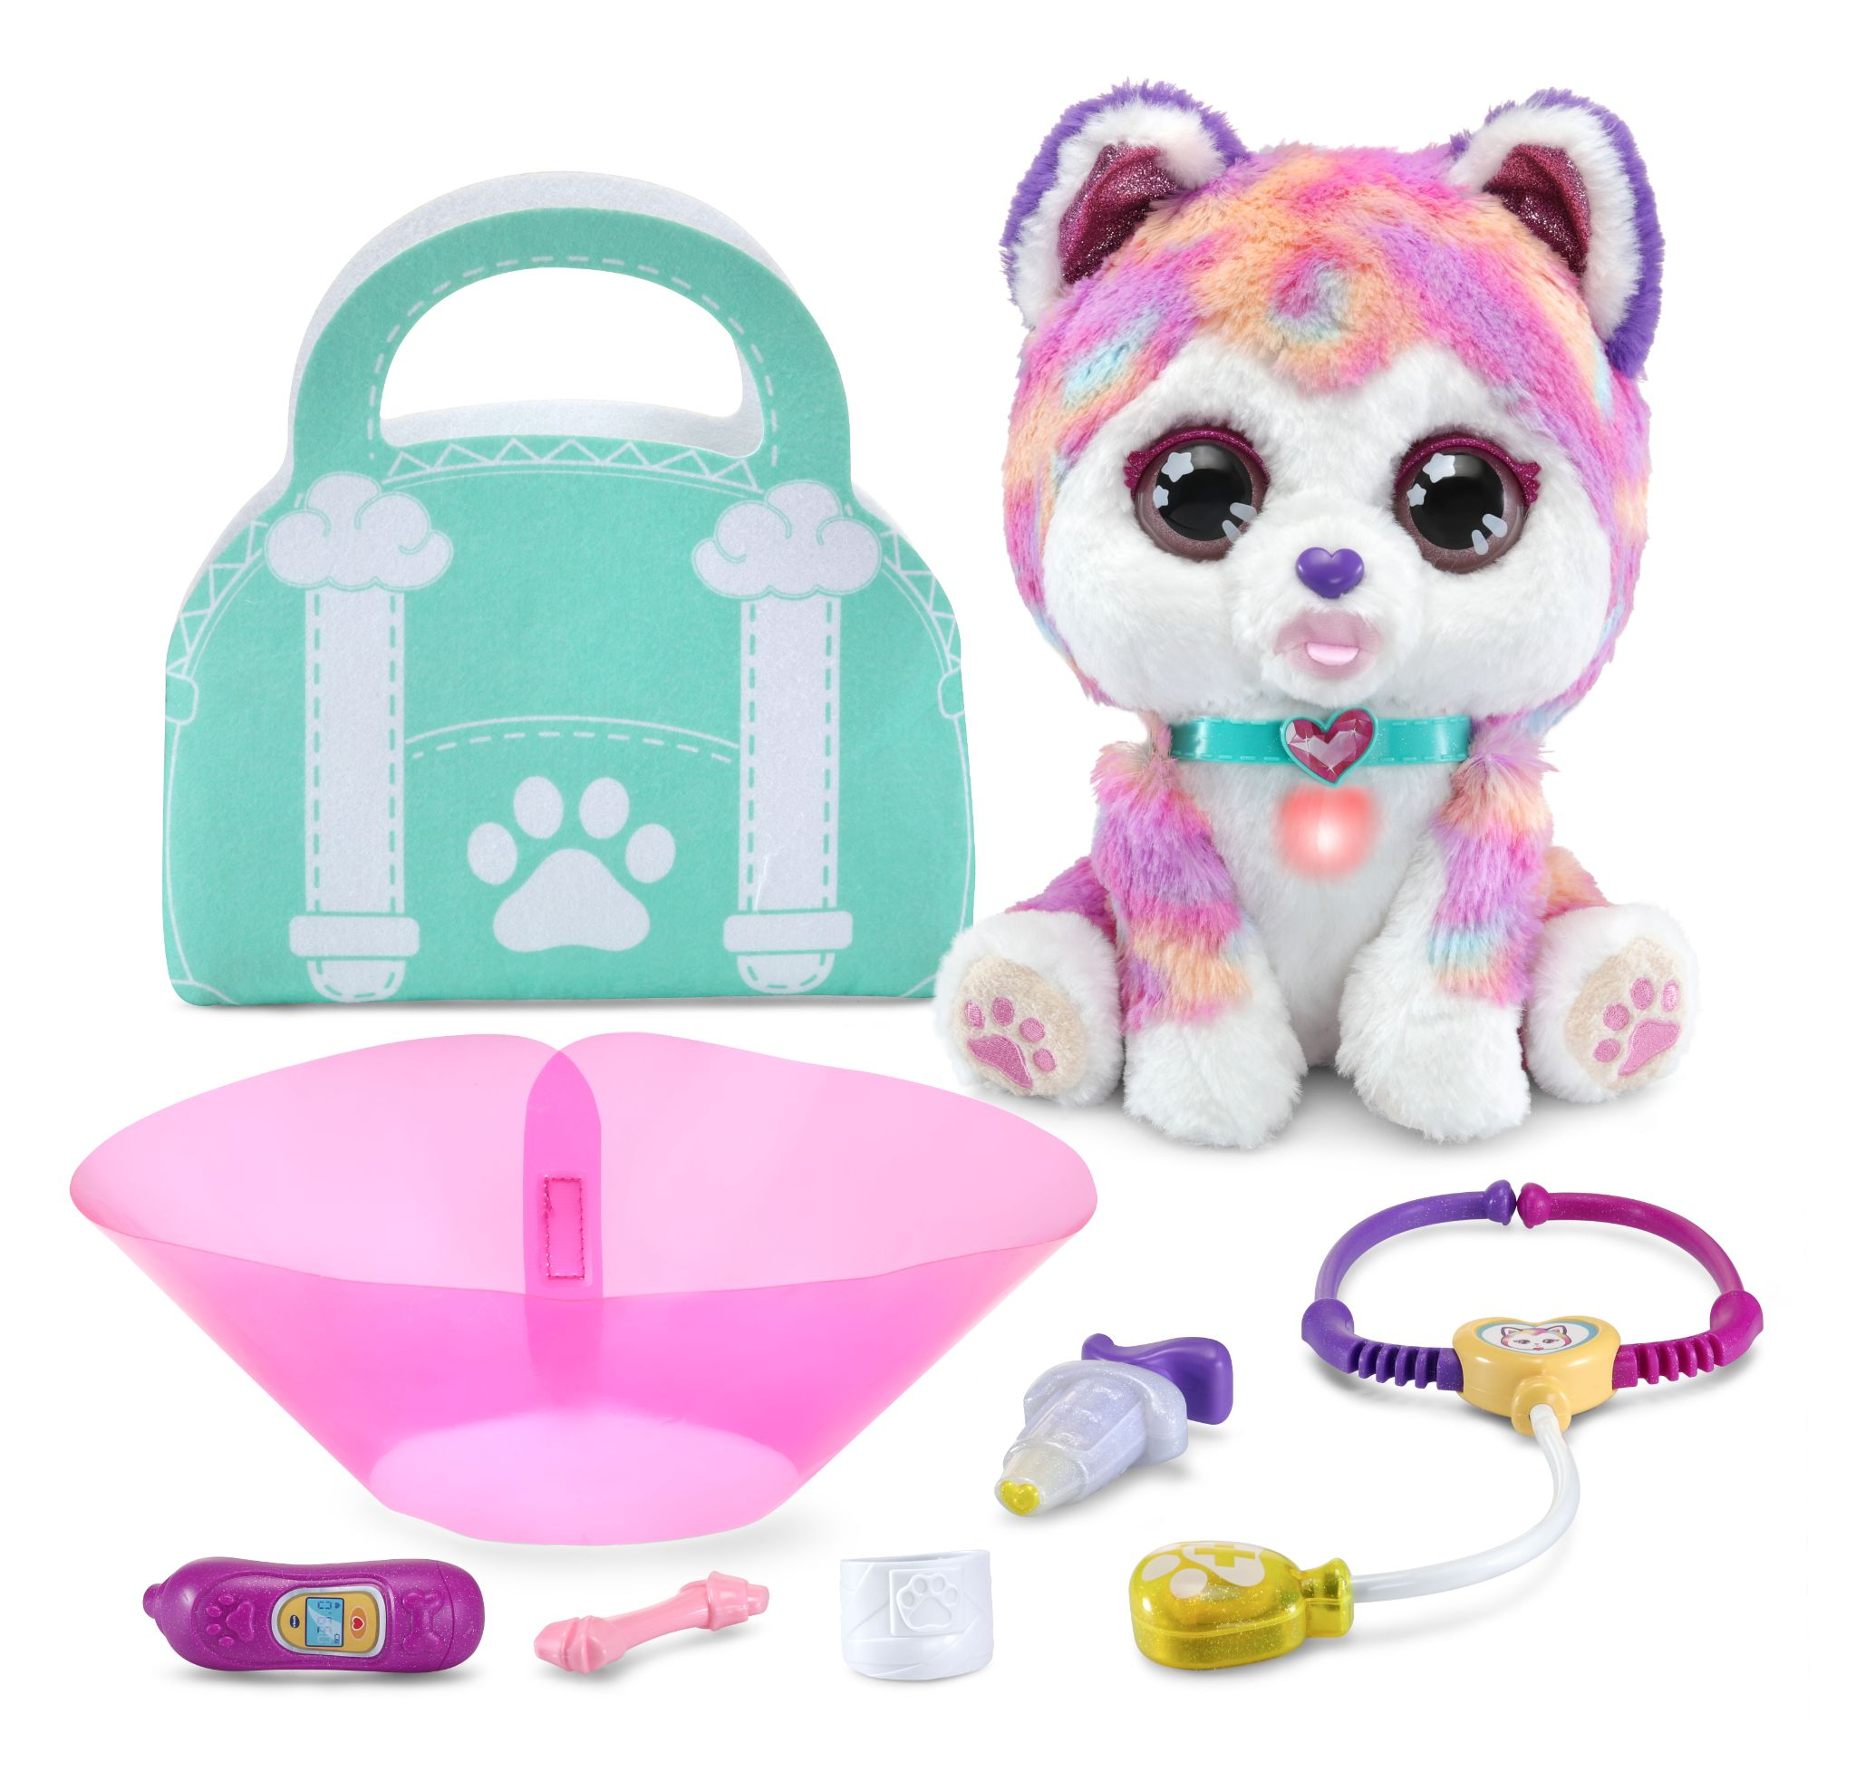
Marble Rush™ Launchpad Set™  Ages: 4+ Years  MSRP: $27.99  Build thrilling stunts, exciting challenges and watch marbles take off with the Marble Rush™ Launchpad Set™. This 89-piece color-coded building set includes a musical light-show rocket ship, thrilling ramps, fast tracks, extreme launchers and bases that all easily connect together. The easy-to-follow leveled guide includes three different builds from beginner to advanced, or create your own courses. When construction is complete, drop the 10 marbles into action and watch them race down ramps to the launcher and jump challenges. Compete with family and friends using the exciting launchers to keep the marbles in motion and bring them back to the beginning. Combine with other Marble Rush™ sets (sold separately) to create an extreme playset. Find more builds at vtechkids.com/marblerush.  Availability: August 2021; Walmart, Target and Amazon | 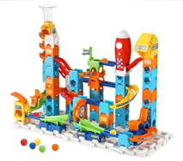
Marble Rush™ Ultimate Set™  Ages: 4+ Years  MSRP: $47.99  Roll through thrilling stunts and exciting challenges with the Marble Rush™ Ultimate Set™. This 145-piece color-coded building set includes a spinning Ferris wheel, a swirling cone that plays a musical light show, thrilling ramps, fast tracks, extreme launchers and bases that all easily connect together. The easy-to-follow leveled guide includes three different builds from beginner to advanced, or create your own courses. When construction is complete, drop the 10 marbles into action and watch them race down ramps and swirl through funnels to the basket or ramp challenges. Compete with family and friends using the exciting launchers and non-stop Ferris wheel to keep the marbles in motion and bring them back to the beginning. Combine with other Marble Rush™ sets (sold separately) to create an extreme playset. Find more builds at vtechkids.com/marblerush.  Availability: August 2021; Walmart, Target, Amazon | 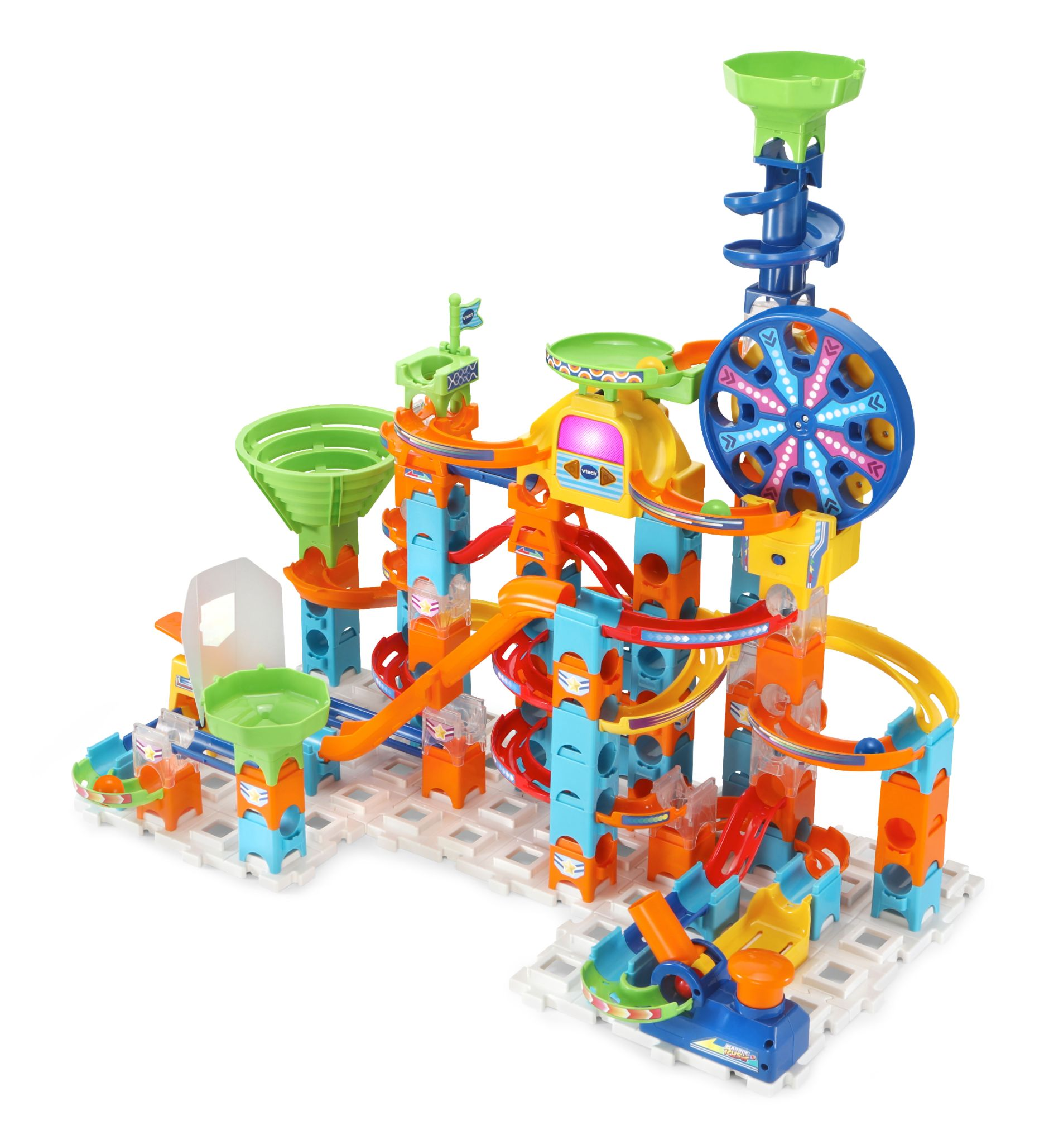
KidiGo™ Basketball Hoop  Ages: 5+ Years  MSRP: $34.99  It’s game on with the KidiGo™ Basketball Hoop and ball! An interactive scoreboard keeps score and cheers you on, celebrating each basket with lights and sounds. Five game modes offer options to play solo or with up to five players with four built-in games, or make up your own rules in Free Play. Play solo in Color Challenge, timing your shot with the colored scoreboard lights, or make the game-winning basket before time runs out in Time Challenge. Now it’s team time! Gather up to four other players or play solo in Score Challenge, sinking as many shots as you can in one minute. Include friends and family in a Hot Potato game. Quick! Make a basket and pass the ball before the music stops. When play is done, flip up the hoop for easy storage. Backboard attaches over most doors with included padded door hooks, or can be mounted with the backboard holes. Mounting hardware is not included.  Availability: August 2021; Walmart, Target and Amazon | 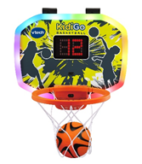
4-in-1 Learning Letters Train™  Ages: 12 - 36 Months  MSRP: $54.99  All aboard for discovery and learning with the 4-in-1 Learning Letters Train™! Take kids from floor play to walker push toy to ride-on to pull cart with this 4-in-1 interactive train and caboose. Sixteen activities encourage motor skills while teaching about letters, numbers, places and more. Venture to the library or visit the pyramids with the six-page travel book and 10 number buttons. Explore all the ways to play with the 13 double-sided alphabet blocks! Insert them into the Recognition Port to hear about letters and objects. H is for hedgehog! Flip the seat panel up to discover a pegged tumbling surface to slide the blocks down, then build a tower on the pull cart. Ready to ride? Be the conductor and turn the dial, press the horn and push the handle. Full steam ahead into a learning journey!  Availability: August 2021; Walmart and Amazon | 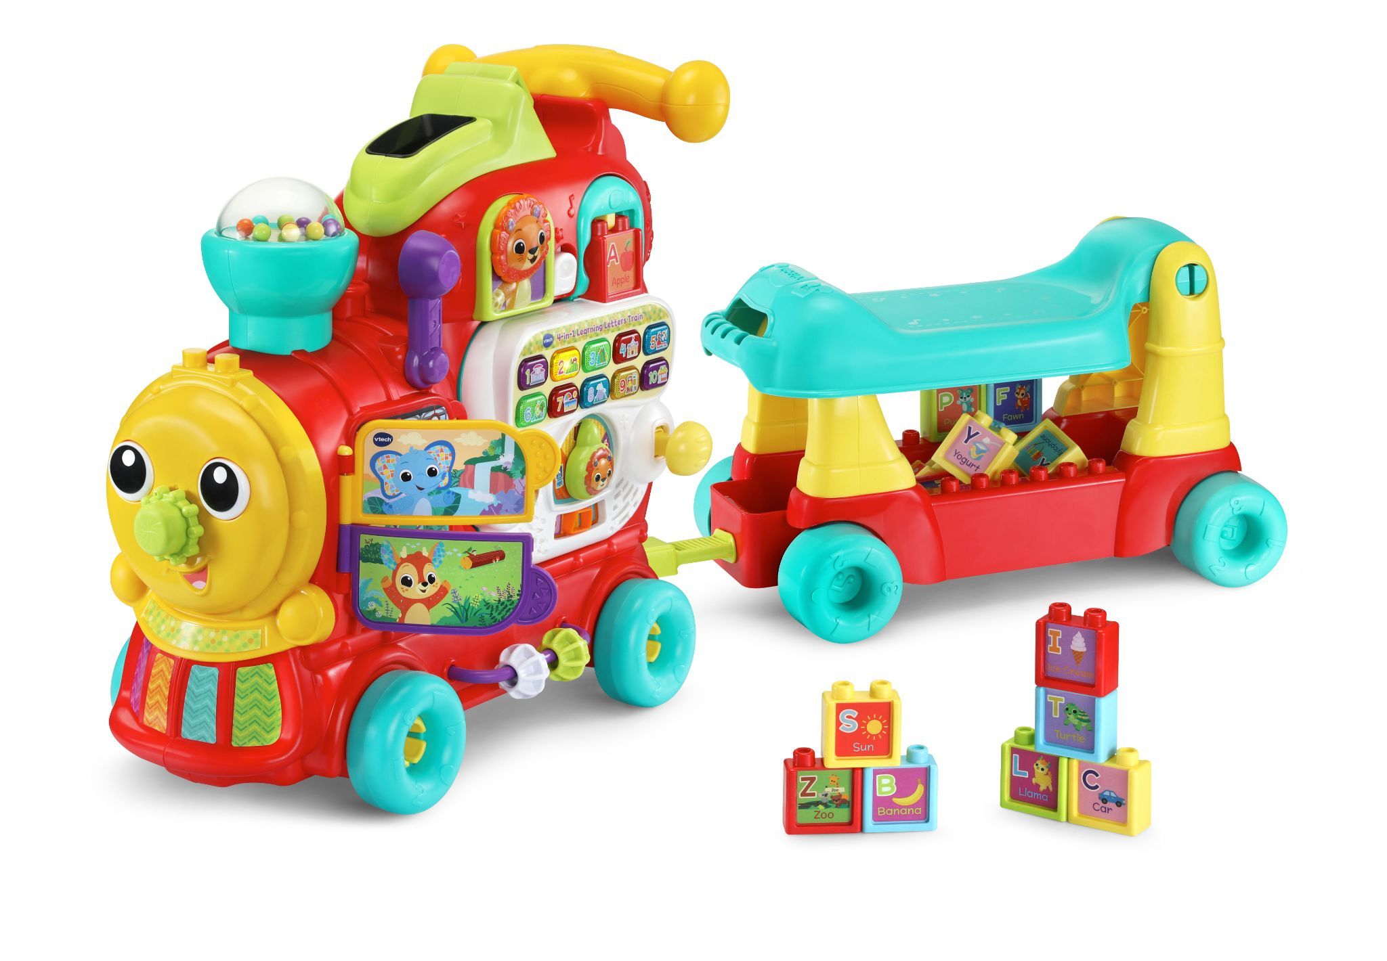

Contacts: Coyne PR
Lauren Fagan, lfagan@coynepr.com
Kaitlin Anilonis, kanilonis@coynepr.com

