Zing 2020 Fact Sheet

Zing continues to inspire imagination and play with a full range of inventive products that combine new tech and old school fun! Joining the company’s industry-renowned bow and arrow line, that already features the thrilling HyperStrike, is the addition of the fun and playful Marshmallow Blasters line! In 2020, the iconic stop-motion-animation Stikbot line which has generated a staggering 440 million-plus views on YouTube since its launch, celebrates its 5th anniversary.

Go Go Bird
Zing is soaring high with the launch of the new Go Go Bird! This thrilling and intelligent flying bird is the perfect mix of traditional R/C and today’s trending drone toys. Go Go Bird looks and flies just like a real bird- providing the most dynamic remote-control aerial experience you can have!

Integrating a lightweight body design, infra-red sensing and a wireless remote control the Go Go Bird brings the tech toys category to new heights! With a six-axis sensor inside, the Go Go Bird can achieve a smart take-off by hand to then fly through its environment! PLUS: thanks to its integrated obstacle-avoiding technology the Go Go Bird will automatically turn around once six feet away from potential obstacles to avoid crashes!

With flying distances of up to 100 feet in the air, you can challenge your friends to a race, perform aerial tricks, or see who can land in the most unique places using its intuitive remote control. The Go Go Bird is available in red and blue and comes with one remote and two rechargeable batteries.
For ages 8+
Available: Fall 2020
US: $39.99
US Retailers: Amazon, Books A Million, Shopping Network, Target (+.com), Zing.store
CA Retailers: Costco, Master Mind, Scheelds

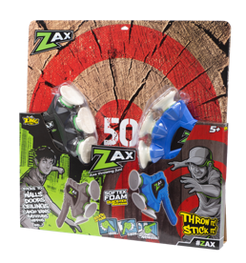
Zax Target Pack
Zax was the on-trend hit of 2019! Continue to experience the thrill of axe throwing at home in a fun and safe way with the Zax Target Pack This pack features two soft, safe throwing axes with Softek foam suction cups that can stick to almost any surface and a target on the back of the packaging– allowing users to hatchet throw just about anywhere (inside or out) and create their own axe throwing lane. See who has the best Zax throwing skills by challenging your friends!
For ages 5+
Available: Now
US: $29.99
US Retailers: Amazon, Zing.store, Mindware, Crackel Barrel (Q4)
CA Retailer: Master Mind
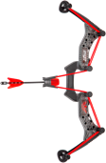
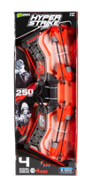
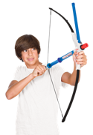
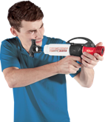
Stikbot Megabot
The next evolution in Stikbot stop-motion animation play is hitting toy aisles in 2020; introducing Stikbot Megabot. These three hyper-stylized vehicles are designed to amp up your Stikbot videos. This new line includes Knockout, Avalanche, and Turbo Cycle.

Celebrating its 5th year, Stikbots are easy-to-pose figures, built with suction cup hands and feet, which can stick to almost any flat surface. With the free Stikbot Studio app, available on iOS and Android, kids can easily create stop-motion movies, complete with built-in music and sound effect options. Users can then share their creations using #Stikbot and see what others are making all over the world! Over the past five years, Stikbot Central has reached nearly 1 million subscribers, generating over 440 million views on YouTube.

For ages 4+
Available: Now
US: $9.99
US Retailer: Amazon, Books A Million, Five Below, Zing.Store

Marshmallow Blasters
Launch a barrage of soft, sweet marshmallow treats indoors or out from the new Marshmallow Blasters from Zing! Marshmallows provides a soft, hearty laugh on impact – thanks to its edible ammo! Great for kids of all ages! PRO TIP: Add cornstarch to your Marshmallow Blaster and watch a cool puff of white dust form as you launch them! New styles include:

Marshmallow Blaster Extreme Blaster: This single-action, lock-and-load unit fires large marshmallows one at a time, launching them up to 40 feet! Simply load in the marshmallow, pump the handle and fire! For ages 8+. Available Now. MSRP: $28.99. Retailers: Zing.store, Amazon (Now), Dylan’s Candy Bar, Froggies, Nordstrom, Shields (Fall 2020)

Marshmallow Blaster Bow & Mallow: The big brother of the Mini Bow & Mallow, this Blaster continues to bring food and fun together! With launching distances of up to 30 feet, your marshmallows will soar through the air! The easy-to-fill cylinder holds 25 miniature marshmallows. For ages 8+. Available Now. MSRP: $25.99. Retailers: Zing.store, Amazon (Now), Dylan’s Candy Bar, Froggies, Nordstrom, Shields (Fall 2020)

HyperStrike
Take your backyard battles to a new level with HyperStrike, from Zing!
This ultimate bow and arrow set is perfect for either one-on-one or team-based fun and fast-paced competition. Designed with low-profile bungee cords, these bows can launch arrows up to an amazing 250 feet! Simply hook the soft foam Zonic Whistle Arrow into the fast-load bungie loops, pull back, aim, and release!
For ages 14+
Available: Now
US: $29.99
US Retailer: Target, Walmart, Amazon, Zing.Store

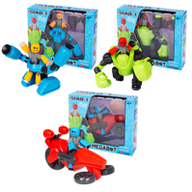

Freeman Public Relations for ZIng
Amy Friedland, 973 470 0400 ext. 25, afriedland@freemanpr.com
Emily Potrzuski, 973 470 0400 ext. 15, epotrzuski@freemanpr.com
Linda D’Isa, 973-470-0400 ext. 20, ldisa@freemanpr.com
Brendan Maguire, 973-470-0400 ext. 12, brendan@freemanpr.com

