INTRODUCING TONIES, THE REVOLUTIONARY CHILDREN’S AUDIO PLAYER AND EUROPEAN TOY SENSATION MAKING ITS U.S. DEBUT SEPTEMBER 2020

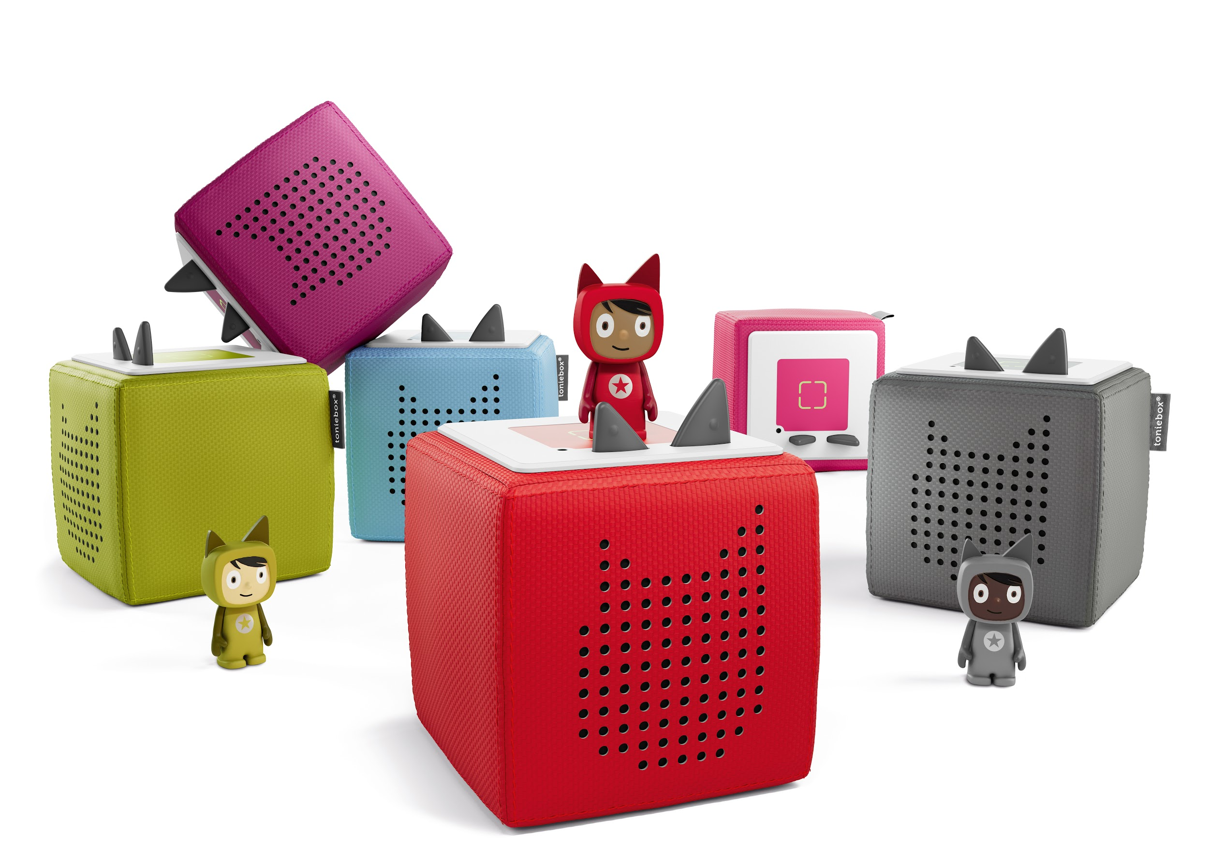

September 23, 2020 (PALO ALTO, CA) - Today, young minds -- and ears! -- in the United States can immerse themselves in the magical world of tonies® -- the original, award-winning, screen-free audio entertainment system designed specifically for children ages 3 and older. Currently the fastest growing toy company in Europe, tonies has made their stateside debut, just in time for the fall and holiday seasons.

tonies was developed by two dads, Patric Faßbender and Marcus Stahl, who sought out to solve a struggle that all parents face: keeping their kids entertained while limiting screen time. They wanted to design a screen-free alternative that inspired creativity and fostered imagination. After three years in development, tonies launched in Europe in 2016 and is now the #3 most popular toy in the region with several accolades.

“When we created tonies years ago, we had one thing in mind: our kids. We wanted to devise a way for children everywhere to experience storytelling in a fresh new way -- one that utilized the ease of modern technology, while stimulating the imagination without screens,” said Patric Faßbender and Marcus Stahl, co-founders of tonies. “We are so proud to bring our beloved tonies to the U.S., and delighted to welcome American families to our expanding global tonies family.”

Designed to foster imagination and active, independent play, tonies is everything young, curious minds need. The Toniebox is a soft, shockproof, five-inch cube made of durable fabric. It contains no screens, sharp corners or edges, ads, camera or a microphone, making it super simple, safe and fun for kids to use. The controls are simple enough that young children can adjust the volume, fast forward, rewind, skip chapters and more all on their own without help from an adult. With seven hours of battery life and no need for Wi-Fi access after the initial set up, the Toniebox is an ideal storytime companion at home or while traveling and out and about.

The Toniebox comes to life when paired with the whimsical collection of Tonies figures, which are hand-painted characters with hours of stories to tell, songs to sing and worlds to explore. There are two types of Tonies: Content Tonies and Creative-Tonies.

Content Tonies are characters that come pre-loaded with stories and songs for easy listening. This fall, U.S. families can choose between 17 individual characters, including classic storybook fairy tales like Pinocchio and Rapunzel. Families will also find beloved stories like Disney’s The Lion King, Frozen and The Little Mermaid and Pixar’s Toy Story, Cars, and Finding Nemo. Even more stories and songs will roll out in 2021 through collaborations with Penguin Random House, Disney, Pixar, Universal and many others.

Creative-Tonies have space for up to 90 minutes of personalized recordings of one’s own songs, stories and greetings. Parents, grandparents and friends can record content from anywhere in the world using tonies’ free smartphone app, and load them onto the Creative-Tonies for easy playback. This means that kids can enjoy recording and listening to their own fantastic creations; as well as recordings from loved ones, providing a unique medium to stay connected.

All tonies content is managed through a secure cloud-based system via the app and website. The tonies app enables parents to easily adjust Toniebox settings like maximum volume, access rights and privileges within seconds, so that they are always in control.

The tonies Starter Kit retails for $99.99 and includes a Toniebox in one of six popular colors (red, green, light blue, pink and gray) and a Creative-Tonie. Each additional Tonie is available for purchase at prices ranging from $11.99-$14.99. tonies is available for purchase online via tonies.com, Target.com, BarnesandNoble.com, Amazon.com, and FAO.com. In-store, tonies can be found at FAO Schwarz in New York (tonies’ U.S. flagship in-store retailer), and at independent toy retailers nationwide.

Get started with tonies today! For more information and to shop the collection, visit tonies.com and follow them on Instagram (@tonies.us), Facebook (@tonies.us) and Twitter (@ToniesUS).

###

